Tel Aviv November 7, 2023
Executive Summary & Investors Review
Roadmap for the German Medicinal Cannabis Project
Yaakov Waksman, Ph.D.
972-52-4114916
waksmanya@gmail.com
- Introduction & Scientific background
Phytocannabinoids (pCBs)
Cannabinoids are several structural classes of compounds found in the cannabis plant. The most notable cannabinoid is the phytocannabinoid tetrahydrocannabinol (THC) (delta-9-THC), the primary psychoactive compound in cannabis. Cannabidiol (CBD) is also a major constituent of temperate cannabis plants and a minor constituent in tropical varieties. At least 113 distinct pCBs have been isolated from cannabis, although only four [THC acid (THCA), cannabidiolic acid (CBDA), cannabichromenic acid (CBCA) and their common precursor cannagerolic acid (CBGA)] have been demonstrated to have a biogenetic origin. After heat decarboxylation, the acids turn to the neutral, active form (THC, CBD, CBC & CBG). The pCBs are multi-ring phenolic compounds, but endocannabinoids (eCBs) are fatty acid derivatives. Both eCBs & pCBS are hydrophobic lipid mediators.
Heat decarboxylation of cannabinoid acids:
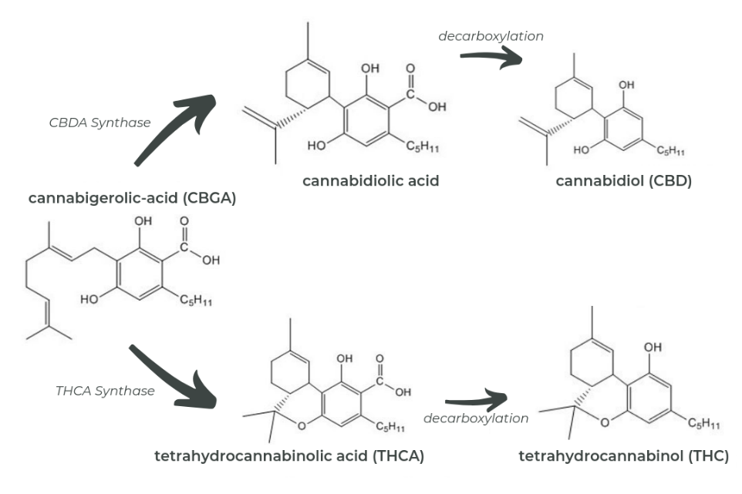
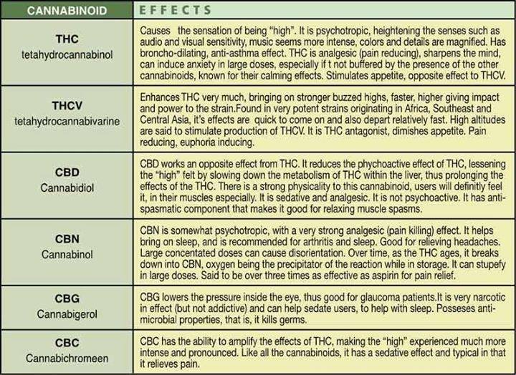
Endocannabinoids (eCBs)
Scientists discovered the brain's opiate receptor in 1973, but it was not until 1988 that Prof. Allyne Howlett and the late Dr. William Devane determined that the mammalian brain has receptor sites that respond to THC found in cannabis. These receptors, named cannabinoid receptors turned out to be the most abundant G-protein coupled receptor (GPCRs) neurotransmitter receptor in the human brain. In 1990 Prof. Lisa Matsuda had mapped the DNA sequence that encodes a cannabinoid receptor (CB1) in the brain and the central nervous system (CNS). Prof. Matsuda cloned this receptor and developed knockout mice that lake CB1. When THC was administrated to these mice it was shown that the pCB had no effect, proving that THC works by activating CB1. Few months later, a second cannabinoid receptor (CB2) was also cloned. The CB2 receptor was found in immune cells and in the peripheral nervous system (PNS). These discoveries resulted in the uncovering of naturally occurring neurotransmitters called endocannabinoids. In 1992, at the Hebrew University of Jerusalem, Dr. Lumir Hanus along with the late Dr. William Devane discovered the eCB – arachidonoyl ethanol amide (AEA) called anandamide [Ananda = bliss in Sanskrit]. The same team later discovered a second major eCB – 2-arachydonil glycerol (2-AG).
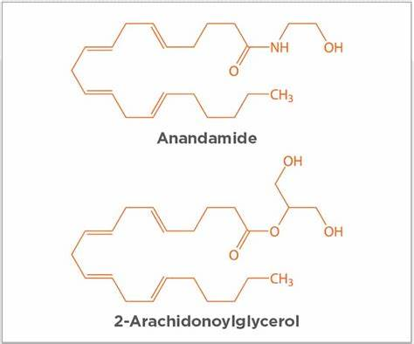
As a result of these studies, scientists came across an unknown molecular signaling system in our bodies that is involved in regulating a broad range of biological functions. This new system was called the endocannabinoid system (ECS) that its goal is to maintain a stable environment despite fluctuations in the external environment. The ECS creates homeostasis within the body. In some cases, there is a deficiency in ECS signaling that is known as clinical eCB deficiency [CED] because the body does not synthesize enough eCBs, does not produce enough eCB receptors, produce abundance of enzymes that break down eCBs or foods & medications that decrease ECS signaling. In these conditions, pCBs can be used to supplement this deficiency by supporting the ECS, treating multitude of diseases & disorders.

Medical cannabis in Germany
Legal/ Regulatory Framework
There are several primary laws and regulations that govern practices regarding cannabis in Germany. The regulations of the German Narcotics Act (Betäubungsmittelgesetz, BtMG) must be observed in relation to all cannabis products (except for cannabidiol (CBD) without trace THC.
Cannabis, defined in the BtMG as “marijuana, plants and parts of plants belonging to the genus cannabis”, is listed in two annexes in the BtMG.
First, cannabis is listed in Annex I which includes narcotics that are – for now – generally not marketable and cannot be prescribed (Annex I BtMG), excluding the following:
* Cannabis seeds, provided they are not intended for unauthorized cultivation.
* Cannabis that originates from cultivation in the EU with certified seed varieties that are listed in Article 9 of Commission Delegated Regulation (EU) No 639/2014 of 11 March 2014 supplementing Regulation (EU) No 1307/2013 of the European Parliament and of the Council establishing rules for direct support schemes for farmers under common agricultural policy support schemes and amending Annex X to that Regulation (OJ L 181, 20.6.2014, p 1, L 181, 20.6.2014, p 1), or: whose THC content does not exceed 0.2%.
* Cannabis whose marketing (other than cultivation) is exclusively for commercial or scientific purposes; and whose misuse for intoxication purposes can be precluded.
* Cannabis (HEMP) planted as protective strips in beet cultivation and destroyed before flowering.
The exemptions also apply to preparations made from these plants and parts of plants if the above conditions are fulfilled.
Second, cannabis for medical purposes is listed in Annex III which includes narcotics that are marketable and can be prescribed. The only cannabinoid included separately in the BtMG is THC, which is listed several times in Annex I and once in Annex II, depending on its exact composition. On the other hand, pure cannabidiol (CBD) is currently not included in the BtMG.
Even though there is no punishment de jure, consumers of medical cannabis can be forced to undergo a medical-psychological assessment to assess their driving suitability. Loss of driver's license is not uncommon, followed by a regime of drug screenings to prove the suitability. Unlike for ethanol, whether one operated a motor vehicle under the influence (or indeed with trace amounts of THC in the bloodstream) is often immaterial.
Details of Medicinal Cannabis use in Germany.
The German Narcotics Act
Up until a major legislative reform in 2017, cannabis was only listed in Annex I BtMG and was therefore not marketable and could not be prescribed. Patients could get cannabis only in exceptional cases and could not receive any reimbursement from health insurers. Since 2017, the BtMG also lists cannabis in its Annex III (see above) which contains those narcotics that can be marketed and prescribed in Germany. Only physicians can prescribe narcotics listed in Annex III (see Section 13 BtMG).
According to Annex III BtMG, medicinal cannabis is only admissible if it stems from a cultivation under state control in accordance with the UN Single Convention on Narcotic Drugs and in preparations that are authorized as finished medicinal products.
Anyone who cultivates, manufactures, trades, imports, exports, delivers, sells, otherwise places on the market, acquires or sells narcotics without trading in them requires a general license according to Section 3 BtMG. In the case of an import to Germany according to Section 11 (1) BtMG, a further permission must be obtained for each individual delivery.
There are currently legislative plans to legalize cannabis in general, which in the long run could mean cannabis being excluded from the scope of the BtMG. However, the planned new legislation is still in its infancy and will follow a phased approach.
Any doctor can prescribe medicinal cannabis to its patients.
The Social Security Code
Pursuant to Section 31 paragraph 6 of the German Social Security Code Vol 5 (Sozialgesetzbuch Fünftes Buch, SGB V), patients can receive reimbursement from public health insurers under certain circumstances.
Section 31 paragraph 6 SGB V regulates that patient with a serious illness (eg, chronic pain, multiple sclerosis, epilepsy, nausea and vomiting after chemotherapy, and appetite enhancement for HIV/AIDS patients) who are insured with a public health insurer have the right to receive cannabis in the form of dried blossoms or extracts, finished medicinal products with cannabis, and medicinal products with the active ingredient Dronabinol or Nabilon (synthetic THC), if: a generally accepted standard therapy does not exist, or in particular cases does not apply according to the justified assessment of the treating doctor, considering expected side-effects and the disease status of the insured patient; and there is a reasonable possibility that the cannabis will have a positive effect on the disease process or on serious symptoms.
The German Medicinal Products Act
Besides the BtMG, the most important statute for medicinal cannabis is the German Medicinal Products Act (Arzneimittelgesetz, AMG) which governs the movement of medicinal products in the interest of the proper and safe supply of medicinal products to humans and animals. The AMG covers the manufacturing and trading of medicinal cannabis within Germany and imports from EU countries, as well as third countries, including the requirements of the manufacturing practice in accordance with the EU “Good Manufacturing Practice” (GMP) rules.
The following licenses are relevant for the handling of medicinal cannabis:
- manufacturing authorization – every manufacturer of medicinal products needs to apply for such authorization, pursuant to Section 13 AMG.
- marketing authorization – finished medicinal products may only be placed on the German market if they have been authorized by the competent German authority or if they are authorized centrally by the EU, pursuant to Section 21 AMG.
- wholesale authorization – any person who engages in the wholesale trading of medicinal products requires an authorization to do so, pursuant to Section 52a AMG.
- import authorization – where medicinal cannabis will be imported from outside the EU, an import authorization, pursuant to Section 72 AMG, is required.
Ionizing radiation -- In the case of cannabis that has been treated with ionizing radiation to reduce germ count, the Ordinance on Radioactive Medicinal Products or Medicinal Products Treated with Ionizing Radiation (AMRadV) must also be observed. Gamma & Beta ionizing radiation destroy some of the cannabis flower terpenes. The partial CB2 receptor agonist – beta caryophyllene (BCP) [a sesquiterpene] terns to the toxic caryophyllene oxide. Therefore, we should develop an alternative sterilization method such as cold zone (O₃) + UV-B light radiation.
Lifestyle Products
Besides the general rules of the BtMG, for so-called “lifestyle products” (often containing CBD), a distinction must be made between different categories such as: food and animal feed., cosmetics and smoking/vaping products (not containing THC).
Food, animal feed and cosmetics law are largely harmonized EU law and therefore applies in all EU countries as a matter of priority. The most relevant legislations in this field are:
the German Food and Feed Code (Lebensmittel-, Bedarfsgegenstände- und Futtermittelgesetzbuch, LFGB).
the General Food Law Regulation (EC) 178/2002.
the Novel Food Regulation (EC) 2015/2283.
Regulation (EC) 767/2009 on marketing feed.
Regulation (EC) 1831/2003 on feed additives for use in animal nutrition.
the Catalogue of Feed Materials (EU) 68/2013 and (EU) 2017/2017; and
the EU Cosmetics Regulation (EC) 1223/2009.
CBD smoking/vaping products that do not contain tobacco or nicotine are considered “herbal products for smoking” and fall within the “tobacco-related products” regulated within the German Tobacco Products Act (Tabakerzeugnisgesetz, TabakerzG).
The legal status of CBD in the USA is a complex issue. The FDA has approved Epidiolex, a drug that contains a purified form of CBD from marijuana, for the treatment of seizures associated with Lennox-Gastaut syndrome or Dravet syndrome in patients 1 year and older. However, the FDA has not approved CBD for use in food, beverages, or dietary supplements. The FDA has also issued warning letters to companies that make unsubstantiated claims about the therapeutic benefits of CBD products. In addition, the legal status of CBD varies from state to state. Some states have legalized CBD for medical or recreational use, while others have not. It’s important to note that the legality of CBD products is still evolving, and it’s advisable to consult with a legal professional or healthcare provider for the most up-to-date information.
In Germany, various regulatory authorities are involved in the cannabis sector. The main authorities responsible for enforcing the laws and regulations for medicinal cannabis and general cannabis (industrial hemp, CBD, etc.) are listed as follow:
The German Federal Institute for Drugs and Medical Devices (BfArM) is an independent federal higher authority within the portfolio of the Federal Ministry of Health and is responsible for medicinal products and devices. In relation to cannabis, the following two agencies of BfArM are of most importance:
The Federal Opium Agency (Bundesopiumstelle) was established in 1952, because of the International Opium Convention of 1912. It is responsible for the issuing of licenses in the traffic of narcotics and/or precursors.
Following the BtMG reform and in line with the UN Single Convention on Narcotic Drugs, the BfArM created a Cannabis Agency (Cannabisagentur) that is responsible for the control and monitoring of the cultivation of cannabis for medicinal purposes. All authorized cultivators must sell all their crops of cannabis to the Cannabis Agency. The Cannabis Agency will purchase and take possession of the produced cannabis. Further, the Cannabis Agency will sell the medicinal cannabis to producers of medicinal products, pharmaceutical wholesalers or pharmacists and will therefore define a sales price.
The individual state authorities are responsible for the general enforcement of the German Medicinal Products Act (AMG). This concerns, in particular, the granting of wholesale and import licenses.
The German Federal Office of Consumer Protection and Food Safety (BVL) and respective state authorities is involved in the co-ordination of official food, animal feed, cosmetics and smoking products monitoring between the federal states.
The German Federal Office for Agriculture and Food (BLE) is responsible for the import regulations regarding third countries, the cultivation notification for industrial hemp and the implementation of THC controls in hemp cultivation.
There are several challenges that market participants in the cannabis sector face and must consider when establishing their business models. The key challenges may be summarized as follows:
Lengthy and Complex Approval Processes:
Licenses for the cultivation of medicinal cannabis are only issued via a lengthy tender process. The timeline of the approval process for licenses at state level can differ in every German state. Certifying manufacturing sites under the EU GMP rules, in third countries, is a very lengthy process.
The regulations for the distribution of CBD products are quite unclear and violations of the law are prosecuted with varying degrees of severity in the different German states.
Lack of Experience:
Since 2017, the cannabis sector has undergone a huge transformation and has taken on enormous importance in the market. The regulations for some product categories remain unclear, or simply missing, making it difficult for the authorities to issue clear recommendations and thus create legal certainty for market participants. Due to the still relatively new subject matter, many of the involved authorities at the state level have not yet fully established a reliable administrative practice and are often hesitant to issue statements or make clear decisions. In addition, since 2021, the new government in Germany has agreed to introduce new legislation envisaging the liberalization of cannabis for recreational use, and thus its decriminalization and at least a partial removal from the BtMG. The process is currently in full swing with an initial preliminary draft bill, and it is expected that at least a partial legalization will occur during this legislative period (see 3.3 Decriminalization or Recreational Regulation). Due to the current uncertainties on how the legislative plans will proceed, there are many planning uncertainties for the industry, for the medical cannabis sector. For example, newcomers to the business are faced with the question of how much they must comply with the strict safety requirements that currently apply, when the measures – which are often cost-intensive – may be overdue in just a few months/years and violations that have occurred by then may be granted amnesty.
Enforcement Differs from State to State:
The interpretation and enforcement of cannabis-related legislation and regulations may differ widely from state to state, depending on experience and political priorities. For example, medicinal cannabis is classified differently in various German states – either as a medicinal product or an active ingredient. It is therefore essential to choose the right location for a cannabis business.
High requirements for cultivation in Germany:
Companies that would like to cultivate cannabis in Germany face different challenges, making it hard for German cultivators to compete with foreign cultivators. Three of the key challenges are listed below.
Only companies authorized by the German Cannabis Agency in a bidding process are allowed to cultivate cannabis in Germany. In May 2019, the Cannabis Agency awarded the contract for the cultivation, harvesting and processing of cannabis for medical purposes for a total of 10,400 kg for four years (2,600 kg for 1 year). The winners were Aphria (now Tilray Medical), Aurora (both Canadian companies) and Demecan (a German company).
The cultivation premises must be highly secured so that unauthorized access can be excluded. Due to the unfavorable weather conditions in the country, the cultivation of cannabis indoors requires a lot of energy, which makes production costly.
Difficulties in Establishing Brand Recognition for Medicinal Cannabis
In Germany, except for very few authorized finished medicinal products, medicinal cannabis is mainly dispensed by pharmacies as a so-called magistral formulation – the flowers and extracts must be “prepared” for the patient in the pharmacy in accordance with the prescription presented and made available to the patient in the correct dosage form. As a result, the product packaging originally branded by the manufacturer does not reach the end consumer, which poses challenges to building recognition in the market. However, some participants in the market have – so far successfully – experimented with collaborations with pharmacies, whereby cannabis flowers or extracts have been dispensed to pharmacy customers as magistral formulations in branded packaging as part of this collaboration.
The German Federal Government legalized medical cannabis in 2017. Its approach to release licenses and the large demand created an attractive market for medical cannabis companies. Today, Germany represents the largest and most profitable medical cannabis market in Europe.
In 2021, over 128,000 patients received medical cannabis in Germany annually.
Insurance companies reimbursed around 60% of medical cannabis prescriptions in 2022.
Over a million German patients will have access to medical cannabis by 2024.
There is no fully harmonized legal landscape within the EU in relation to medicinal cannabis, which leads to different rules across EU member states and can also lead to various cross-jurisdictional issues. In Germany, this is particularly noticeable in connection with the import of medicinal cannabis from third countries outside the EU. For the importation of medicinal cannabis from third countries, the biggest challenge for manufacturers in third countries is obtaining an EU GMP certification to make importation to the EU possible.
Some countries have concluded Mutual Recognition Agreements (MRAs) with the EU. Upon successful completion of the equivalence assessment or preparatory phase provided for in some MRAs, during which the parties evaluate each other’s GMP inspection systems, inspections are considered mutually recognized. Even if an MRA is in place, it needs to be carefully evaluated for each country regarding whether the MRA also includes cannabis, as the scopes of agreements vary.
However, the strict EU GMP rules are not applicable where the cannabis product is classified as an API (Active Pharmaceutical Ingredient) instead of a medicinal product.
Is Cannabis an API, herbal drug or a herbal medicinal product?
In Germany, the classification is currently not harmonized between the federal states (Bundesländer). In some states cannabis flower is considered to be an active substance, in others it is classified as a medicinal product (herbal drug) or as a finished Herbal Medicinal Product (HMP).
However, the classification defines which kind of GMP standard / certificate is needed for import. If you are a supplier, for example in Canada, and you want to export your Cannabis to Germany, you will either need to have a GMP certificate according to Part I (for medicinal products) or Part II (for active substances or APIs of the EU-GMP Guide.
This classification needs to be confirmed by the authority of the country of origin, and the German authority must also have the same classification for the product to be imported. As the import license falls within the competence of the individual states, such classification also differs across Germany. Some state authorities allow for cannabis flowers to be imported as an API (no EU GMP certification is necessary), while others classify cannabis as a medicinal product and prohibit importation until the manufacturing site has been EU GMP-certified. Several legal elements must be considered that affect access to medical cannabis.
Untrained Physicians
Only a physician can prescribe cannabis or finished medicinal products with cannabis (currently, see Article 13 paragraph 1 sentence 1 BtMG). However, many physicians are still reluctant to prescribe cannabis. This is caused by the persistent stigma of cannabis as a recreational narcotic. Furthermore, physicians often have a lack of knowledge about prescribable cannabis products and possible effects.
Few Medical Studies
Apart from authorized finished medicinal products containing cannabis, such as Sativex, there are few medical studies regarding the effects of cannabis products on serious diseases.
However, where a therapy with medicinal cannabis has been approved by the statutory health insurers (see 1.1 Source of Regulations), participation in an accompanying survey conducted by the German Federal Institute for Drugs and Medical Devices (BfArM) would have been obligatory. This survey was completed by 31 March 2022 and the results were released on 6 July 2022. Although the survey has been partly criticized in professional circles, especially because the data sets were insufficient, it did provide information on the scope of application of medicinal cannabis, the average user and the average effectiveness of the treatment as perceived by patients, which, for example, in the case of cannabis flowers was rated as positive by over 90% of those treated.
Reimbursement Depends on the Health Insurer
As outlined in 1.1 Source of Regulations, patients with a serious illness can, under certain circumstances, be reimbursed by their public health insurer. However, when medicinal cannabis is prescribed for the first time, the patient must ask for the public health insurer’s approval. Although this approval can only be refused in justified exceptional cases, it is still a bureaucratic burden that often leads to a delay for patients. To reduce this bureaucratic burden, a health insurance company has for the first time already signed a contract with the German Society for Pain Medicine (DGS) to facilitate the provision of medicinal cannabis, especially in pain therapy. Rebate contracts between pharmaceutical wholesalers of medicinal cannabis and public health insurers are also in place.
Use of Non-controlled Cannabinoids in Food
Foods containing cannabinoids have been trending in recent years and are still of interest, with the topic being much discussed. However, foods containing cannabinoids are currently not marketable in Germany due to the following reasons.
In Germany, food and food supplements containing cannabinoids are currently classified as “novel foods” and therefore are not marketable without a corresponding authorization.
Pursuant to the Novel Food Catalogue of the European Commission, extracts of Cannabis sativa L. and derived products containing cannabinoids are considered novel foods, as a history of consumption (before 1997) has not been demonstrated. This applies to both the extracts themselves and to any products to which they are added as an ingredient (such as hemp seed oil). It further applies to extracts of other plants containing cannabinoids and synthetically obtained cannabinoids.
German case law and authorities have often confirmed the classification of food and food supplements that contain the cannabinoid cannabidiol (CBD) as novel food, as briefly summarized below.
Several administrative court decisions considered CBD-based food as novel food. The Federal Government of Germany and the Federal Office of Consumer Protection and Food Safety (BVL) have both stated that they are currently not aware of any cases in which CBD products would be marketable as food. From the BVL’s point of view, either an application for authorization of a medicinal product or an application for authorization of a novel food must be submitted for ingestible products containing CBD before they are placed on the market. Within the framework of these procedures, the safety of the product must be proven by the applicant.
Novel foods are only marketable after prior authorization by the European Commission and an addition to the so-called Union List, in accordance with Article 10 ff Novel Food Regulation. So far, the European Commission has not authorized any food or food supplements containing CBD. Foodstuffs containing CBD are therefore not yet marketable in the light of the requirements of the novel food regime.
Many local authorities have acted forcefully against companies that are selling food and food additives containing CBD. In some cases, products have had to be taken off shelves and administrative proceedings started. However, as previously discussed, enforcement priorities often differ from state to state.
Some consumers or trading organizations have successfully brought claims for cease-and-desist against CBD food businesses in civil courts.
Currently, the European Food Safety Authority (EFSA) has 19 applications to approve CBD as a novel food. In June 2022, EFSA indicated in a statement that the assessments on CBD will be suspended until new data on safety is available. So far, there have been no new developments in this regard.
Food Containing Cannabinoids Can Fall Under the BtMG
Food and food supplements are not marketable in Germany in case they are considered narcotics pursuant to the BtMG.
CBD itself is not listed as a narcotic in the BtMG. However, many products containing CBD include CBD extracts that derive from the whole cannabis plant and may therefore contain THC residues.
In its decision of 19 November 2020 (C-663/18), the European Court of Justice ruled that CBD is not a narcotic, even if a CBD preparation is contaminated with THC but the THC content does not exceed 0.2%.
However, according to many German authorities, CBD products with a THC content of less than 0.2% are only not to be classified as a narcotic drug if the additional requirements of the exception of Schedule I of the BtMG for cannabis apply (see 1.1 Source of Regulations).
However, the current draft for the new cannabis legislation will likely also lead to changes in the BtMG, with medicinal cannabis being taken out of the scope of the law.
Low THC content - the THC content of the food product may not exceed 0.2%.
Commercial purpose
For a long time, a major hurdle for CBD products containing trace THC has been that CBD is only exempt from narcotics law if the CBD product has a mere commercial purpose. German legal literature, many authorities and almost all lower criminal courts in Germany have argued that such commercial purpose must also be present with the end user (the consumer). According to this view, products derived from the cannabis plant that can be ingested by the end user can never pursue a commercial use.
In a landmark decision in 2021, the German Federal Court of Justice (Bundesgerichtshof, BGH) ruled that this interpretation is too narrow and not compatible with the intention of the legislature. Rather, it is sufficient that only one of the participants in the commercial transaction sells a product to an end user with a commercial purpose (decision of 21 April 2021, 6 StR 240/20). According to the BGH, no other rules apply to food.
No misuse for intoxication purposes
Another hurdle is the question of misuse of the CBD product for intoxication purposes. The BGH has confirmed in its recent decision that an abuse of the food product derived from the cannabis plant for intoxication purposes must be excluded for all possible uses of the product. Therefore, the BGH confirmed the previous decision of the regional court according to which hemp tea with a THC content under 0.2% can be a classified as a narcotic if the dried plant parts could also be used for baking cannabis cookies. According to the expert opinions issued in the court proceedings, with a skillful baking process it is possible to make the THC usable for intoxication purposes.
Legalization of recreational use
After the 2021 German federal election, the resulting coalition announced in their coalition agreement they plan to legalize cannabis for purposes of recreation, although concrete legislation to this effect has not yet been introduced. A study conducted by the University of Düsseldorf in 2021 reported that legalizing cannabis could raise more than €4.7 billion in additional revenue in Germany.
The Greens, The Left, and the Free Democratic Party want the government to legalize the regulation of cannabis for private consumption. They say that this will help protect adult consumers from buying cannabis laced with other harmful chemicals. They also say that buying cannabis on the black market stigmatizes ordinary citizens, preventing them from seeking help if they need it and increasing the chance that they will buy harder drugs. Cannabis shops would eliminate this risk and prevent minors from buying the drug with the implementation of legal minimum age checks for purchase.
Initial medical cannabis research in Germany
Dronabinol was rescheduled in 1994 from annex I to annex II of the Narcotics Law (Betäubungsmittelgesetz) in order to ease research; in 1998 dronabinol was rescheduled from annex II to annex III and since then has been available by prescription whereas Δ9-THC is still listed in annex I. Manufacturing instructions for dronabinol containing compendial formulations are described in the Neues Rezeptur-Formularium.
Although Δ9-THC is still listed in annex I, in a few cases, patients have been able to obtain from the federal drug authority a special permit to import natural cannabis through a pharmacy.
In February 2008, seven German patients were legally being treated with medicinal cannabis, distributed by prescription in pharmacies.
On 4 May 2016, the Cabinet of Germany approved legislation allowing the use of cannabis for seriously ill patients who have consulted with a doctor and "have no therapeutic alternative".
German Health Minister Hermann Gröhe presented the legal draft on the legalization of medical cannabis to the cabinet which took effect on 10 March 2017. Licenses will be given by "Federal Institute for Drugs and Medical Devices" to companies for growing medical cannabis and import according to strict EU-GMP standards. As of March 2017, the seriously ill can obtain cannabis with a doctor's prescription, paid for by health insurance.
To date, the recreational use of cannabis is not permitted in Germany; however, the new German government, elected in September 2021, is planning a liberalization of cannabis for recreational use. According to the coalition treaty between the governing parties, the government will initiate the controlled distribution of cannabis to adults for recreational purposes in licensed stores. An initial legalization white paper was published by the government in October 2022 with an update in April 2023. Recently, at the end of April 2023, the responsible German Ministry of Health published a preliminary draft bill (Draft Law on the Controlled Use of Cannabis and on the Amendment of Other Provisions – the “Cannabis Dispensary Act” (Entwurf eines Gesetzes zum kontrollierten Umgang mit Cannabis und zur Änderung weiterer Vorschriften – “Cannabisabgabegesetz”)) which is now under departmental review within the federal government. The legislative plans also provide for numerous amendments to other relevant laws.
As regards cannabis for recreational use, the first draft bill includes provisions on the classification of cannabis, supply chains, (home) cultivation, importation and exportation, advertising, controlled dispensing, and criminal and administrative sanctions for violations of the law. At present, the draft law provides that cannabis can only be dispensed to adult members via cultivation associations (so-called Anbauvereinigungen) and includes extensive provisions on how these associations must be organized. Importation and exportation, dispatching and distance selling (including internet trading) and advertising will be entirely prohibited. Furthermore, the current draft bill stipulates that synthetic cannabinoids and combined products will be prohibited.
According to relevant information from the press, the legalization of cannabis will take place in a two-pillar model, with the first pillar being the recently published draft preliminary bill. In a second step, dispensing in specialized stores will be implemented as a scientifically designed, regionally limited and time-limited model project. However, this second step is not currently a priority, and it remains to be seen when the government will proceed with it.
Based on the above, many questions regarding the liberalization are still open – for example, which shops, if any, will be licensed in the future to sell cannabis for recreational use, and concerning the future handling of medicinal cannabis. Nonetheless, due to the medically recognized effect, it is likely that medicinal cannabis will continue to be offered alongside cannabis for recreational use. This is due to the already more secure access for patients and to the possible and sometimes not insignificant cost coverage by health insurers.
Furthermore, it is unclear how the increasing demand will be met. Experts estimate that the amount of cannabis grown in Germany will be far from sufficient to meet demand. However, the importation and exportation of cannabis for recreational use goes against the UN Single Convention on Narcotic Drugs. At the same time, it is also unlikely that the demand for cannabis for recreational use can be met through the planned so-called Cannabis Clubs or private self-cultivation.
It therefore remains to be seen how and when the legalization of cannabis for recreational use will be implemented in German law, and what the market will look like in the future. These strict requirements will most likely change once the new legislation has been enacted.
About 4 million adult Germans use cannabis regularly in 2022. Many drive to the Coffee-shops of Amsterdam to enjoy smoking cannabis flowers and concentrates together with people from the whole world.
So far, German authorities have allowed imports of cannabis from the following jurisdictions: Australia, Denmark, Israel, Jamaica, Canada, Columbia, Lesotho, Malta, New Zealand, the Netherlands, North Macedonia, Austria, Poland, Portugal, Spain, Uganda and Uruguay.
The medical cannabis in Germany will be worth 7.7 billion Euros by 2028.
In 2020, Germany imported 9,249 kilograms of dried marihuana inflorescence.
Germany relied on import from the Netherlands (Bedrocan) and Cannada (Canopy Growth, Tilaray, Cronos, Aurora, Aphria). Recently, Germany imported medical cannabis from Israel, Spain, Portugal, Australia & Uruguay. In July 2021 Germany started to grow domestic medical cannabis by Demecan company.
The European cannabis market in 2021 worth 477 million US$ and growth at a compared annual growth rate (CAGR) of 67% to reach 3.8 billion US$ by 2025.
The total sale of medical cannabis in Europe in 2019 was about 250 million US$. The overall US spending on medical cannabis in 2020 was 8.5 billion US$.
In Germany, the average cannabis dried flowers cost is very high about 23 Euros per gram and about 6 Euros per gram in the Netherlands. In Israel, medical cannabis costs about 8 Euros per gram while recreational, illegal cannabis costs about 28 Euros per gram.

Summary & Discussion
Germany is the largest, faster growing and most profitable medical (and recreational) market in Europe.
Each year, cannabis facilities in Germany get bigger and the industry will continue to grow - but the number of suppliers may not. Those who stay in business will do it through know-how, production of high-quality products and production efficiency (survival of the fittest). The direct connections to universities & government authorities are crucial.
To succeed, prosper & survive in the German Medical Cannabis sector, we must focus on high quality, low price, reliable & variable products - using updated scientific & medical approaches.
The most important issue in Germany nowadays is to educate physicians & pharmacists about medical cannabis. To lead the field and gain customer's confidence, we should build an active WEBSITE online that will constantly summarize the advances in various aspects of medical cannabis research.
We can organize monthly public lectures of Israeli & European scientists and medical cannabis experts.
We should learn from the experience gained during twelve years of the huge Israeli medical cannabis project. The Pros & Cons of the Israeli project should be studied carefully to fit to the German conditions.
The global cannabis industry needs high quality, medical evident-based information on the treatment of different diseases by medical cannabis.
By initiating a "German Cannabis University or College" (in Berlin or München) - our firm "Gesund-High" will get the cutting-edge knowledge in cannabinoid research. Nowadays, cannabis users learn to appreciate scientific knowledge that is explained in a simple way at eye level. Sustainable, non-polluting, environment friendly, energy efficient, organic cannabis cultivation is the current trend in the USA, Canada & Europe.

Viel Gluk & Gesundheit
Good Luck for all of us.

