Tel Aviv May, 2022
Methods to produce more CBDA
And less THCA in Industrial Hemp.
Ozonization & Hydrogenation of pCBs
Yaakov Waksman Ph.D.
waksmanya@gmail.com
Introduction & Literature Review
The plant Cannabis sativa L., is an ancient yet controversial crop. Cannabis cultivars are commonly divided into “Fiber-type” (or hemp) that are used for the production of fiber and/or seed protein & oil and “Drug-type” (or marijuana) cultivars that are used for recreational, ritual, or medicinal purposes ( McPartland and Guy 2017).
Fiber-type Cannabis cultivars typically have low content (<0.4%) of THC and intermediate content (2–4%) of CBD while drug-type cultivars typically have high content (14–40% ) of THC and low content (<1%) of CBD (Small and Cronquist 1976). However, cultivars exist with alternative chemical profiles such as drug-type cultivars with high levels of CBD and other classifications based on chemotype have been proposed (Hazekamp et al. 2016; Wenger et al. 2020). The most commonly used chemotypes are based on the ratio between CBD and THC, where chemotype I is THC-dominant, chemotype II has similar levels of both THC and CBD, and chemotype III is CBD-dominant. Some Cannabis plants synthesize cannabichromene (CBC) or cannabigerol (CBG). CBG-dominant plants are considered chemotype IV (Morimoto et al. 1997; Fournier et al. 2004). Within the Cannabis plant, cannabinoids are synthesized in multicellular epidermal glands (glandular trichomes [GTs]) that are most abundant on the bracts of mature female inflorescences. The cannabinoid biosynthetic pathway has been largely elucidated, and for many steps in the pathway, the corresponding enzymes have been isolated and characterized.
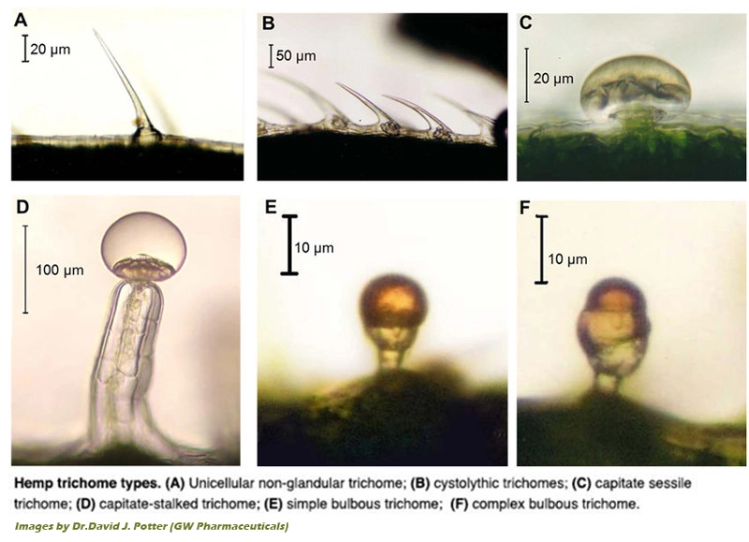
Potential Benefits of Cannabis Trichomes to the Plant
The exact benefit of cannabinoids and terpenes for the plant has yet to be discovered but several findings point to defense-related functions. This is consistent with a common role of trichomes in many plant species (Levin, 1973). Early studies have also hypothesized that THC protects against ultraviolet (UV) radiation, as cannabis plants produce significantly elevated levels of THC when exposed to higher levels of UVB radiation, possibly resulting in the development of geographical chemotypes (Pate, 1983). A recent study found that CBD could be a potential sunscreen additive as its application to human keratinocyte and melanocyte cells led to improved cell viability after exposure to UVB radiation, suggesting that cannabinoids protect cells against this type of potentially DNA-damaging radiation and supporting the geographical chemotype hypothesis (Gohad et al., 2020). These findings indicate that cannabinoids may be secreted and concentrated around flowers to protect the reproductive organs – and thereby the next generation – from the effects of sun damage. Genotypes that originate from closer to the equator will produce higher levels of cannabinoids due to the higher incidence of UVB radiation in that region.
Solar ultraviolet radiation (UVR) induces molecular and genetic changes in human skin cells, which result in cancer, photo-ageing and photosensitivity disorders. The use of sunscreens is advocated to prevent such photo-damage. However, most current formulations contain synthetic UVR filters that are non-biodegradable and can damage fragile marine creatures.
pCBs biosynthesis {updated}
Cannabinoid biosynthesis relies on two precursors from two distinct metabolic pathways: olivetolic acid (OA) from the polyketide pathway and geranyl-geranyl pyrophosphate (GPP) from the methylerythritol phosphate (MEP) pathway. Olivetolic acid is c-terminally prenylated with GPP into cannabigerolic acid (CBGA) by CBGA synthase - a trans-membrane aromatic prenyltransferase with a plastid localization signal (Fellermeier and Zenk 1998; Luo et al. 2019). CBGA is then secreted into the extracellular storage cavity and further processed by secreted cannabinoid oxidocyclases that perform different types of oxidative cyclization of its linear prenyl moiety into derived cannabinoid acids: tetrahydrocannabinolic acid (THCA), cannabidiolic acid (CBDA), and cannabichromenic acid (CBCA) (Taura et al. 1995; Morimoto et al. 1998; Sirikantaramas et al. 2005; Rodziewicz et al. 2019).
Cannabis plants accumulating a lot of CBGA are assumed to have nonfunctional cannabinoid oxidocyclases (De Meijer & Hammond 2005; Onofri et al. 2015).
The three currently known cannabinoid oxidocyclase enzymes: THCA synthase (THCAS), CBDA synthase (CBDAS), and CBC synthase (CBCAS) are highly similar in their biochemical properties and sequence characteristics (Taura et al. 2007; Laverty et al. 2019). The amino acid sequences are also highly similar, with THCAS and CBCAS being 92% identical to each other and respectively 84% and 83% identical to CBDAS (Sirikantaramas et al. 2004; Taura et al. 2007; Laverty et al. 2019).
THCAS, CBDAS, and CBCAS are members of the berberine bridge enzyme (BBE)-like gene family (PF08031) (Sirikantaramas et al. 2004; Taura et al. 2007). This family is named after an oxidocyclase from Eschscholzia californica involved in alkaloid biosynthesis and part of the larger oxygen-dependent FAD-linked oxidoreductase family (PF02913) (Winkler et al. 2008). Like other BBE-like synthases, THCAS, CBDAS, and CBCAS contain an N-terminal signal peptide, a flavin adenine dinucleotide (FAD)-binding domain, a substrate-binding domain, and a BBE-like specific C-terminus that is part of the FAD-binding module (Sirikantaramas et al. 2004; Taura et al. 2007). In accordance with this domain structure, THCAS and CBDAS have been found to be catalytically active in the extracellular storage cavity of the GT and rely on covalently bound FAD and O₂ for their activity (Sirikantaramas et al. 2005; Rodziewicz et al. 2019). CBCAS is less extensively studied, but considering its high sequence similarity with THCAS, probably shares these biochemical activities (Morimoto et al. 1997; Taura et al. 2007; Gülck and Møller 2020).
Although environmental factors play a role in determining the amount of cannabinoids present in different parts and stages of the plant (Rustichelli et al. 1998), in most populations the ratio between THCA and CBDA has been found to be under genetic control (Mandolino et al. 2003; Weiblen et al. 2015; Toth et al. 2020; Wenger et al. 2020).
Co-dominant inheritance of CBDA and THCA chemotypes is consistent with a Mendelian single-locus (de Meijer et al. 2003; Onofri et al. 2015; Weiblen et al. 2015). This led to the model in which THCAS and CBDAS are encoded by alternate alleles of the same gene (B_{T} and B_{D}, respectively) (de Meijer et al. 2003). However, later genome sequencing revealed that they are encoded by different genes (rather than alleles) within a large polymorphic genomic region with low levels of recombination (Laverty et al. 2019; Grassa et al. 2021). Thus, they are currently treated as separate genes.
The inheritance of chemical phenotype in Cannabis sativa L. (2003)
Etienne P M de Meijer, Manuela Bagatta, Andrea Carboni, Paola Crucitti, V M Cristiana Moliterni, Paolo Ranalli, and Giuseppe Mandolino.
Genetics. 2003 Jan; 163(1): 335–346.
Four crosses were made between inbred Cannabis sativa plants with pure cannabidiol (CBD) and pure Delta-9-tetrahydrocannabinol (THC) chemotypes. All the plants belonging to the F(1)'s were analyzed by gas chromatography for cannabinoid composition and constantly found to have a mixed CBD-THC chemotype. Ten individual F(1) plants were self-fertilized, and 10 inbred F(2) offspring were collected and analyzed. In all cases, a segregation of the three chemotypes (pure CBD, mixed CBD-THC, and pure THC) fitting a 1:2:1 proportion was observed. The CBD/THC ratio was found to be significantly progeny specific and transmitted from each F(1) to the F(2)'s derived from it. A model involving one locus, B, with two alleles, B(D) {CBD} and B(T) {THC}, is proposed, with the two alleles being co-dominant. The mixed chemotypes are interpreted as due to the genotype B(D)/B(T) at the B locus, while the pure-chemotype plants are due to homozygosity at the B locus (either B(D)/B(D) or B(T)/B(T)). It is suggested that such co-dominance is due to the codification by the two alleles for different isoforms of the same synthase, having different specificity for the conversion of the common precursor cannabigerol [CBGA] into CBDA or THCA, respectively.
Recently it was found that the "Alleles Model" was wrong. The different enzymes are encoded by different genes.
The genes encoding THCAS, CBDAS, and CBCAS have been identified (Sirikantaramas et al. 2004; Taura et al. 2007; Laverty et al. 2019).
The THCAS gene comprises a 1638 bp intronless open reading frame [ORF] that is found in all drug-type cultivars (Sirikantaramas et al. 2004; Vergara et al. 2019). For this reason, the gene has been used as a diagnostic marker for detecting psychoactive cultivars for crop breeding and forensics (Kojoma et al. 2006; Kitamura et al. 2016). It should be noted, however, that a nonpsychoactive cultivar from Malawi has a THCAS gene but accumulates the cannabinoid precursor CBGA instead of THCA (chemotype IV). This is probably due to a single amino acid mutation leading to a defective (B_{T0}) variant (Onofri et al. 2015). Recently, a different CBGA-dominant cultivar was found to have another single amino acid mutation in THCAS genes (Garfinkel et al. 2021). Gene copy number variation has been suggested based on amplicon sequencing of the THCAS locus (McKernan et al. 2015; Weiblen et al. 2015; Vergara et al. 2019). But amplicons may have included closely related genes such as CBCAS. Thus, it remains unclear if THCAS occurs in multiple copies and, consequently, if copy number variation could be a target for the breeding of cultivars.
The CBDAS gene comprises a 1635 bp intronless ORF that is found in all CBDA-producing cultivars (Taura et al. 2007). However, different missense mutations have been described from CBGA-dominant (i.e., chemotype IV) hybrid cultivars from Italy and Ukraine that are considered B_{D01} and B_{D02} variants, respectively (Onofri et al. 2015).
In THCA-dominant cultivars, fragments have been found that are 93% identical to functional CBDAS and share a four base pair deletion that results in a truncated and most probably nonfunctional protein (Weiblen et al. 2015; Cascini et al. 2019; Vergara et al. 2019). This deletion showed strict association with THCA-producing (chemotypes I and II) cultivars, suggesting tight genetic linkage of CBDAS with THCAS. Indeed, it could be used to discriminate between fiber and drug-type cultivars as well as accurately predict chemotype in feral (wild) and cultivated plants (Cascini et al. 2019; Wenger et al. 2020). Notably, up to three different variants of such putative pseudo-genes were detected in single cultivars (Vergara et al. 2019) suggesting multiple duplicated loci.
The CBCAS gene comprises a 1638 bp intronless ORF. It was recently identified and described based on genome sequencing of the cultivar “Finola” (Laverty et al. 2019). Based on sequence comparisons, “inactive THCA” synthase sequences described from European fiber-type cultivars more than a decade earlier were also considered CBCAS (Kojoma et al. 2006; Laverty et al. 2019).
The genetics of cannabinoid synthesis has been studied for several years and different genes encoding these enzymes are known, each made of a single exon, with THCAS and CBCAS sharing 92% identity at amino acid level and 84% and 83% identity compared to CBDAS, respectively. While THCAS and CBDAS have been widely studied at genetic and molecular level, little information is available on CBCAS genes.
Originally, Kojoma et al. obtained from hemp varieties gene sequences highly related to functional THCAS, putatively encoding for complete polypeptides, but differing for several single nucleotide polymorphisms (SNPs). They named these sequences fiber-type THCAS genes, under the assumption that they were not functional and unable to synthesize cannabinoids. Since then, a number of so-called fiber-type THCAS sequences have been found in both hemp and high THCA varieties.
In 2019, Laverty et al. demonstrated that a fiber-type THCAS gene coded for a 71 kDa CBCAS, is capable of transforming the CBGA precursor into CBCA and that the accumulation of CBCA correlated with the transcriptional level of CBCAS in various Cannabis tissues, with the highest level observed in female floral tissue.
More recently, a comprehensive clade-based classification of all cannabinoid oxidocyclases proposed the naming of all fiber-type THCAS as CBCAS since they belonged to the same clade of the only functionally CBCAS characterized. Based on these results, today they are collectively referred to as CBCAS.
Even though the CBCAS enzyme was biochemically characterized over 20 years ago, data on it are still scattered and somehow in disagreement. For example, one of the main inconsistencies with current evidence lies in previous analyses, where CBCA accumulation was demonstrated to be prominent during the juvenile stages of plant development, declining with maturity and irrespective of the chemotype at flowering.
A number of complete and partially annotated genomic sequences have been published in the latest years and information about the transcribed genes in different stages and tissues, as well as on putative regulators of secondary metabolites is already known.
Despite the behavior as co-dominant alleles at a single locus observed in segregation analyses, THCAS and CBDAS genes have been recently mapped to separate loci in tight linkage on the same chromosome. Moreover, in these loci there are multiple copies of THCAS- and CBDAS-related sequences. A few functional genes are expressed and therefore contribute to the final chemotype, while others are pseudogenes or partially functional sequences.
The biochemical reason why industrial Hemp produces THCA
Many hemp inflorescences accumulate traces of residual THCA at concentrations close and sometimes above the limit of 0.20% of dry weight set by E.U., despite the lack of a functional THCAS gene in their genomes and years of breeding aimed at eliminating the accumulation of this cannabinoid. Some hypotheses have been proposed: the first one is that the CBDAS could produce with very low efficiency THCA from CBGA, due to its high similarity with THCAS; Alternatively, sequences corresponding to putative CBCAS could be responsible for this residual production of THCA, small but apparently difficult to eliminate, since the substitutions at the protein level with functional THCAS are minimal and do not involve protein active sites or residues required for THCA synthesis. Gaining a deeper knowledge of CBCAS sequences and of their transcription levels could help to better define the process behind the synthesis of THCA in hemp genotypes as an unexpected by-product and consequently guide future breeding & biochemical strategies.
CBDAS: CBGA CBDA >> THCA
CBCAS: CBGA CBCA >> THCA
The V.V. research group will focus on biochemical inactivation of both: THCAS, CBDAS & CBCAS enzymes in industrial Hemp. We'll also focus on ways to block the expression (or transcription) of the THCAS, CBDAS & CBCAS genes.
The high CBD cultivar = CBDRX serves as an important genetic tool to study pCBs biosynthesis
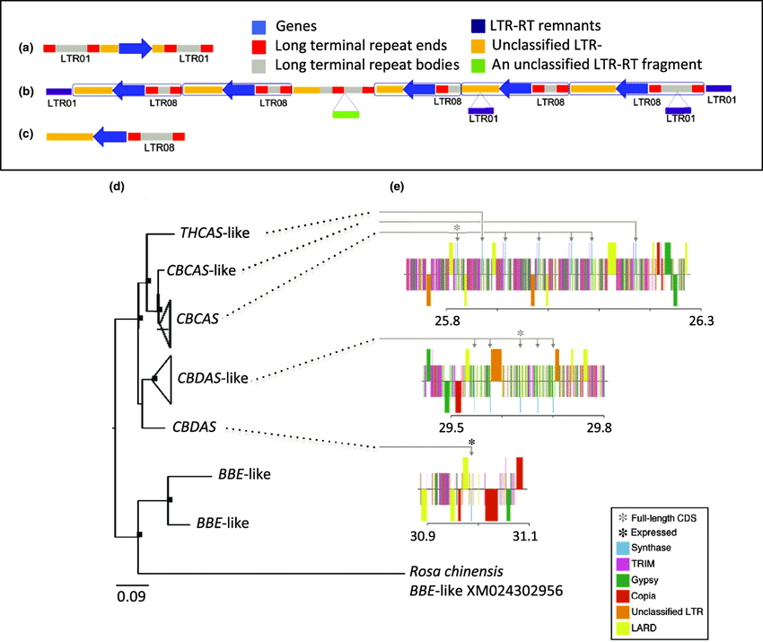
High-cannabidiol (CBD) cultivar (CBDRx) Cannabis sativa cannabinoid synthase genes located among long terminal repeat [LTR] retro-transposons (LTRRTs). Shown are LTR-RT ends, LTR-RT bodies, unclassified LTR-RTs, LTR-RT remnants and an unclassified LTR-RT fragment. Synthase copies and LTR-RTs occurred in tandemly repeated cassettes at 26 and 29 Mb. (a) Each of seven cassettes in the 26 Mb array consisted of a synthase paralog flanked by a pair of LTR01s. (b) The array at 29 Mb was flanked by a pair of LTR01s and included five cassettes, each consisting of a synthase sequence with a downstream LRT08. (c) The solitary synthase sequence at 31 Mb was similarly associated with a downstream LTR08. (d) CBDRx cannabinoid synthase gene tree rooted with closely related berberine bridge enzyme (BBE-like) sequences from CBDRx and rose (Rosa). Sequences > 97% similar are collapsed at the tips of the tree. Nodes bearing black squares indicate Bayesian posterior probabilities > 0.90. The classification of paralogs is based on a broader phylogenetic analysis of published cannabinoid synthase sequences (Weiblen et al., 2015). Tandem synthase copies located at 26 Mb comprised a clade including a partial THCAS-like sequence, a partial CBCAS-like sequence and five sequences matching CBCAS (Laverty et al., 2019). Four of the five CBCAS sequences in this array were truncated but otherwise identical to the complete gene. Synthase copies at 29 Mb were more closely similar to CBDAS than to THCAS or CBCAS. (e) Functionally annotated maps of the cannabinoid synthase arrays in CBDRx. Synthase arrays are depicted in blue, terminal repeat retro-transposons in miniature (TRIM) in pink, gypsy-like transposable elements in green, copia-like transposons in dark orange, unclassified LTRs in light orange, and large retro-transposon derivative elements (LARD) in yellow. Color bands are arbitrarily offset above and below the center line to facilitate visual location of synthase arrays within regions of highly repetitive DNA. Four of the five CBCAS sequences at 26 Mb were incomplete and no expression of the single full-length CBCAS sequence was detected. At 29 Mb, only one of the CBDAS-like copies was full-length and no expression was detected. Only the solitary CBDAS sequence at 31 Mb was highly expressed in CBDRx.
Hypothesis: The first Cannabis sativa oxidocyclase to evolve was CBDAS, the second was THCAS and the third was CBCAS.
CBDAS THCAS CBCAS
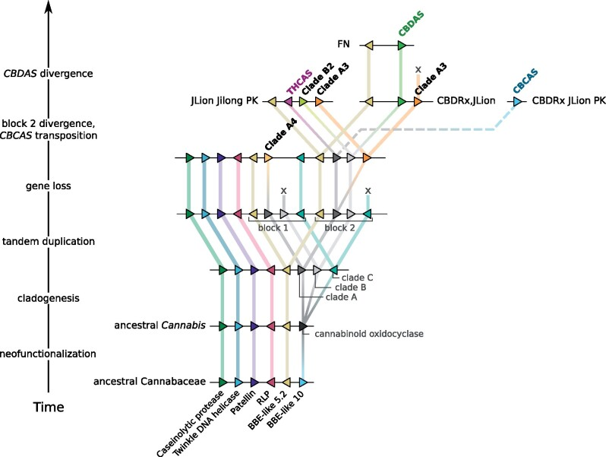
THCAS
CBDAS
CBCAS
Evolutionary model of cannabinoid oxidocyclase gene duplication and diversification. Most parsimious hypothesis based on micro-synteny patterns and phylogenetic reconstruction. Triangles indicate genes colored according to their homology and putative orthologs are connected with colored lines. Dashed line indicates transposition of CBCAS to another syntenic block. Cannabinoid oxidocyclase genes are labeled in boldface.
BBE, berberine bridge enzyme; RLP, receptor-like protein.
CBDAS THCAS CBCAS
In classical genetics, syntenic genes were originally defined as genes that lie on the same chromosome. Today, however, biologists usually refer to synteny as the conservation of blocks of order within two sets of chromosomes that are being compared with each other.

Transposon
A transposable element (TE, transposon, or "jumping gene") is a DNA sequence that can change its position within a genome, sometimes creating or reversing mutations and altering the cell's genetic identity and genome size. Transposition often results in duplication of the same genetic material.
Transposable elements [TEs] make up a large fraction of the genome and are responsible for much of the mass of DNA in a eukaryotic cell. Although TEs are selfish genetic elements, many are important in genome function and evolution. Transposons are also very useful to researchers as a means to alter DNA inside a living organism.
There are at least two classes of TEs: Class I TEs or retro-transposons generally function via reverse transcription, while Class II TEs or DNA transposons encode the protein transposase, which they require for insertion and excision, and some of these TEs also encode other proteins.
Retro-transposons (also called Class I transposable elements or transposons via RNA intermediates) are a type of genetic component that copy and paste themselves into different genomic locations (transposon) by converting RNA back into DNA through the process of reverse transcription using an RNA transposition intermediate.
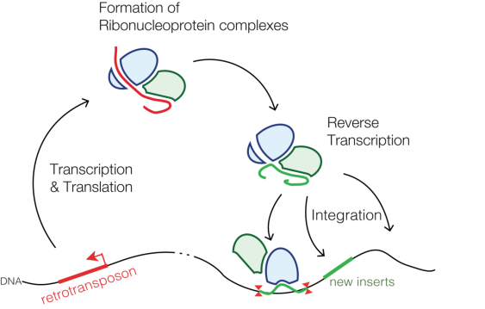
Through reverse transcription, retro-transposons amplify themselves quickly to become abundant in eukaryotic genomes such as maize (49–78%) and humans (42%). They are only present in eukaryotes but share features with retroviruses such as HIV, for example, discontinuous reverse transcriptase-mediated extra-chromosomal recombination.
These retro-transposons are regulated by a family of short non-coding RNAs termed as PIWI [P-element induced wimpy testis]-interacting RNAs (piRNAs). piRNA is a recently discovered class of ncRNAs, which are in the length range of ~24-32 nucleotides. Initially, piRNAs were described as repeat-associated siRNAs (rasiRNAs) because of their origin from the repetitive elements such as transposable sequences of the genome. However, later it was identified that they acted via PIWI-protein. In addition to having a role in the suppression of genomic transposons, various roles of piRNAs have been recently reported like regulation of 3’ UTR of protein-coding genes via RNAi, trans-generational epigenetic inheritance to convey a memory of past transposon activity, and RNA-induced epigenetic silencing.
RNAI is a non-coding RNA that is an antisense repressor of the replication of some E. coli plasmids, including ColE1. Plasmid replication is usually initiated by RNAII, which acts as a primer by binding to its template DNA. The complementary RNAI binds RNAII, prohibiting it from its initiation role. The rate of degradation of RNAI is therefore a major factor in the control of plasmid replication. This rate of degradation is aided by the pcnB (plasmid copy number B) gene product, which poly-adenylates the 3' end of RNAI targeting it for degradation by PNPase.
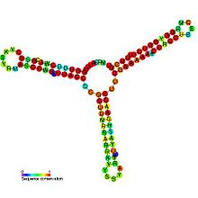
RNAi Structure
There are two main types of retro-transposons, long terminal repeats (LTRs) and non-long terminal repeats (non-LTRs). Retro-transposons are classified based on sequence and method of transposition.
Due to their replicative nature, retro-transposons can increase eukaryotic genome size quickly and survive in eukaryotic genomes permanently. It is thought that staying in eukaryotic genomes for such long periods gave rise to special insertion methods that do not affect eukaryotic gene function drastically.
Purification and Characterization of Cannabidiolic-acid Synthase from Cannabis sativa L.: BIOCHEMICAL ANALYSIS OF A NOVEL ENZYME THAT CATALYZES THE OXIDOCYCLIZATION OF CANNABIGEROLIC ACID TO CANNABIDIOLIC ACID (1996)
Futoshi Taura, Satoshi Morimoto & Yukihiro Shoyama.
JBC 271: 29 pp 17411-6, July 19 1996
THC
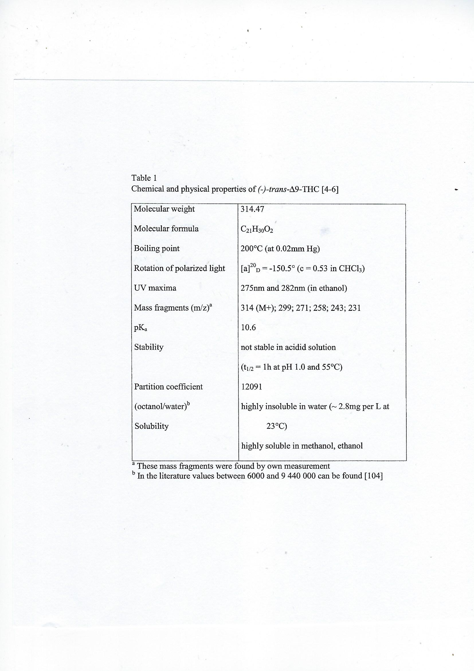
Characterization of CBDAS, THCAS & CBCAS
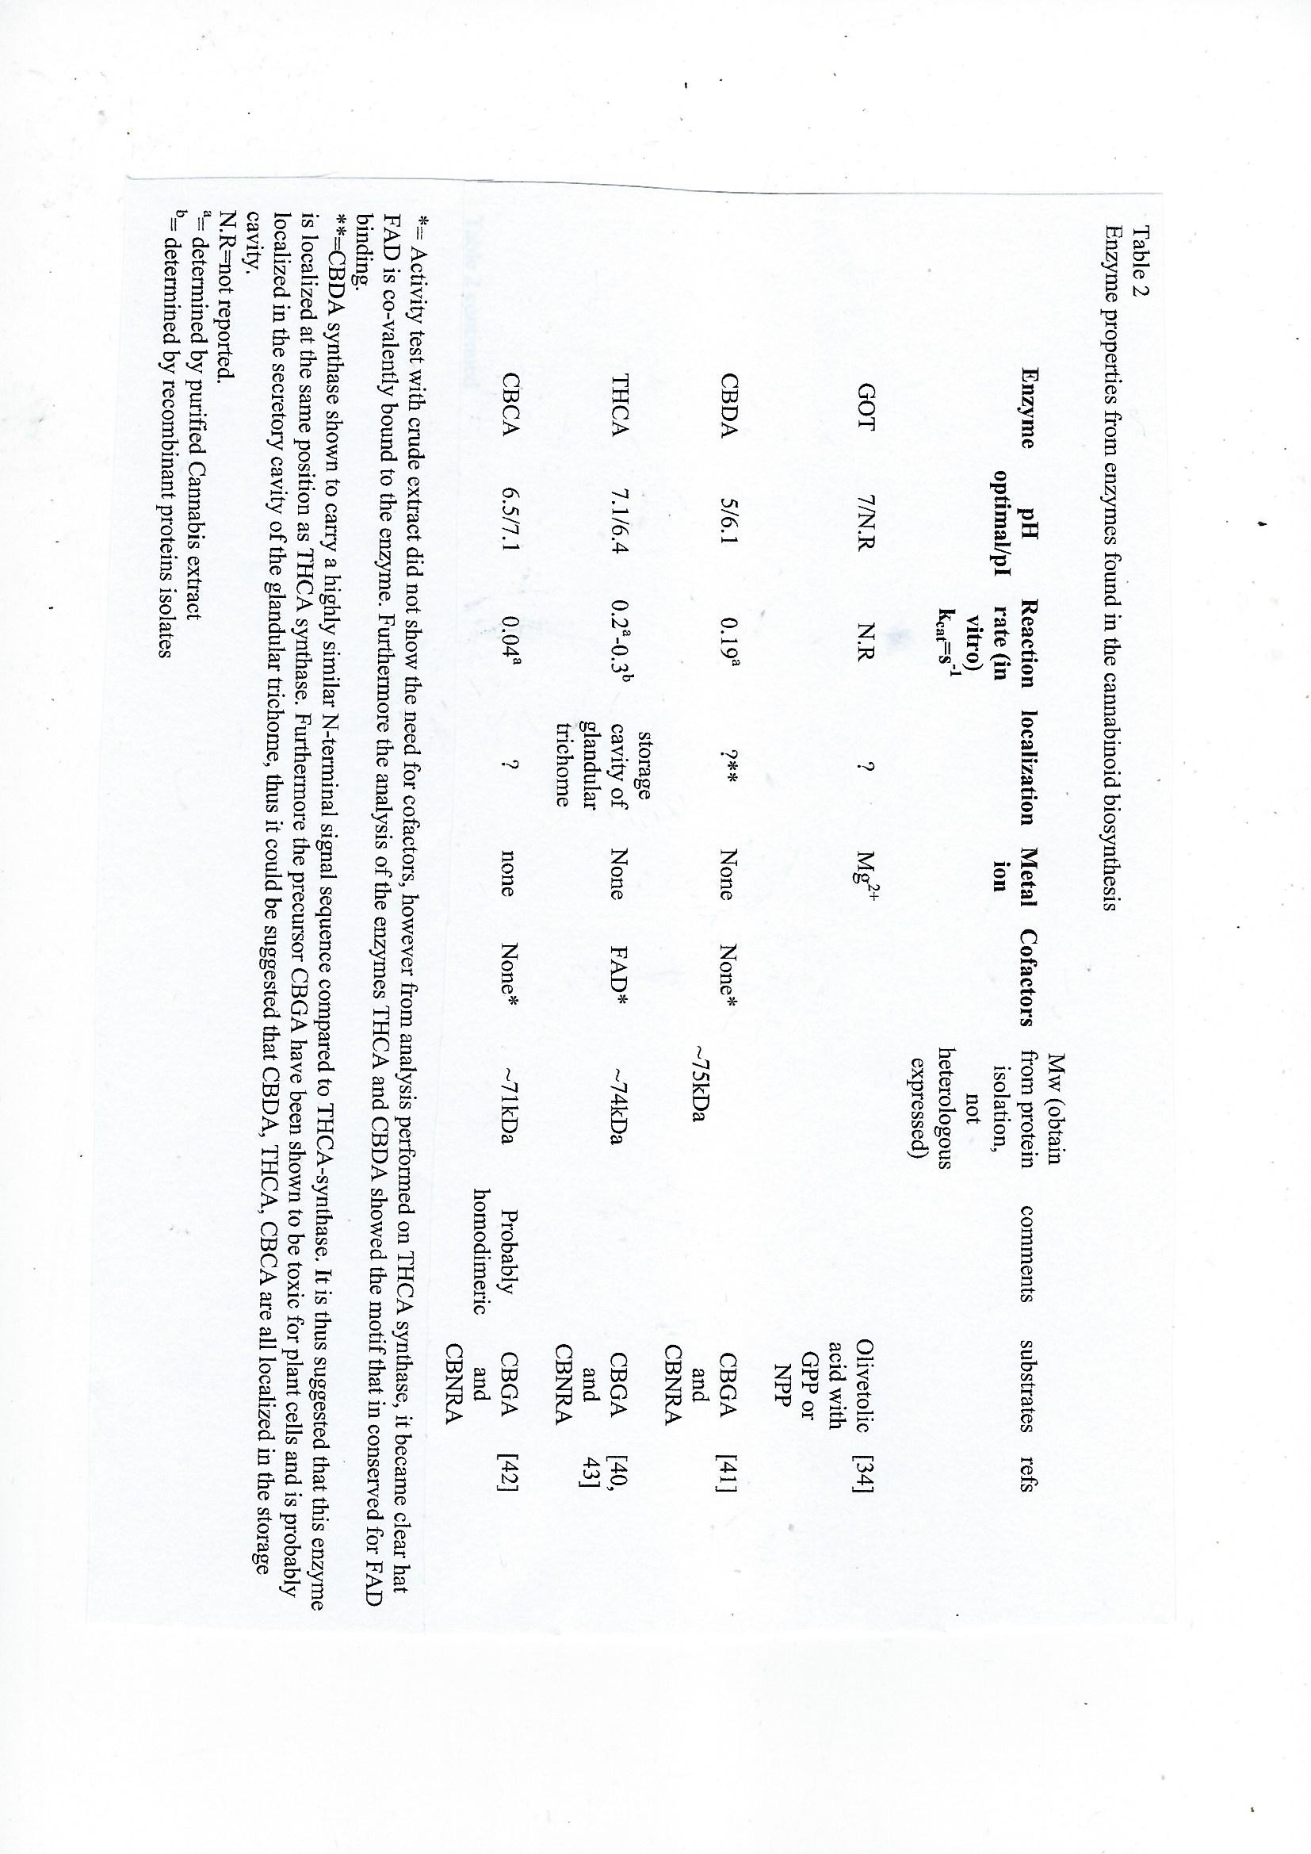
The optimal pH / pI
CBDAS = 5/6.1, THCAS = 7.1/6.4, CBCAS = 6.5/7.1
Only CBDAS is active at low pH.
CBDAS have the higher Molecular weight = 75 kDa > 74 of THCAS > 71 of CBCAS. The bigger enzyme is getting smaller & smaller by evolution.
CBDAS THCAS CBCAS
Substrate Specificity of CBDAS
CBDA synthase exhibited Michaelis-Menten kinetics in response to changes in CBGA concentration. The enzyme displayed a maximal specific activity of 2.57 nanokatals/mg for this substrate, corresponding to a kcat of 0.19 s−1. This turnover number seemed to be relatively low, but it was almost identical to that for Δ1-THCA formation by THCAS (kcat = 0.20 s−1). Cannabinerol [CBNRA], the Z-isomer of CBGA, was also converted by CBDA synthase to CBDA, although the enzyme showed lower Kcat and higher Km values for CBNRA as compared with CBGA. In contrast to the acidic cannabinoids, the neutral cannabinoids, CBG and cannabinerol [CBNR], did not undergo oxidocyclization by CBDAS, indicating that a carboxyl group in the substrate is essential for the enzymatic cyclization of the monoterpene moiety.
The oxidocyclases cannot act on neutal pCBs [CBG or CBNR] lacking the COOH side group that is essential.
Cannabinerol = CBNRA
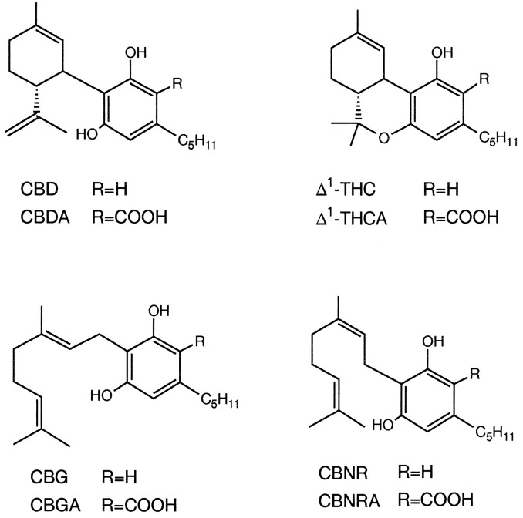
Structures of cannabinoids. CBD, cannabidiol; Δ1-THC, Δ1-tetrahydrocannabinol; CBNR, cannabinerol.
Concerning the substrate specificity, CBDA synthase catalyzes the formation of CBDA from CBNRA as well as CBGA. Since the C-1-C-2 double bond of CBGA has the same configuration as that of CBNRA, CBDA formation could proceed from CBGA through CBNRA to CBDA. However, CBDA synthase displayed much higher activity for CBGA than CBNRA, indicating that CBNRA is not an intermediate in the oxidocyclization of CBGA into CBDA. In addition, the lower substrate specificity for CBNRA suggests that CBDA is biosynthesized predominantly from CBGA rather than CBNRA. This is supported by the fact that the content of CBNRA in the CBDA strain is much lower than that of CBGA (0.08 versus 2.8 mg/g of rapidly expanding leaves).
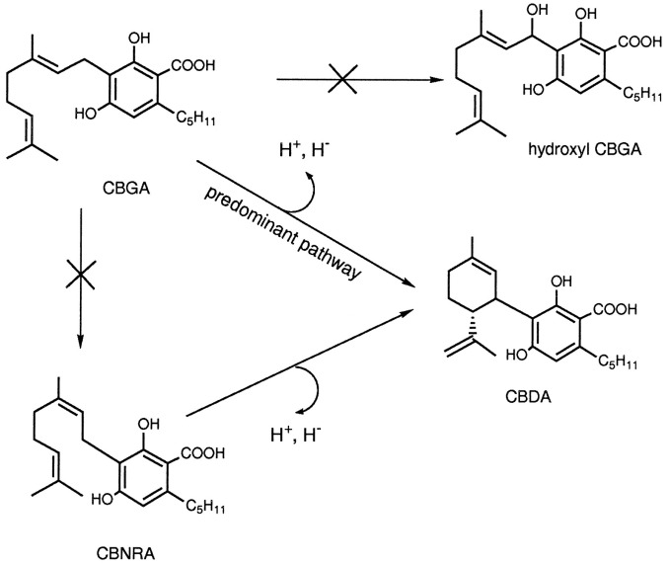
Many biochemical properties of CBDA synthase are closely related to those of Δ1-THCA synthase. As reported, THCA S catalyzes the oxidocyclization of CBGA with a higher turnover number (0.20 s−1) for CBGA than for CBNRA. In addition, the molecular mass, pI, and NH2-terminal sequence of both enzymes are quite similar. Although CBDA has a different ring system from Δ1-THCA, these similarities suggest that both cannabinoids are formed by a similar reaction mechanism.
Inhibition of THCAS & CBDAS by Mercury [Hg+2] Atoms

Inhibition of THCAS by FMN [competition with FAD cofactor]

Inhibition of THCAS & CBDAS by Hydrogen Peroxide.
A physical and genetic map of Cannabis sativa identifies extensive rearrangement at the THC/CBD acid synthase locus (2019)
Genome Res. 29(1):146-156.
Kaitilin U. Laverty et al.
Cannabis sativa is widely cultivated for medicinal, food, industrial, and recreational use, but much remains unknown regarding its genetics, including the molecular determinants of cannabinoid content. Here, we describe a combined physical and genetic map derived from a cross between the drug-type strain ‘Purple Kush [PK]’ and the hemp variety ‘Finola’. The map reveals that cannabinoid biosynthesis genes are generally unlinked, but that aromatic prenyltransferase (AP), which produces the substrate [CBGA] for THCA synthase and CBDA synthases, is tightly linked to a known marker for total cannabinoid content. We further identify the gene encoding CBCA synthase (CBCAS) and characterize its catalytic activity, providing insight into how cannabinoid diversity arises in cannabis. Strikingly, THCAS and CBDAS (which determine the drug vs. hemp chemotype) are contained within large (>250 kb) retro-transposon-rich regions that are highly non-homologous between drug- and hemp-type alleles, and are furthermore embedded within ~40 Mb of non-recombining repetitive DNA. The chromosome structures are similar to those in grains such as wheat, with recombination focused in gene-rich, repeat-depleted regions near chromosome ends.
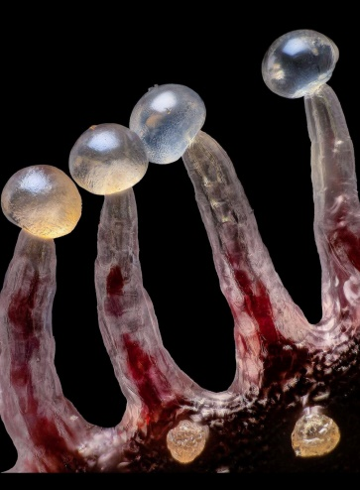
pH Optimum of THCAS, CBCAS & CBDAS
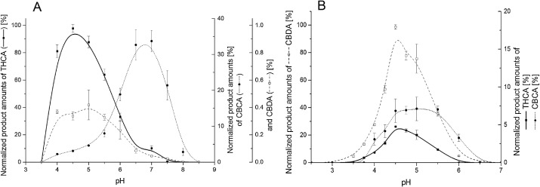
The peak product amounts of THCAS – at pH 4.5
The peak product amounts of CBDAS – at pH 5.0
The peak product amounts of CBCAS – at pH 7.0
CBDAS produces about three times more products compared to CBCAS & THCAS. CBDAS >> CBCA > THCAS
There must be an evolutionary advantage in increasing the pH optimum of pCBs synthesizing enzymes from 4.5 or 5.0 to 7.0.
CBDAS THCAS CBCAS
As the TG matures, more H₂O₂ is produced and the pH inside the secretory space drops from 7.0 to about 5.0. Alternatively, the initial optimal pH of CBDAS was 5 - from one end it was reduced to 4 in THCAS and from the other hand it was increased to 7 in CBCAS.
The temperature optimum of THCAS, CBCAS & CBDAS
is 52 degrees Celsius.

The Current Legal Status of Hemp in the USA
One of the goals of the 2014 Farm Bill was to generate and protect research into hemp. The 2018 Farm Bill continues this effort. Section 7605 re-extends the protections for hemp research and the conditions under which such research can and should be conducted. Further, section 7501 of the 2018 Farm Bill extends hemp research by including hemp under the Critical Agricultural Materials Act [CAMA]. This provision recognizes the importance, diversity, and opportunity of the plant and the products that can be derived from it, but also recognizes an important point: there is a still a lot to learn about hemp and its products from commercial and market perspectives.
Under the 2018 Farm Bill hemp is treated like other agricultural commodities in many ways. This is an important point. While there are provisions that heavily regulate hemp, and concerns exist among law enforcement—rightly or wrongly—that cannabis plants used to derive marijuana will be comingled with hemp plants, this legislation makes hemp a mainstream crop. Several provisions of the Farm Bill include changes to existing provisions of agricultural law to include hemp. One of the most important provisions from the perspective of hemp farmers lies in section 11101. This section includes hemp farmers’ protections under the Federal Crop Insurance Act [FCIA]. This will assist farmers who, in the normal course of agricultural production, face crop termination (crop losses). As the climate changes and as farmers get used to growing this “new” product, these protections will be important.
The allowed pilot program to study hemp (often labeled “industrial hemp”) was approved about 8 years ago by both the U.S. Department of Agriculture (USDA) and state departments of agriculture. This allowed small-scale expansion of hemp cultivation for limited purposes. The 2018 Farm Bill is more expansive. It allows hemp cultivation broadly, not simply pilot programs for studying market interest in hemp-derived products. It explicitly allows the transfer of hemp-derived products across state lines for commercial or other purposes. It also puts no restrictions on the sale, transport, or possession of hemp-derived products, so long as those items are produced in a manner consistent with the law. However, the new Farm Bill does not create a completely free system in which individuals or businesses can grow hemp whenever and wherever they want. There are numerous restrictions.
A lot of industrial Hemp is destroyed recently in the USA
When hemp crop is tested “hot,” meaning it contained more than the legal amount of THC, the chemical in cannabis that gets people high. Per rules from the USDA, if the cannabis plant has 0.3% THC or less, it’s considered hemp and legal. Any higher, it’s illegal.
Staying under this threshold means walking a fine line for Hemp farmers, who are learning to grow a new crop and navigating a new industry. Almost 20% of Indiana State’s hemp crop was destroyed at 2020 for THC levels between 0.41% and 13%, according to Don Robison, seed administrator with the Office of Indiana State Chemist. Although it’s hard to say for sure, his highest estimates guess these amounts to about 150 acres total. In many cases, farmers let their crops approach higher THC concentrations because the quantity of the valuable CBD is directly tied to the quantity of THC in Hemp plants. For a farmer to ensure lower THC levels, they may also be sacrificing potential profit.
The only way to stay below 0.3% THC is to harvest it way before it’s mature. Hemp farmer say: "It would be like picking your apples when they’re green as grass, there’s no benefit to harvesting early”.
Hemp was initially thought to be a lucrative opportunity for farmers. But the few, that shell out tens of thousands of dollars on costly hemp seeds [about 1 $ each], also risk losing their crop at the end of the season.
The problem is not specific to Indiana. Many states use the 0.3% threshold, which is a federal limit, so hemp farmers across the U.S. (and Europe) are affected.
In hopes of helping Hemp growers better understand their crops, researchers at Purdue University contribute to the Midwest Hemp Cannabis Database, a resource with information on THC and CBD levels of different cannabis strains.
Marguerite Bolt, Purdue hemp extension specialist, said farmers send samples in from their crops for testing and the results are added to the larger database. It’s a way for hemp farmers to research the potential yield, compliance and profitability of the strains they’re considering growing, she said. However, cannabinoid chemical assay is expensive (about 75$ each) and the results are received by the farmer about 10 days latter – and sometimes it is too late and the whole field is tested "hot" and have to be destroyed.
One way to solve this acute, economic problem is to increase the production of CBDA and decrease the production of THCA in industrial hemp plants.
Common biosynthesis routes in GTs
of both Cannabis & Humulus
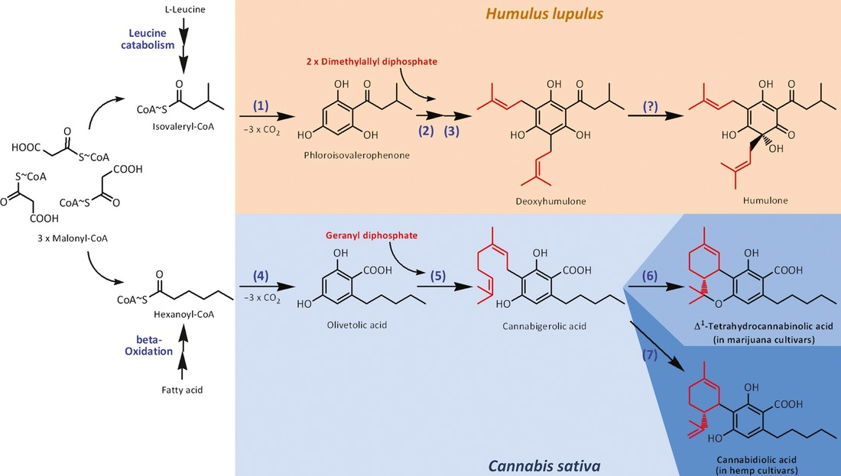
Humulone is produced in both plants.
The V.V. research group will study the medical components shared by both Humulus & Cannabis plants.
Enhanced tolerance of industrial hemp (Cannabis sativa L.) plants on abandoned mine land soil leads to overexpression of cannabinoids (2019)
Rabab Husain et al.
PLoS ONE 14(8), Published: August 29, 2019
Abstract
Industrial activities have a detrimental impact on the environment and health when high concentrations of pollutants are released. Phytoremediation is a natural method of utilizing plants to remove contaminants from the soil. The goal of this study was to investigate the ability of Cannabis sativa L. to sustainably grow and remediate abandoned coal mine land soils in Pennsylvania. In this study, six different varieties of industrial hemp (Fedora 17, Felina 32, Ferimon, Futura 75, Santhica 27, and USO 31) were grown on two different contaminated soil types and two commercial soils (Miracle-Gro Potting Mix and PRO-MIX HP Mycorrhizae High Porosity Grower Mix). Plants growing in all soil types were exposed to two environmental conditions (outside and in the greenhouse). Seed germination response and plant height indicated no significant differences among all hemp varieties grown in different soils, however on an average, the height of the plants grown in the greenhouse exceeded that of the plants grown outdoors. In addition, heavy metal analysis of Arsenic, Lead, Nickel, Mercury, and Cadmium was performed. The concentration of Nickel was 2.54 times greater in the leaves of hemp grown in mine land soil outdoors when compared to greenhouse conditions. No differences were found between the expressions of heavy metal transporter genes. Secondary metabolite analysis of floral buds from hemp grown in mine land soil displayed a significant increase in the total Cannabidiol [CBD] content (2.16%, 2.58%) when compared to Miracle-Gro control soil (1.08%, 1.6%) for outdoors and in the greenhouse, respectively. Molecular analysis using qRT-PCR indicated an 18-fold increase! in the expression of the cannabidiolic acid synthase [CBDAS] gene in plants grown on mine land soil. The data indicates a high tolerance to heavy metals as indicated from the physiological and metabolites analysis.
Introduction
Depletion of the ozone layer and global warming are two of the biggest issues at hand due to the release of toxic pollutants into the environment. Inorganic pollutants include heavy metals such as Fe, Mn, Zn, Cu, Mg, Mo, and Ni, which are necessary for plant growth but are detrimental to the environment at high concentrations in the soil. Leaching of these heavy metals into surrounding areas through rainwater runoff poses a dangerous environmental and health risk. Metals with an unknown biological purpose such as Cd, Cr, Pb, Co, Ag, Se, and Hg can also become accumulated and in high amounts become toxic. Phytoremediation is a natural, cost-effective process in which plants are used to remove unsafe compounds from the soil. Many plants have been studied and deemed effective at removing toxins from the soil. However, only a small number of those plants have numerous beneficial applications outside of phytoremediation. Methods of extraction and disposal of these plants have not been well defined.
Industrial hemp has been reported to be a hyperaccumulator. A previous study confirmed metal accumulation in both hemp roots and above ground tissues without noticeable changes in plant growth and morphology. However, the mechanism of accumulation remained unexplained. Significantly, hemp’s short growing cycle, decreased need for pesticides, and low plant maintenance makes it an ideal candidate for phytoremediation studies.
The purpose of this study was to explore the potential of industrial hemp as an eco-friendly way to remediate abandoned mine land soils in Pennsylvania. To do that, physiological parameters such as seed germination, plant height, and days-to-flowering were examined. In addition, uptake of heavy metals such as Arsenic, Lead, Nickel, Mercury, and Cadmium, changes in soil pH, and total cannabinoid content were examined in six different varieties of industrial hemp (Fedora 17, Felina 32, Ferimon, Futura 75, Santhica 27, and USO 31) grown on two contaminated soil types and two commercial soil types both outdoors and in the greenhouse. Additionally, this study presents a detailed review on the possible mechanisms of metal uptake.
The presence of heavy metals in the soil influences the mechanism of uptake of secondary metabolites in plants, because of oxidative stress, and eventually may be causing lipid peroxidation to stimulate the production of bio-active compounds. Industrial hemp’s secondary metabolites, such as cannabinoids and terpenoids, are found in the glandular trichomes [GTs] of the cannabis plant.
Total CBD and total THC was analyzed from the floral buds of the Fedora 17 variety grown on the field, mine land 1, and Miracle-Gro soils.
Total THC content in the floral buds collected from plants grown in Miracle-Gro soil outdoors or in the greenhouse was higher than the floral buds collected from plants grown in mine land soil outdoors or in the greenhouse and field conditions.
Heavy metals also reduce THC production in industrial hemp
Total THC levels in mine land 1 soil with the Fedora 17 variety remain under the European Economic Community (EEC) legal threshold limit of 0.3%, whereas the Fedora 17 variety in Miracle-Grow indoors is over the legal limit for industrial hemp.
Total CBD content in the floral buds grown in mine land 1 soil in both outdoors and in the greenhouse was higher than the floral buds grown in Miracle-Gro in both environmental parameters and in the field, which can be concluded due to the heavy metal stress.
To estimate the alteration of gene expression of hemp in outdoor mine land conditions, a qRT-PCR was performed on the Ferimon variety. Cannabinoid pathway starts with the synthesis of olivetolic acid by tetraketide synthase and olivetolic acid cyclase. Afterwards, olivetolic acid is converted into Cannabigerolic acid (CBGA) by CBGA synthase. Finally, THCA, CBCA and CBDA are synthesized from CBGA by THCA synthase (THCAS), CBCAS and CBDAS, respectively. In this study, we measured gene expression of five cannabinoid pathway genes.
Notably, Cannabidiolic acid synthase (CBDAS) was expressed 18! Times higher in the mine land soil, however there was no significant difference between mine land 1 and Miracle-Gro soil in the tetrahydrocannabinolic acid synthase (THCAS) expression.
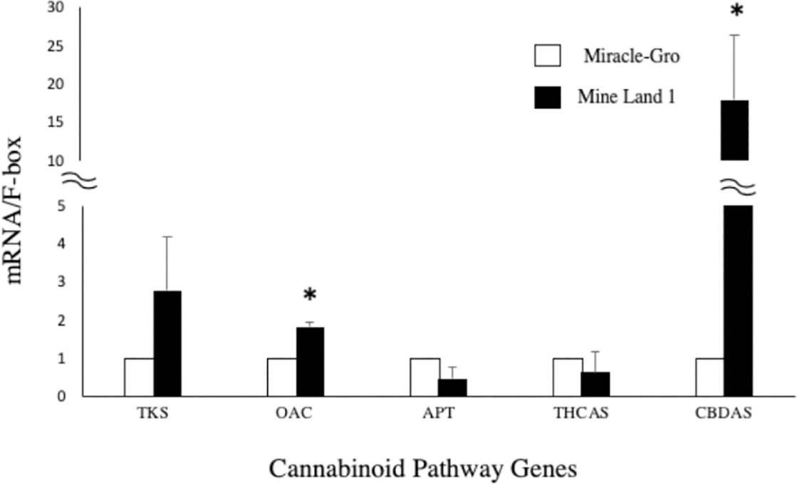
The gene expression of Cannabinoid pathway genes in mine land and Miracle-Gro soil. Hemp plants grown under Miracle-gro soil were used for normalization. Bars ±standard error of the mean. Asterisk means significant difference in statistical analysis (P<0.05, n = 3).
Interestingly, among the other three upstream genes, olivetolic acid cyclase [OAC] gene expression was also enhanced in mine land 1.
THCAS gene expression is low in hemp plants and is not affected by heavy metals in the soil.
In summary, hemp increased total CBD content under high heavy metal conditions and was a result of enhancement of CBDAS and OAC gene expression. This is the first study to demonstrate that gene expression of CBDAS can be remarkably influenced by mine land soil conditions [high concentration of heavy metals such as Fe] which agrees with an increase in secondary metabolite production in Camellia sinensis.
A recent study showed that hemp could improve phenolic production when used for phytoremediation of heavy metals. These results provide promising insight into the metabolic networking mechanism and the signaling cross-talk that could occur during the biosynthesis of CBD and THC molecules, just two of the 125 known phytocannabinoids [pCBs] of industrial hemp.
Hypothesis: Adding Fe (or Mg / Mn), by foliar spray, after the end of the vegetative stage, will increase the expression of CBDAS, increasing CBDA content while reducing THCA content in industrial hemp.
Biosynthesis & Metabolism of pCBs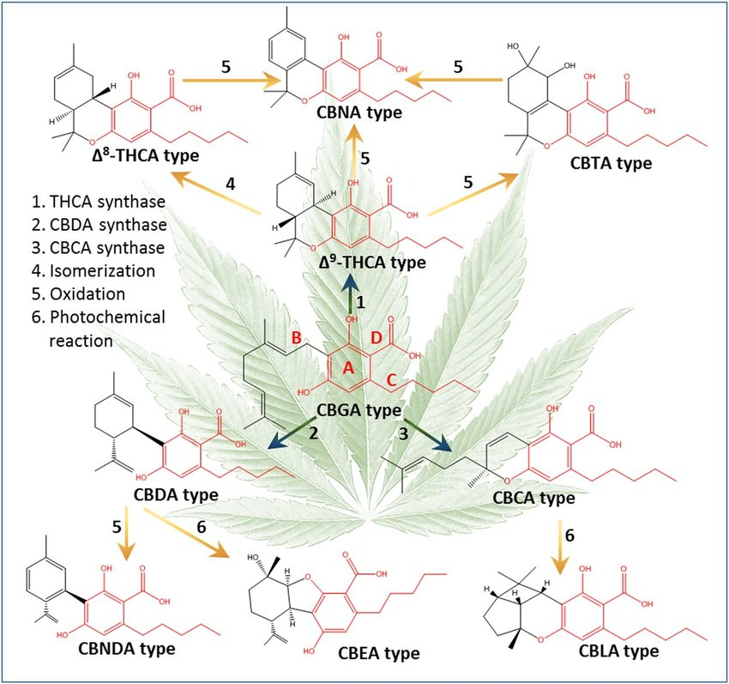
#6. CBDA CBEA and CBCA CBLA
# 5. THCA CBNA or CBTA.
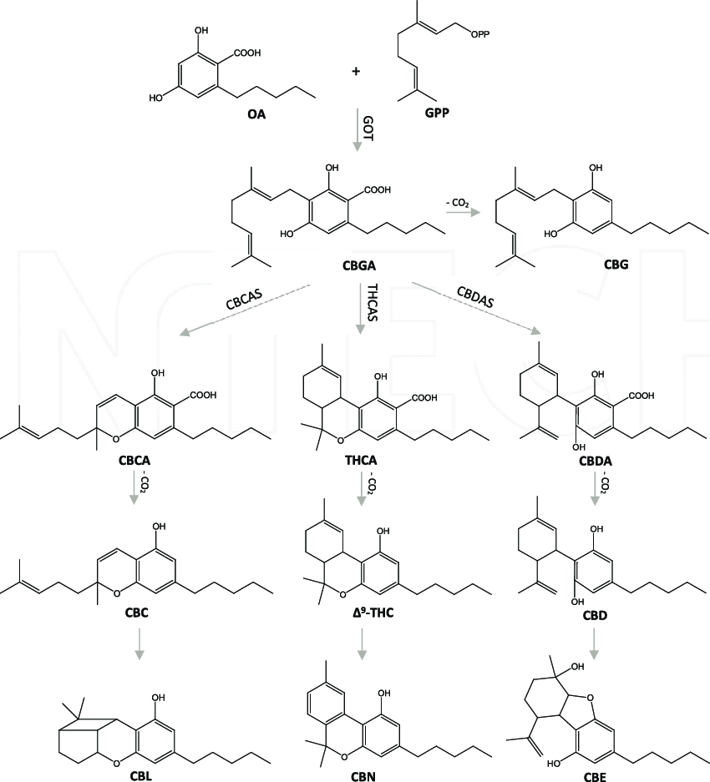
CBE molecule does not contain the Phenol moiety. Does it absorb UV light?
At V.V. research center we'll focus on CBE, CBEA, CBL & CBLA because of their high stability.
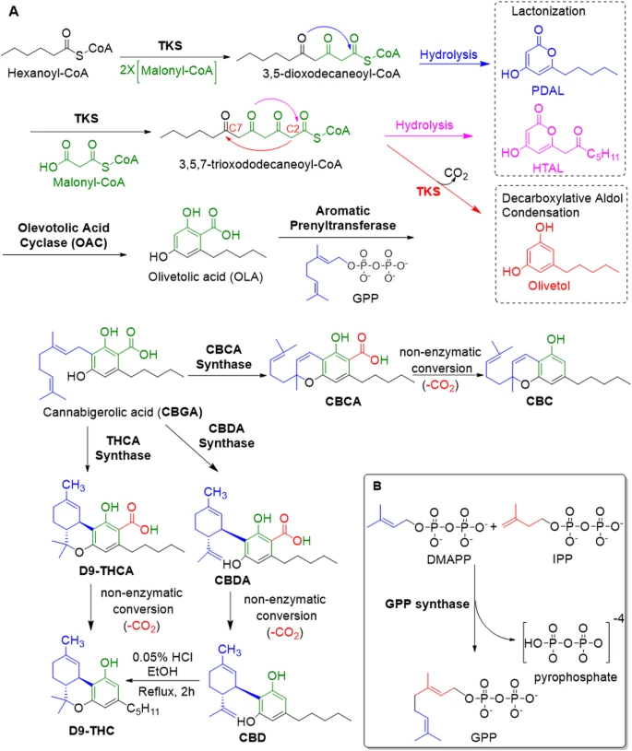
Biosynthesis of cannabinoids
- Cannabinoid biosynthetic pathway for Δ9-tetrahydrocannabinol (Δ9-THC), cannabidiol (CBD), and cannabichromene (CBC) including by-product formation (pentyl diacetic lactone (PDAL), hexanoyl triacetic acid lactone (HTAL), and olivetol shown in the dotted box) and highlighting the chemical conversion of CBD into THC, long thought to be the source of THC (Mechoulam R ), but this conversion does not! occur in vivo.
- Synthesis of geranyl pyrophosphate (GPP) from dimethylallyl pyrophosphate (DMAPP) and isopentenyl pyrophosphate (IPP) catalyzed by geranyl pyrophosphate synthase [GPPS].
Mode of action of THCAS
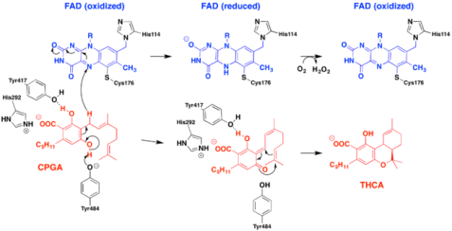
CBGA
Oxidized FAD Reduced FAD Oxidized FAD (His114, Cys176)
(Tyr417, His292) CBGA FAD (OX)
Production of THCA by hydride transfer between amino acid OH (negatively charged) or N (positively charged) side groups, through CBGA precursor, to FAD cofactor in the process of oxido-cyclisizing the terpene moiety of the precursor molecule.
Tyr484 (481) interacts with the monoterpene moiety of CBGA.
Hypothesis: There have to be an important evolutionary advantage in producing the 3 different molecules – CBDA, THCA & CBCA from the same precursor.
Hydride transfer by NAD
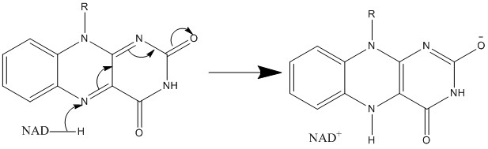
Flavin = Isoalloxazine Ring System
Flavin (from Latin flavus, "yellow") is the common name for a group of organic compounds based on pteridine, formed by the tricyclic heterocycle isoalloxazine. The biochemical source is the vitamin riboflavin [B2]. The flavin moiety is often attached with an adenosine diphosphate to form flavin adenine dinucleotide (FAD), and, in other circumstances, is found as flavin mononucleotide (FMN), a phosphorylated form of riboflavin. It is in one or the other of these forms that flavin is present as a prosthetic group in flavoproteins.
The flavin group is capable of undergoing oxidation-reduction reactions, and can accept either one electron in a two-step process or two electrons at once. Reduction is made with the addition of hydrogen atoms to specific nitrogen atoms on the isoalloxazine ring system.
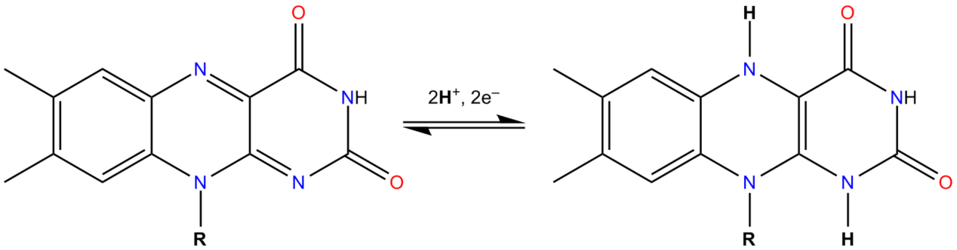
Both free and protein-bound flavins are photoreducible, that is, able to be reduced by light, in a mechanism mediated by several organic compounds, such as some amino acids, carboxylic acids and amines. This property of flavins is exploited by various light-sensitive proteins. For example, the LOV domain, found in many species of plant, fungi and bacteria, undergoes a reversible, light-dependent structural change which involves the formation of a bond between a cysteine residue in its peptide sequence and a bound FMN.
Hypothesis: Absorption of UV-B by FAD reduces the isoalloxazine ring system, enhancing the enzymatic oxydo-cyclase activity inside Cannabis sativa GTs.
THCAS, CBDAS & CBCAS
THCAS developed from CBDAS
What are the evolutionary benefits for Cannabis plant that already produces CBDA to start producing THCA?
Glandular trichomes [GTs] are known to be the sites of cannabinoid accumulation in Cannabis sativa. They cover the surface of the aboveground plant parts but are most abundant on the floral bracts of pistillate (female) plants. According to their external features, three types of GTs are recognized: bulbous, capitate-sessile, and capitate-stalked trichomes. The gland head consist of disc cells containing cytoplasm and a non-cellular intrawall secretory cavity. The lipoplasts in the disc cells of globose heads synthesize lipophilic terpenes that migrate through the plasma membrane and into the cell wall adjacent to the secretory cavity. They subsequently pass through the cell wall and accumulate in the secretory cavity in the form of secretory vesicles. Numerous vesicles of different sizes and densities are localized in the secretory cavity. Lipophilic terpenes and phenols, when released from their respective lipoplasts and vacuole compartments, accumulate in the plasma membrane/cell wall interface, where enzymes combine these precursors into cannabinoids. Mature glands possess the highest concentration of major cannabinoids, such as CBD in the fiber strains and THC in the drug strains of Cannabis sativa.
The Cannabis genus comprises three species defined by their phytocannabinoid [pCB] content: the low-THC = C. sativa L., the high Δ9-THC, = C. indica Lam., and an intermediate species, = C. ruderalis Janisch (Mechoulam 1970: Thomas and ElSohly 2016). However, as the three species readily interbreed and many existing cultivars are hybrids, a monotypic classification, C. sativa, is gaining traction with subdivisions into chemotypes rather than species (Pellati et al. 2018). Varieties used for drug consumption, characterized by a high content of Δ9-THC [Marijuana], are often not morphologically distinguishable from low-THC fiber-type varieties [Hemp]. Biosynthesis proceeds through the same pathways in all species.
The cannabinoids are biosynthesized in the glandular trichomes [GTs], or “marijuana bud” of female flowers. Trichome-poor male flowers are typically very low in cannabinoids. Trichomes are also present on bracts, leaves, and on the underside of the anther lobes of male flowers. Trichōma, (Greek for “hair”), are classified as stalked, sessile, or bulbous. Bulbous GTs, the smallest in size, produces limited cannabinoids; the other two morphologies are responsible for almost all cannabinoid production. Sessile trichomes, supported by a short stalk, have a globule head {"crystals") comprising a multicellular disc of secretory cells with a subcuticular metabolite storage cavity. Stalked trichomes have a slightly larger globose head, raising several hundred microns above the epidermal surface. The relative contribution of sessile and stalked trichomes to cannabinoid production remains unclear. As the GT develops, a shift from Sesquiterpenes to monoterpenes production is taking place. The disc cells proliferate from 8 to 14.
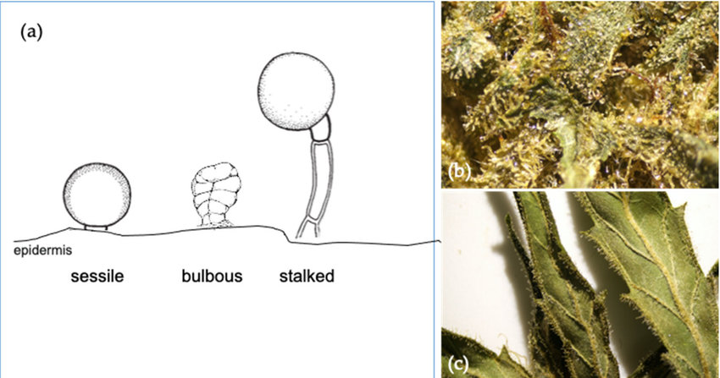
Cannabis plant Glandular Trichomes
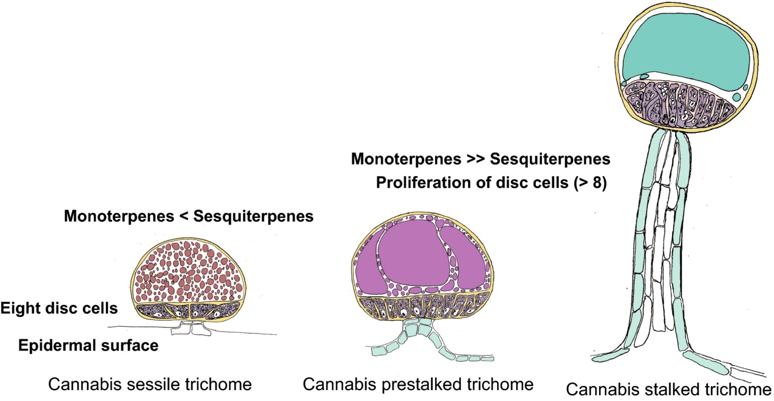
Crystal Ball Light Refraction & Condensation
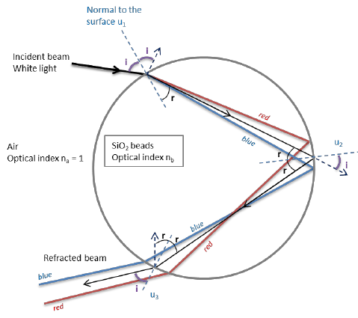
Diagram of white light refraction by a spherical quartz particle.
Hypothesis: The TG head condenses blue & UV light on the secretory cells and the enzymes inside the secretory cavity.
…Back to GENETICS:
In 2012 Kuroki and Morimoto reported an X-ray crystal structure of THCA synthase that provides significant mechanistic insight: the active site locks FAD in place through two covalent bonds with His114 and Cys176 (Shoyama et al. 2012). This covalent immobilization is supported by a series of key H-bonds with 10 additional residues, making FAD a permanent feature of the enzyme. This ligand, along the Cys37-Cys99 disulfide bridge, drives proper folding of the rest of the active site. These combine to immobilize CBGA to facilitate hydride transfer to FAD setting up a formal enantio-specific hetero Diels-Alder reaction (Zirpel 2018), although the mechanism likely proceeds through a standard carbocation ionic pathway.
Hypothesis: The folding of the active site of THCAS is affected by UV-B light absorption and Heavy Metals such as Manganese.
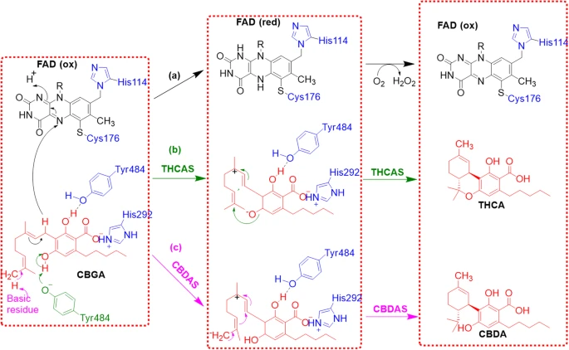
Reaction mechanism for the conversion of cannabigerolic acid (CBGA) into tetrahydrocannabinolic acid (THCA) proposed by Taura et al (2019).
- Covalently incorporated flavin adenine dinucleotide (FAD) in black,
- THCA synthase pathway is shown in green,
- Cannabidiolic acid (CBDA) synthase pathway is shown in purple; CBDA and THCA in red.
CBDAS is a 517-amino acid polypeptide with a theoretical mass of 59 kDa, although no crystal structure has been obtained. Experimentally, it has been detected as a 74 kDa protein, possibly the result of post-translational N-glycosylation of seven Asn residues (Taura et al. 2007; Taura et al. 1996). Like THCAS, CBDAS is also a flavinated enzyme; His114 and Cys176 are the most likely FAD-binding sites based on analogy with THCAS. Morimoto has proposed that the mechanism of the two enzymes is likely very similar (Taura et al. 2007b). The Morimoto group has proposed that the significant difference between their primary modes of action is in the proton transfer step: CBDAS abstracts a proton from the terminal methyl group of CBGA instead of from the hydroxyl group targeted by THCAS, this change in region-selectivity determines the cyclization (Taura et al. 2007; Taura et al. 2019).
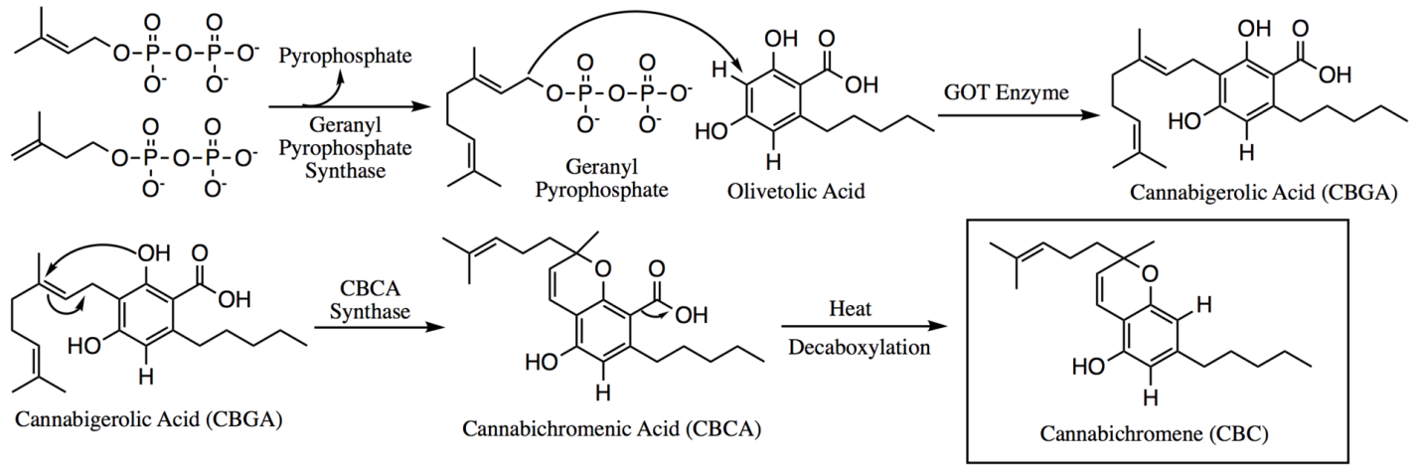
Biosynthesis of CBCA from CBGA by CBCAS
Despite this minor difference in mechanism, THCAS and CBDAS have 84% sequence identity (Taura et al. 2007b), with mutations at key active site residues likely explaining their differing cyclization specificity (Onofri et al. 2015). They both generate eight different products, although in different ratios. Whereas THCAS produces CBDA and CBCA as minor products, CBDAS produces small amounts of THCA and CBCA in addition to CBDA (Zirpel et al. 2018). This similarity can be exploited and a simple point mutation, A414V in THCAS yields an enzyme analog with threefold higher catalytic activity for the production of CBDA than THCAS, but also with 19-fold higher production of THCA and a broadened pH spectrum for the production of CBDA, THCA, and CBCA (Zirpel et al. 2018).
THCAS produce: THCA >> CBDA > CBCA
CBDAS produce: CBDA >> THCA > CBCA.

THCAS is derived from CBDAS {Recent findings}
Sequence variants of THCA- and CBDA-synthases were isolated from different Cannabis sativa L. strains expressing various wild-type and mutant chemical phenotypes (chemotypes). Expressed and complete sequences were obtained from mature inflorescences. Each strain was shown to have a different specificity and/or ability to convert the precursor CBGA into CBDA and/or THCA type products. The comparison of the expressed sequences led to the identification of different mutations, all of them due to SNPs. These SNPs were found to relate to the cannabinoid composition of the inflorescence at maturity and are therefore proposed to have a functional significance. The amount of variation was found to be higher within the CBDAS sequence family than in the THCAS family, suggesting a more recent evolution of THCA-forming enzymes from the CBDAS group. We therefore consider CBDAS as the ancestral type of these synthases.
CBDAS THCAS CBCAS
Recently the sequence of CBCAS was reported by Page and Stout (2019). The sequence identity between CBDAS and THCAS is near identity: 96% (van Bakel et al. 2011). CBCAS was isolated and partially purified from young leaves of C. sativa (Morimoto et al. 1998; Morimoto et al. 1997). In contrast to CBDAS and THCAS, CBCAS seems to be homo-dimer with a determined native molecular mass of 136 kDa and a maximum activity at pH 6.5. A molecular mass of 71 kDa was estimated for the monomers using SDS-PAGE. According to kinetic data, CBCAS has a higher affinity for CBGA than THCAS and CBCAS (Morimoto et al. 1998). CBCA and its neutral form CBC are both racemic. Studies by Morimoto suggested that both enantiomers of CBCA are formed by a CBCAS catalyzed reaction in a molar ratio of 5:1 (Morimoto et al. 1997). It is still unknown which of the two isomers is the major product (Taura et al. 2007a; Morimoto et al. 1997; Gaoni and Mechoulam 1971).
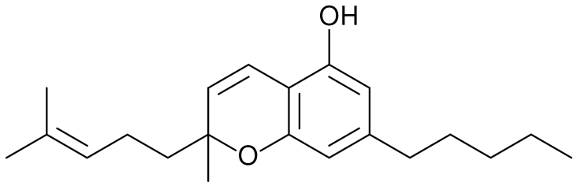
Chemical structure of Cannabichromene [CBC]
Hypothesis: The fact that CBCAS have much higher affinity to CBGA compared to CBDAS & THCAS suggests that it was the last Cannabis sativa oxidocyclase to evolve.

In chemistry, a racemic mixture is one that has equal amounts of left- and right-handed enantiomers of a chiral molecule. The first known racemic mixture was racemic acid, which Louis Pasteur found to be a mixture of the two enantiomeric isomers of tartaric acid from grapes.
A sample with only a single enantiomer is an enantiomerically pure or enantiopure compound.
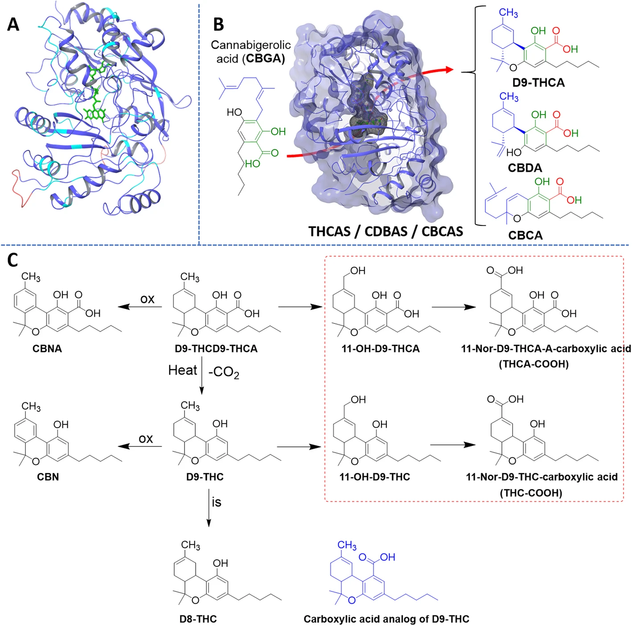
Racemic (Tartaric) acid
Hypothesis: The precursor molecule CBGA, enters one side of the active site of THCAS / CBDAS / CBCAS – interacts with the active site amino acids, FAD cofactor and leaves the enzyme from the opposite side of the active site as the product: THCA / CBDA / CBCA.
Hypothesis: FMN inhibits THCAS, CBDAS & CBCAS as a result of the competition with the FAD cofactor, proving the crucial role of the "tail" moiety of the common pCBs synthetic enzymes cofactor. Flavin adenine dinucleotide [FAD] consists of two portions: the adenine nucleotide (adenosine monophosphate [AMP]) and the flavin mononucleotide (FMN) bridged together through their phosphate groups. Adenine is bound to a cyclic ribose at the 1' carbon, while phosphate is bound to the ribose at the 5' carbon to form the adenine nucleotide.
Hypothesis: The adenine monophosphate and the cyclic ribose of FAD cofactor together with negatively or positively chargrd amino acid residues in the active pocket of the oxidocyclases, perform the chemical attack on the monoterpene of CBGA to produce CBDA, THCA & CBCA.
Amino acids of THCAS that interact with the Phenol moiety of CBGA:
Tyr417, His292. The 1st interacts with OH and the 2nd with COOH.
Amino acids that interact with the Monoterpene moiety of CBGA:
Tyr484 (481) & His292 (basic residue).
Amino acids that interact with the FAD cofactor:
His114, Cys176 (178).
Other AAs in the active site of THCAS:
Asp115, Gly113, Ile241, Tyr175 & Tyr417.

Comparison of CBDAS, CBCAS, THCAS and the metabolism of cannabinoids. Homology model of THCAS developed from CBDAS.
- Residues conserved from THCAS are purple while variant residues are cyan, sequence insertions are red, and FAD is green.
- Active site of these enzymes highlighted with a cartoon showing conversion to THCA, CBDA and CBCA from CBGA.
- Experimentally demonstrated oxidation (ox) and isomerization (is) reactions and metabolic fates (encircled) for Δ9-THCA. Carboxyclic acid analog of delta-9-THC is colored in blue.
THCAS molecule
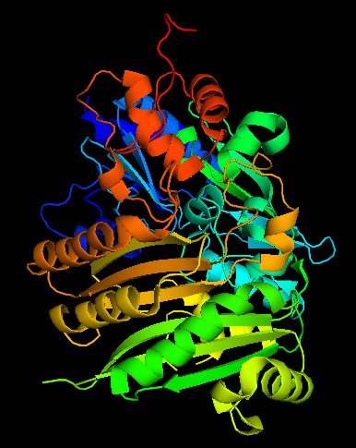
Berberine Bridge Enzyme [BBE]
Berberine bridge enzyme-like (BBE-like enzymes) form a subgroup of the superfamily of FAD-linked oxidases (SCOPe d.58.32), structurally characterized by a typical fold observed initially for vanillyl-alcohol oxidase (VAO). This proteins are part of a multigene family (PF08031) that can be found in plants, fungi and bacteria.
BBE-like enzymes family, form a large subgroup that have a special C-terminal structural element adjacent to the substrate binding region. An homonym of this family is the (S)-reticuline oxidase or berberine bridge enzyme from California poppy (Eschscholzia californica), the responsible of catalyzing the conversion of (S)-reticuline to (S)-scoulerine. This conversion is made by an oxidative ring closure reaction. The product of this reaction is the C-C bond and is referred to as the berberine bridge.
BBE-like enzymes are in the large family of FAD-linked oxidases. Regarding the structure of this particular family, they have a FAD binding module formed by the N- and C- terminal parts of the protein. There is a substrate binding module that, in collaboration with isoalloxazine ring of FAD, disposes the environment for efficient substrate binding and oxidation.
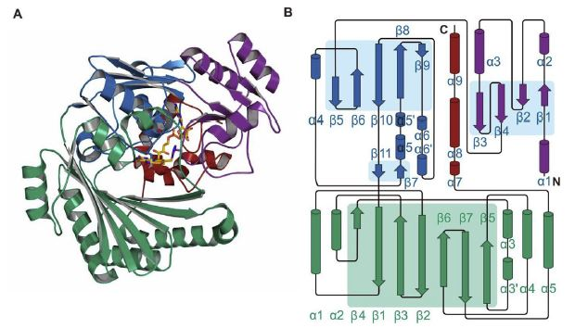
A: Structural properties of the BBE-like enzymes. Sub-domains of the upper flavin-binding module are shown in purple, blue and red.
B: Secondary structure elements are in consecutively order for a-helices and b-strands in the flavin- and substrate-binding modules and are differenced in green and blue, respectively.
A common reaction of BBE-like enzymes from plants is the oxidation of carbohydrates at the anomeric center to the appropriate lactones. A member of these enzymes is hexose oxidase (HOX) from Chondrus crispus, a red algae that belongs to the division of Rhodophyta. But HOX enzyme is more related to bacterial BBE-like enzymes than to members present in plants.
Red Algae
The origins of plants may go back hundreds of millions of years earlier than previously thought, according to fossil evidence. Ancient rocks from India suggest plants resembling red algae lived 1.6 billion years ago in what was then shallow sea.
The discovery may overturn ideas of when relatively advanced life evolved, say scientists in Sweden. They identified parts of chloroplasts, structures within plant cells involved in photosynthesis.
The earliest signs of life on Earth are at least 3.5 billion years old.
The first single-celled microscopic life forms evolved into larger multi-cellular eukaryotic organisms (made up of cells containing a nucleus and other structures within a membrane).
Dr. Therese Sallstedt of the Swedish Museum of Natural History discovered some of the fossils. She described them as "the oldest fossil plants that we know of on Earth in the form of 1.6 billion year old red algae. They show us that advanced life in the form of eukaryotes (like plants, fungi and animals) have a much deeper history on Earth than what we previously have thought".
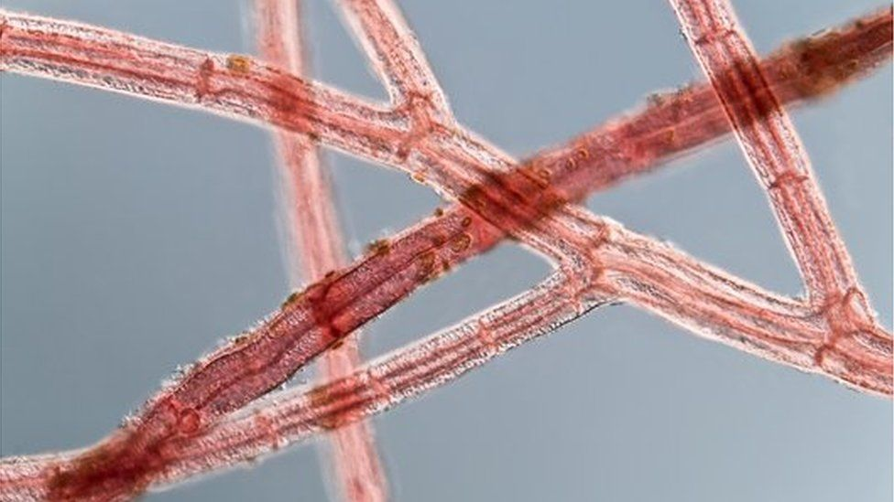
Red algae from the Baltic Sea
The scientists found thread-like fossils and more complex "fleshy" colonies in sedimentary rock from central India. Both have characteristics of modern red algae, a type of seaweed.
The oldest known red algae before the present discovery date back 1.2 billion years. The Indian fossils are 400 million years older, suggesting that the early branches of the tree of life began much earlier than previously thought. There is also debate over whether red algae belong in the plant kingdom or in a class of their own.
Modern red algae are best known for two commercial products - gelatinous texturing agents [Agar. Agar] used in making ice cream - and Nori - the seaweed used to wrap sushi.
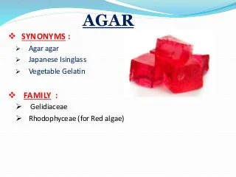
Hypothesis: The origin of pCB synthases = BBE-type oxido-cyclases is from Red Algae that lived in shallow waters and developed protection from high UV radiation in order to survive the abiotic stress.

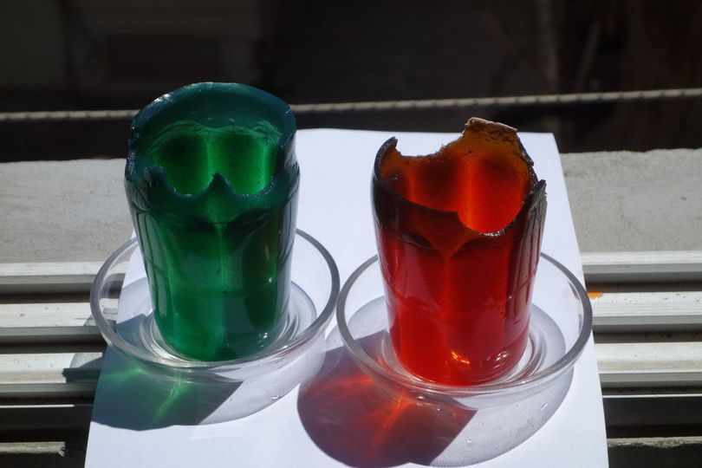
Edible glasses made of Agar.Agar

FAD Cofactor inside THCAS
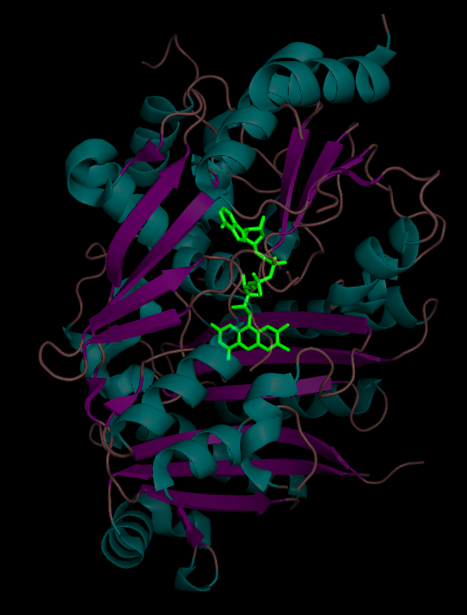
Flavin adenine dinucleotide (FAD) is a redox-active coenzyme associated with various proteins, which is involved with several enzymatic reactions in metabolism. A flavoprotein is a protein that contains a flavin group, which may be in the form of FAD or flavin mononucleotide (FMN). Many flavoproteins are known: components of the succinate dehydrogenase complex, α-ketoglutarate dehydrogenase, component of the pyruvate dehydrogenase complex and THCAS, CBDAS and CBCAS.
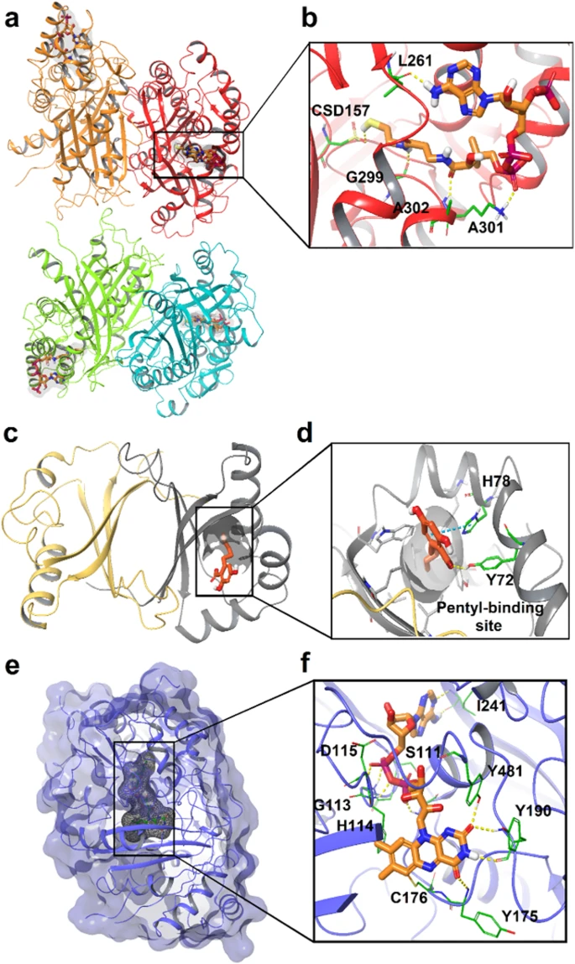
D = Asp, I = Ile, S = Ser, Y = Tyr, G = Gly, H = His, C = Cys.
X-ray diffraction structures of three key enzymes implicated in cannabinoid biosynthesis. Key active site residues are highlighted in green, and interaction diagrams, generated by the authors using the Schrödinger computational software suite (Maestro 2020).
a) tetrameric tetraketide synthase (TKS) from C. sativa in complex with Coenzyme A (CoA, 6GW3), CoA is orange, with the four tetramers in red, orange, light green and cyan respectively (Kearsey et al. 2020);
b) Expansion of the active site;
c) Olivetolic acid cyclase (OAC) from C. sativa (5BO9) (Yang et al. 2016), the pentyl-binding pocket and its key residues are gray, olivetolic acid (OLA) is orange, chain A is gray and chain B is in light orange;
d) Expansion of the active site, inverted;
e) THCAS from C. sativa (3VTE) bound to flavin adenine dinucleotide (FAD) and without ligand. FAD is orange and the protein navy;
f) Expansion of the active site (Shoyama et al. 2012)
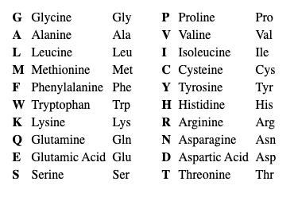
Amino acids in the active site of THCAS:
Asp115, Gly113, His114 & Cys173 in the left side of FAD and Ile241, Tyr481, Ser111 & Tyr175 in the right side.
Updated Genetic Aspects
Results emerging from recent studies showed significant genetic difference among two subgroups of Cannabis in two genes regulating accumulation of THC in this plant species, allowing discriminating between drug and fiber varieties. A first point of novelty in the recent works relates to the study of both THCAS and CBDAS genes. In fact, considering that their derived proteins compete for the same substrate, the involvement of both genes can provide a stronger and more robust discrimination between drug and fiber varieties. Nonetheless, another point of novelty related to the identification of 18 amino acid substitutions in alignment of the sequences of high-THC and low/absent-THC accessions. This information is essential to gain insights into the functionality of the enzyme. With this regard, four amino acid substitutions appeared to induce a decrease in THCAS activity in the fiber-type cannabis plants, and one of them was deleterious. Furthermore, the earlier stop codon at position 195 and the 4 bp deletion in the CBDAS sequence producing a frame-shift both cause a truncated protein and a non-functional enzyme in high-THC accessions. Assuming that the protein encoded by THCAS could still be active in fiber-type genotypes, the (shared) intermediate substrate [precursor] cannabigerolic acid [CBGA] would be preferentially metabolized by the high-affinity CBDAS-encoded enzyme. Drug-type genotypes possess an opposite trend, having the CBDAS protein completely inactive and THCAS functional. In this condition, the substrate CBGA could be transformed by THCAS only despite its relatively low affinity for the enzyme. Both these results were confirmed and validated at the metabolic level by the chemical analysis of cannabinoids.
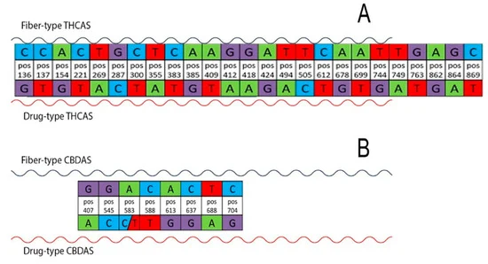
Significant single-nucleotide polymorphisms (SNPs) able to discriminate between the two cannabis subgroups of the different varieties (drug-type vs. fiber-type) are shown. Twenty-five significant SNPs are highlighted for THCAS (A) and eight for CBDAS (B). Each base change and its corresponding position (pos) in the gene are indicated.
The origin, evolution, and phylogenetic relationships of the cannabinoid oxidocyclase genes remain unclear. To elucidate these aspects, we performed comparative genomic analyses of Cannabis, related genera within the Cannabaceae family, and selected out-group species. Results show that cannabinoid oxidocyclase genes originated in the Cannabis lineage from within a larger gene expansion in the Cannabaceae family. Localization and divergence of oxidocyclase genes in the Cannabis genome revealed two main blocks, each comprising tandemly repeated cannabinoid oxidocyclase genes. By comparing these blocks with those in genomes from closely related species, we propose an evolutionary model for the origin, duplication, and diversification of cannabinoid oxidocycloase genes. Based on phylogenetic analyses, we propose a comprehensive classification of three main clades and seven sub-clades that are intended to aid unequivocal referencing and identification of cannabinoid oxidocyclase genes. Our data suggest that cannabinoid phenotype is primarily determined by the presence/absence of single-copy genes. Although wild populations of Cannabis are still unknown, increased sampling of landraces and wild/feral populations across its native geographic range is likely to uncover additional cannabinoid oxidocyclase sequence variants.
Fiber-type cultivars typically have low content (<0.4%) of THC and intermediate content (2–4%) of CBD while drug-type cultivars typically have high content (14–40%) of THC and low content (<1%) of CBD (Small and Cronquist 1976). However, cultivars exist with alternative chemical profiles such as drug-type cultivars with high levels of CBD and other classifications based on chemotype have been proposed (Hazekamp et al. 2016; Wenger et al. 2020). The most commonly used chemotypes are based on the ratio between CBD and THC, where chemotype I is THC-dominant, chemotype II has similar levels of both THC and CBD, and chemotype III is CBD-dominant. Some Cannabis plants synthesize cannabichromene (CBC) or cannabigerol (CBG; CBG-dominant plants are considered chemotype IV) (Morimoto et al. 1997; Fournier et al. 2004).

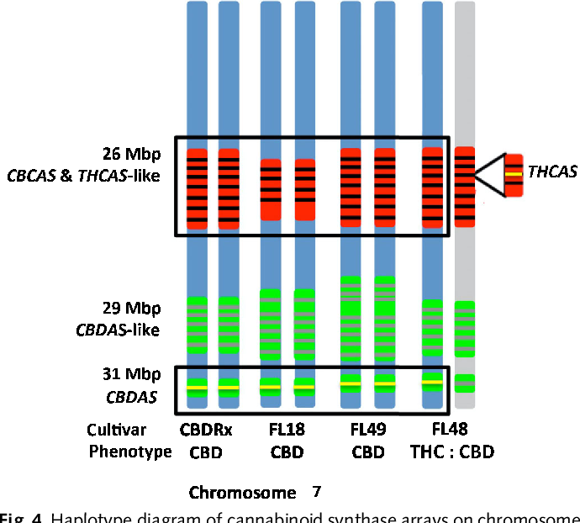
Haplotype diagram of cannabinoid synthase arrays on chromosome 7
Haplotype diagram of cannabinoid synthase arrays on chromosome 7 in the high-cannabidiol (CBD) cultivar (CBDRx) and First Light Cannabis sativa genomes. High-CBD cultivars (CBDRx, FL18, FL49) lacked a functional THCAS at 26 Mb and carried a single functional CBDAS per homologous chromosome at 31Mb. The intermediate cultivar FL48 produced both THC and CBD, and carried both functional CBDAS and THCAS, which are, respectively, identical to those carried by the high-CBD cultivars and Skunk#1, a high-THC cultivar (Weiblen et al., 2015). FL48 is heterozygous at the THCAS locus based on coverage analysis, whereas the CBDAS-like array at 29 Mb assembled on the same contig and is homozygous.
A contig--from the word "contiguous"--is a series of overlapping DNA sequences used to make a physical map that reconstructs the original DNA sequence of a chromosome or a region of a chromosome.
Flavin Adenine Dinucleotide [FAD]
FAD can exist in four redox states, which are the flavin-N(5)-oxide, quinone, semiquinone, and hydroquinone. FAD is converted between these states by accepting or donating electrons. FAD, in its fully oxidized form, or quinone form, accepts two electrons and two protons to become FADH₂ (hydroquinone form). The semiquinone (FADH·) can be formed by either reduction of FAD or oxidation of FADH₂ by accepting or donating one electron and one proton, respectively.
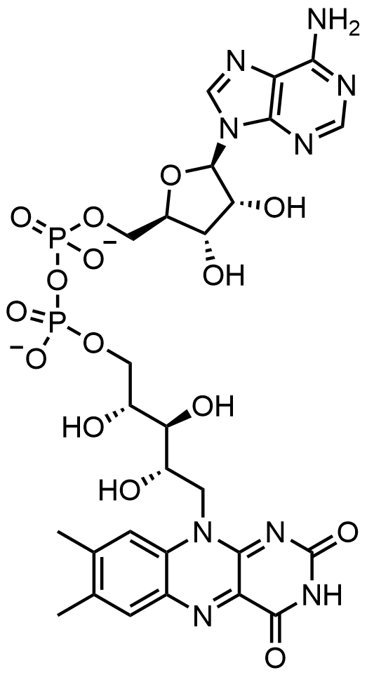
FADH₂
Flavin adenine dinucleotide consists of two portions: the adenine nucleotide (adenosine monophosphate [AMP]) and the flavin mononucleotide (FMN) bridged together through their phosphate groups. Adenine is bound to a cyclic ribose at the 1' carbon, while phosphate is bound to the ribose at the 5' carbon to form the adenine nucledotide. Riboflavin is formed by a carbon-nitrogen (C-N) bond between the isoalloxazine and the ribitol. The phosphate group is then bound to the terminal ribose carbon, forming a FMN. Because the bond between the isoalloxazine and the ribitol is not considered to be a glycosidic bond, the flavin mononucleotide is not truly a nucleotide. This makes the dinucleotide name misleading; however, the flavin mononucleotide group is still very close to a nucleotide in its structure and chemical properties.
Riboflavin [Vitamin B2]
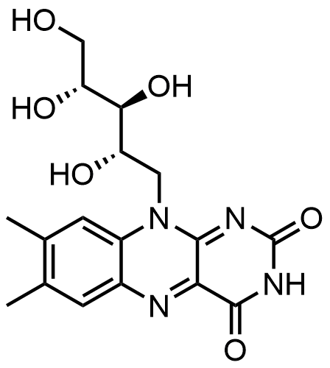
RiboFlavin & Flavin Mono Nucleotide [FMN]
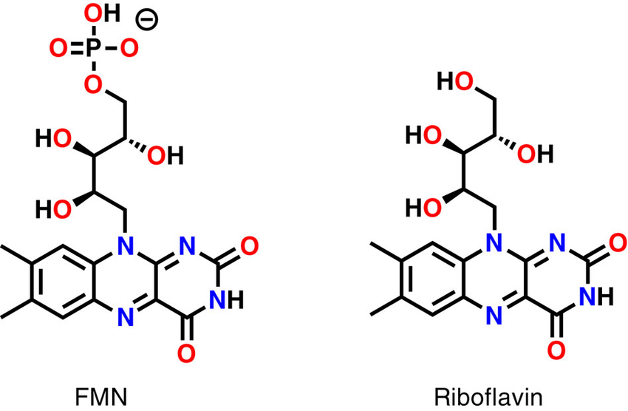
*
*
Reaction of FAD to form FADH₂
FAD can be reduced to FADH₂ through the addition of 2 H+ and 2 e−. FADH₂ can also be oxidized by the loss of 1 H+ and 1 e− to form FADH. The FAD form can be recreated through the further loss of 1 H+ and 1 e−. FAD formation can also occur through the reduction and dehydration of flavin-N(5)-oxide. Based on the oxidation state, flavins take specific colors when in aqueous solution. Flavin-N(5)-oxide (superoxidized) is yellow-orange, FAD (fully oxidized) is yellow, FADH (half reduced) is either blue or red based on the pH, and the fully reduced form is colorless. Changing the form can have a large impact on other chemical properties. For example, FAD, the fully oxidized form is subject to nucleophilic attack, the fully reduced form, FADH₂ has high polarizability. The half reduced form is unstable in aqueous solution. FAD is an aromatic ring system, whereas FADH₂ is not. This means that FADH₂ is significantly higher in energy, without the stabilization through resonance that the aromatic structure of FAD provides. FADH₂ is an energy-carrying molecule, because, once oxidized it regains aromaticity and releases the energy represented by this stabilization.
The spectroscopic properties of FAD and its variants allows for reaction monitoring by use of UV-VIS absorption and fluorescence spectroscopies. Each form of FAD has distinct absorbance spectra, making for easy observation of changes in oxidation state. A major local absorbance maximum for FAD is observed at 450 nm, with an extinction coefficient of 11,300. Flavins in general have fluorescent activity when unbound (proteins bound to flavin nucleic acid derivatives are called flavoproteins). This property can be utilized when examining protein binding, observing loss of fluorescent activity when put into the bound state. Oxidized flavins have high absorbance of about 450 nm, and fluoresce at about 515-520 nm.
Hypothesis: The effect of light on pCBs biosynthesis is caused by the light absorption of the FAD cofactor that is bound covalently to the enzymes: THCAS, CBDAS & CBCAS. The most important is the peak light absorption at 260 nm that both FAD & pCBs have. The enzyme and its product absorb light at the border between UV-C & UV-B.

Absorption spectra of FAD in phosphate buffer
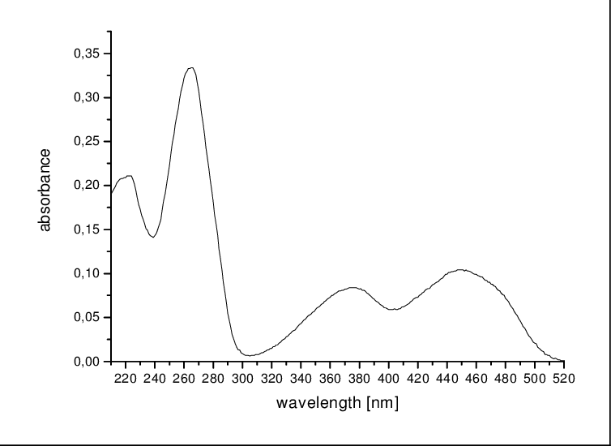
First peak at: 260 nm, Second peak at: 370 nm, third peak at: 450 nm.

Absorption spectra of FAD and its redox derivatives embedded in a flavoprotein
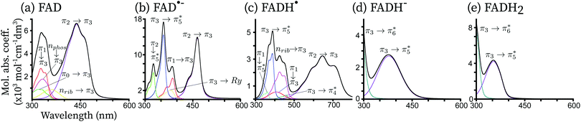
Theoretical vibrationally resolved spectrum of FAD and its redox derivatives. Besides, the contributions of the most important electronic configurations are also explicitly shown. For all redox forms, the lowest-energy peak [first from the left] is represented by a single electronic transition of the type π → π* centered on the isoalloxazine ring. The second peak of FAD, FAD˙− and FADH˙ shows a complex pattern, involving three to four electronic transitions. For FADH− and FADH₂ the second transition finds its maximum above 300 nm, and it corresponds to a π → π* transition in both cases. All excitations with a non-negligible oscillator strength up to 300 nm are shown. The x-axis is in nm while the y-axis is in units of molar absorption coefficient. The individual electronic excitation contributions are shown in several colors with an interpretation of the electronic excitations in terms of single orbital excitations indicated on top of each contribution. The total spectrum (black) corresponds to the sum of all individual contributions.
π → π* Transition – Lone Pair of Electrons
In chemistry, a lone pair refers to a pair of valence electrons that are not shared with another atom in a covalent bond and is sometimes called an unshared pair or non-bonding pair. Lone pairs are found in the outermost electron shell of atoms. They can be identified by using a Lewis structure. Electron pairs are therefore considered lone pairs if two electrons are paired but are not used in chemical bonding. Thus, the number of electrons in lone pairs plus the number of electrons in bonds equals the number of valence electrons around an atom.
Lone pair is a concept used in valence shell electron pair repulsion theory (VSEPR theory) which explains the shapes of molecules. They are also referred to in the chemistry of Lewis acids and bases. However, not all non-bonding pairs of electrons are considered by chemists to be lone pairs. Examples are the transition metals where the non-bonding pairs do not influence molecular geometry and are said to be stereochemically inactive. In molecular orbital, the concept of a lone pair is less distinct, as the correspondence between an orbital and components of a Lewis structure is often not straightforward. Nevertheless, occupied non-bonding orbitals (or orbitals of mostly nonbonding character) are frequently identified as lone pairs.
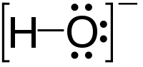
Lone pairs (shown as pairs of dots) in the Lewis structure of hydroxide
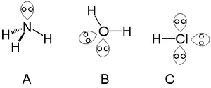
Lone pairs in ammonia (A), water (B), and hydrogen chloride (C)
A single lone pair can be found with atoms in the nitrogen group, such as nitrogen in ammonia. Two lone pairs can be found with atoms in the chalcogen group, such as oxygen in water. The halogens can carry three lone pairs, such as in hydrogen chloride [HCl].
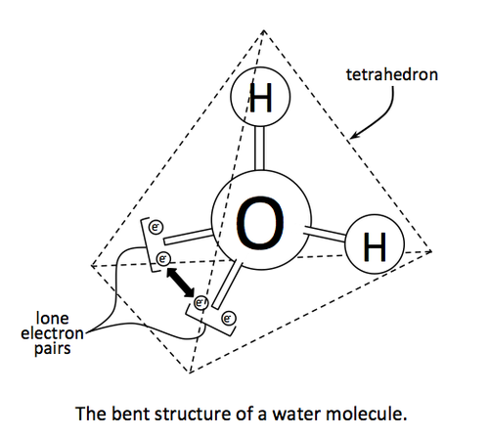
FAD in Cryptochrome protein
Cryptochromes are a class of flavoproteins proposed as candidates to explain magneto-reception of animals, plants and bacteria. The main hypothesis is that a biradical is formed upon blue-light absorption by flavin adenine dinucleotide (FAD). In a protein milieu, the oxidized form of FAD can be reduced, leading to four redox derivative forms: anionic and neutral semi-reduced radicals, and anionic and neutral fully reduced forms. All these forms have a characteristic electronic absorption spectrum, with a strong vibrational resolution. Here, we carried out a normal mode analysis at the electrostatic embedding QM/MM level of theory to compute the vibrationally resolved absorption spectra of the five redox forms of FAD embedded in a plant cryptochrome. In the case of the neutral radical form of FAD, the absorption spectrum is reproduced only if the presence of a tryptophan radical is considered.
The simulations of the UV-visible absorption spectrum in complex media are a difficult task in theoretical chemistry. Here, we have developed and implemented the analytic second-derivatives of the electrostatic embedding QM/MM ESPF method for unrestricted wave functions. This method allows, among other molecular properties, the vibrational analysis of minimum energy structures and the simulations of the vibrationally resolved spectra in protein. We have applied this methodology to simulate the absorption spectrum of FAD and its four redox derivatives (two radicals and two reduced forms, one of each anionic and one neutral) embedded in the Arabidopsis Thaliana cryptochrome protein.
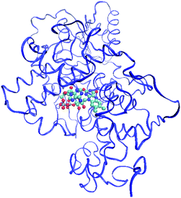
FAD (colored balls) inside Cryptochrome protein (blue)
The theoretical absorption spectrum in protein shows a perfect agreement with the experimental spectrum for the non-radical forms, reproducing both - the intensity, peak position and vibrational peak structure of the electronic transitions found between 300 nm and 600 nm. In contrast, the agreement in the case of the radical forms is only moderate. As discussed recently, the signature of tryptophan [Trp] and tyrosine [Tyr] radicals could be found in the absorption spectra of FAD˙− and FADH˙. On the one hand, for FAD˙−, a tyrosil peak appears at the same position corresponding to the π → π* transition. The position and shape of both peaks are similar, and therefore we cannot conclude that a tyrosil signature is present. On the other hand, the theoretical FADH˙ absorption spectrum in protein can only be matched to the experimental spectrum considering the lowest intense peak of the Trp radical at around 500 nm. We estimate the proportion between the two species
as 1 : 1.
Hypothesis: THCAS, CBCAS & CBDAS are kind of UV-A & UV-B Cryptochromes = light & magneto receptors.
THCAS, CBDAS & CBCAS sense the changes in UV radiation in order to produce pCBs at noon hours when all the enzymatic precursors (including olivetolic acid [OA]) are present in the GTs in high concentrations.
Effect of different Light sources on Cannabis
HPS = high pressure sodium, NS1 = "Valoya" has developed advanced LED lighting such as its proprietary NS1 spectra, specifically for plant growing purposes. The spectra are a close sun match and appear white to human eyes enabling researchers to spot the smallest of differences on plant leaves and stems ensuring a precise visual inspection. AP673P/L = "Valoya" roof LED Lights.
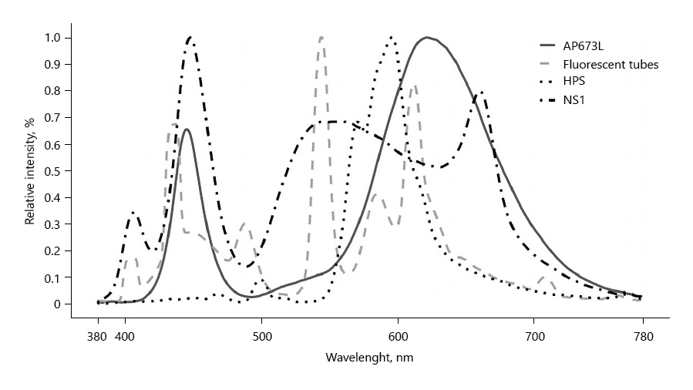
Peak light intensity of AP673L: 450 & 640 nm
Of NS1: 405, 560 & 660 nm
Of HPS: 600 nm.
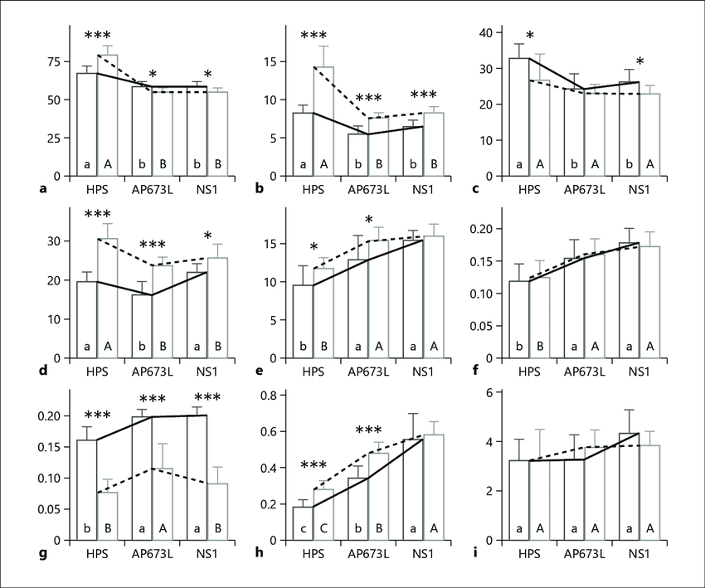
Bar graphs (mean and standard deviation) of plant parameters evaluated. a Height (cm). b Stem (g/plant). c Flowers (g/plant). d Leaves (g/plant). e THC in flowers (%). f CBD in flowers (%). g THCV in flowers (%). h CBG in flowers (%). i Yield of cannabinoids (g/plant). Different letters inside the bars show significant differences (Tukey HSD, p < 0.05). Solid lines and lower case letters are for trial 1, and dashed lines and upper case letters are for trial 2. Significant differences between trials are represented by asterisks (* p < 0.05, ** p < 0.01, *** p < 0.001).

(‒)-Cannabidiolic Acid, a Still Overlooked Bioactive Compound: An Introductory Review and Preliminary Research (2020)
M. Formato et al.
Molecules 2020, 25(11), 2638;
Light Absorption of CBDAS
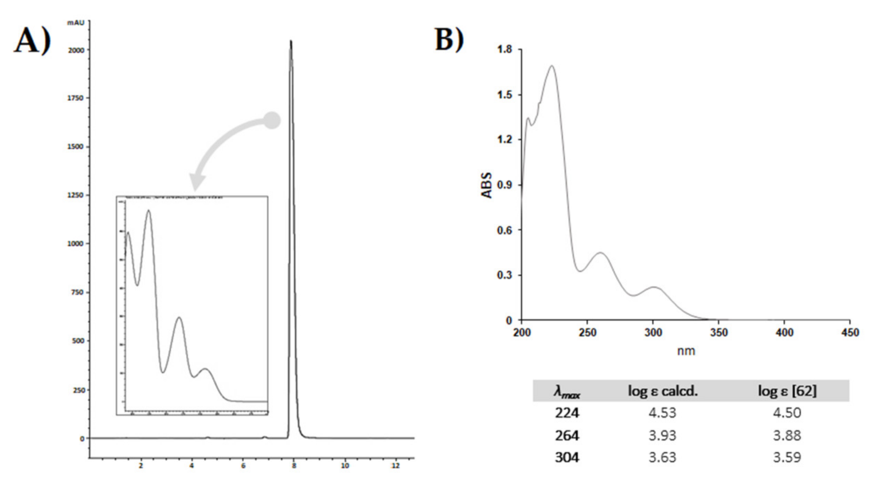
- HPLC-UV-DAD chromatographic profile of purified compound; UV-DAD spectrum is into the box. The RP-18 PLC-isolated compound (10 mg/mL, MeOH) was analysed by the HPLC 1260 INFINITY II system (Agilent, Santa Clara, CA, USA), equipped with an Agilent G7129A auto-sampler, an Agilent GY115A DAD-UV-visible detector, and a Quaternary pump Agilent G711A. The analysis was carried out using the Luna® Phenyl-Hexyl column (150 × 2 mm, 3 µm). The mobile phase consisted of a binary solution A: 0.1% HCOOH in H2O, B: 0.1% HCOOH in CH3CN. A linear gradient was started at 55% B, held for 1.5 min, and linearly ramping to 95% B in 6.50 min. The mobile phase composition was maintained at 95% B for another 2 min, then returned to the starting conditions and allowed to re-equilibrate for 3 min. The total analysis time was 13.00 min. The injection volume was 3.0 μL; the flow was set at 0.3 mL/min. (B) UV-Vis spectrum of CBDA from hemp pollen, acquired in the range 190–450 nm using a UV-1700 double beam spectrophotometer (Shimadzu, Kyoto, Japan). The pure metabolite was solubilized in MeOH with a final concentration of 0.5 × 10-5 M. The table below shows the calculated molar extinction coefficients (log ε). Literature values are reported for comparison.
The first peak of light absorption: 224 nm
The second peak of light absorption: 264 nm
The third peak of light absorption: 304 nm.
THCAS developed from CBDAS
Cannabidiolic acid [CBDA] is a 22-carbon terpenophenolic compound and represents the main phytocannabinoid [pCB] in the fiber and seed-oil hemp varieties. The biosynthesis of this compound is through cannabidiolic acid synthase (CBDAS), a covalently flavinylated oxidase, which catalyzes the stereo-selective oxido-cyclization of cannabigerolic acid [CBGA] into CBDA.
CBDAS is an ancestral type from which tetrahydrocannabinolic acid synthase (THCAS) evolved.
Sequence heterogeneity of cannabidiolic- and tetrahydrocannabinolic acid-synthase in Cannabis sativa L. and its relationship with chemical phenotype (2015)
Chiara Onofri , Etienne P M de Meijer, Giuseppe Mandolino
Phytochem., 2015 Aug; 116:57-68.
Sequence variants of THCA- and CBDA-synthases were isolated from different Cannabis sativa L. strains expressing various wild-type and mutant chemical phenotypes (chemotypes). Expressed and complete sequences were obtained from mature inflorescences. Each strain was shown to have a different specificity and/or ability to convert the precursor CBGA into CBDA and/or THCA type products. The comparison of the expressed sequences led to the identification of different mutations, all of them due to single nucleotide [SNPs]. These SNPs were found to relate to the cannabinoid composition of the inflorescence at maturity and are therefore proposed to have a functional significance. The amount of variation was found to be higher within the CBDAS sequence family than in the THCAS family, suggesting a more recent evolution of THCA-forming enzymes from the CBDAS group. We therefore consider CBDAS as the ancestral type of these synthases.
CBDAS THCAS
Both CBDAS and THCAS belong to the family of berberine bridge enzyme [BBE]-like enzymes. Briefly, hexanoyl-CoA, which was found to be formed by an acyl-activating enzyme (AAE) in glandular trichomes [GTs], undergoes a Claisen-like condensation involving three malonyl-CoA nucleophiles. Thus, a tetra-β-ketide CoA is built up. This latter cyclizes to olivetolic acid (OA) by a α+β barrel (DABB) protein, properly called olivetolic acid cyclase (OAC). Prenylation (through a geranyl diphosphate [GDP] from the 2-C-methyl-D-erythritol 4-phosphate; DOXP = 1-deoxy-D-xylulose 5-phosphate (MEP/DOXP) pathway) of olivetolic acid yields cannabigerolic acid (CBGA) by CBGA synthase. CBGA can then undergo oxidative cyclization to achieve CBDA, THCA and/or cannabichromenic acid (CBCA) compounds.

Interactions of THCAS Histidine & Cysteine with FAD
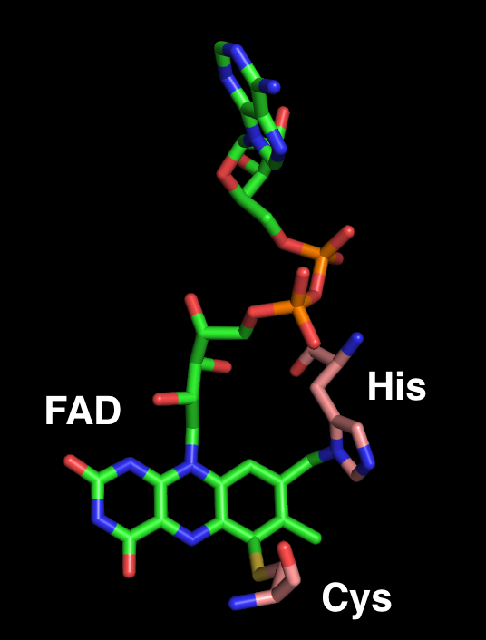
FAD cofactor is covalently bound to THCAS molecule
THCAS <–> Mn++; CBDAS <–> Fe++
In mining soils, most of the heavy metals are composed of Iron, Manganese & Magnesium.
Hypothesis: The heavy metal ions affect the conformational structure of FAD cofactor in a way that increase or decrease the activity of pCBs synthesizing enzymes – THCAS, CBCAS & CBDAS.
Transition Metals
In chemistry, the term transition metal (or transition element) has three possible definitions:
The IUPAC definition defines a transition metal as "an element whose atom has a partially filled d sub-shell, or which can give rise to cations with an incomplete d sub-shell".
Many scientists describe a "transition metal" as any element in the d-block of the periodic table, which includes groups 3 to 12 on the periodic table. In actual practice, the f-block lanthanide and actinide series are also considered transition metals and are called "inner transition metals". Cotton and Wilkinson expand the brief IUPAC definition (see above) by specifying which elements are included. As well as the elements of groups 4 to 11, they add scandium and yttrium in group 3, which have a partially filled d sub-shell in the metallic state. Lanthanum and actinium, which they consider group 3 elements, are however classified as lanthanides and actinides respectively. English chemist Charles Rugeley Bury (1890–1968) first used the word transition in this context in 1921, when he referred to a transition series of elements during the change of an inner layer of electrons (for example n = 3 in the 4th row of the periodic table) from a stable group of 8 to one of 18, or from 18 to 32. These elements are now known as the d-block.
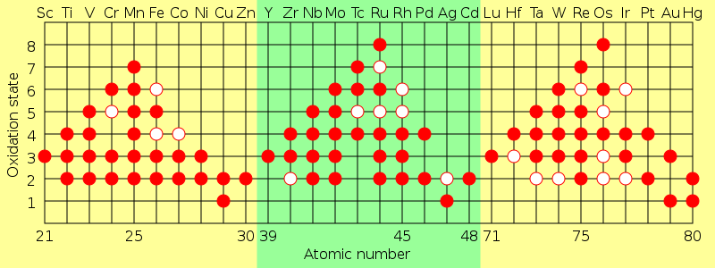
Oxidation states of the transition metals. The solid dots show common oxidation states, and the hollow dots show possible but unlikely states.
Manganese (atomic number = 25) have 6 [maximal] oxidation states.
Iron (atomic number = 26) have 3 oxidation states.
Iron [Fe] Atom
Iron is a chemical element with symbol Fe (from Latin: ferrum) and atomic number 26. It is a metal that belongs to the first transition series and group 8 of the periodic table. It is, by mass, the most common element on Earth, right in front of oxygen (32.1% and 30.1%, respectively), forming much of Earth's outer and inner core. It is the fourth most common element in the Earth's crust.
Iron reacts readily with oxygen and water to give brown to black hydrated iron oxides, commonly known as rust. Unlike the oxides of some other metals, that form passivating layers. Rust occupies more volume than the metal and thus flakes off, exposing fresh surfaces for corrosion. Although iron readily reacts, high purity iron, called electrolytic iron, has better corrosion resistance.
Chemically, the most common oxidation states of iron are iron (II) and iron (III). Iron shares many properties of other transition metals, including the other group 8 elements, ruthenium and osmium. Iron forms compounds in a wide range of oxidation states, −2 to +7. Iron also forms many coordination compounds; some of them, such as ferrocene, ferrioxalate, and Prussian blue, have substantial industrial, medical, or research applications.
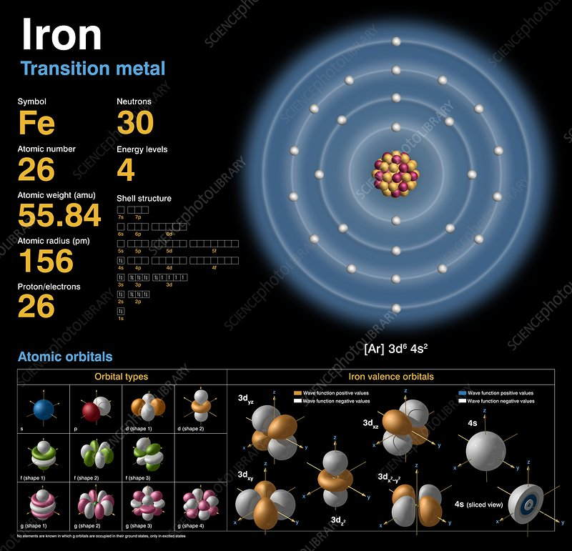
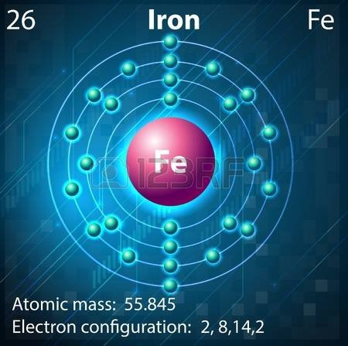
The only difference between Fe and Mn atoms is in the number of electrons in the third orbital around the nucleus – 14 in Fe and 13 in Mn.
Manganese [Mn] Atom
Manganese is a chemical element with the symbol Mn and atomic number 25. It is a hard, brittle, silvery metal, often found in minerals in combination with iron. Manganese is a transition metal with a multifaceted array of industrial alloy uses, particularly in stainless steels. It improves strength, workability, and resistance to wear. Manganese oxide is used as an oxidizing agent; as a rubber additive; and in glass making, fertilizers, and ceramics. Manganese sulfate can be used as a fungicide.
Manganese is also an essential human dietary element, important in macronutrient metabolism, bone formation, and free radical defense systems. It is a critical component in dozens of proteins and enzymes. It is found mostly in the bones, but also the liver, kidneys, and brain. In the human brain, the manganese is bound to manganese metalloproteins, most notably glutamine synthetase in astrocytes.
Manganese was first isolated in 1774. It is familiar in the laboratory in the form of the deep violet salt potassium permanganate. It occurs at the active sites in some enzymes. Of particular interest is the use of a Mn-O cluster, the oxygen-evolving complex, in the production of oxygen by plants.
The most common oxidation states of manganese are +2, +3, +4, +6, and +7, though all oxidation states from −3 to +7 have been observed. Mn2+ often competes with Mg2+ in biological systems, with the ion also being very similar in its properties to Ca2+ and Zn2+. Manganese compounds where manganese is in oxidation state +7, which are mostly restricted to the unstable oxide Mn₂O₇, compounds of the intensely purple permanganate anion MnO₄−, and a few oxy-halides (MnO₃F and MnO₃Cl), are powerful oxidizing agents. Compounds with oxidation states +5 (blue) and +6 (green) are strong oxidizing agents and are vulnerable to disproportionation.
Aqueous solution of KMnO₄ illustrating the deep purple of Mn (VII) as it occurs in permanganate.
The most stable oxidation state for manganese is +2, which has a pale pink color, and many manganese (II) compounds are known, such as manganese (II) sulfate (MnSO₄) and manganese (II) chloride (MnCl₂). This oxidation state is also seen in the mineral rhodochrosite (manganese (II) carbonate). Manganese (II) most commonly exists with a high spin, S = 5/2 ground state because of the high pairing energy for manganese (II). However, there are a few examples of low-spin, S =1/2 manganese (II). There are no spin-allowed d–d transitions in manganese (II), explaining why manganese (II) compounds are typically pale to colorless.
The +3 oxidation state is known in compounds like manganese (III) acetate, but these are quite powerful oxidizing agents and also prone to disproportionation in solution, forming manganese (II) and manganese (IV). Solid compounds of manganese (III) are characterized by its strong purple-red color and a preference for distorted octahedral coordination resulting from the Jahn-Teller effect.
Permanganate (+7 oxidation state) compounds are purple, and can gives glass a violet color. Potassium permanganate, sodium permanganate, and barium permanganate are all potent oxidizers.
The rare oxidation state +1 exists in some organo-manganese compounds such as the MnC₅H₄CH₃(CO)₃.
Manganese occurs in soils in three oxidation states: the divalent cation, Mn+2 and as brownish-black oxides and hydroxides containing Mn (III,IV), such as MnOOH and MnO₂. Soil pH and oxidation-reduction conditions affect which of these three forms of Mn is dominant in a given soil. At pH values less than 6 or under anaerobic conditions, Mn (II) dominates, while under more alkaline and aerobic conditions, Mn (III,IV) oxides and hydroxides predominate. These effects of soil acidity and aeration state on the form of Mn can be modified or controlled by microbial activity. Microbial respiration can cause both the oxidation of Mn+2 to the oxides, and it can cause reduction of the oxides to the divalent cation.
The Mn (III,IV) oxides exist as brownish-black stains and small nodules on sand, silt, and clay particles. These surface coatings on other soil particles have high surface area and carry negative charge. The charged sites can adsorb and retain various cations, especially heavy metals (e.g., Cr₃+, Cu₂+, Zn₂+, and Pb₂+). In addition, the oxides can adsorb organic acids and other compounds. The adsorption of the metals and organic compounds can then cause them to be oxidized while the Mn (III,IV) oxides are reduced to Mn+2[e.g., Cr+2 to Cr (VI) and colorless hydroquinone to tea-colored quinone polymers.
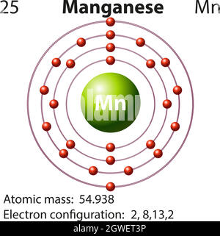
The 2 outer orbital electrons participate in chemical reactions
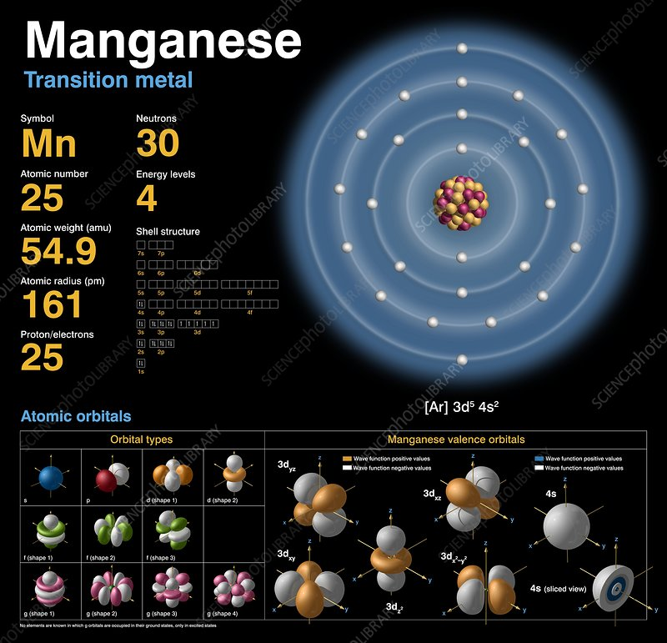

Magnesium [Mg] = Alkaline Metal
Magnesium is a chemical element with the symbol Mg and atomic number 12. It is a shiny gray solid which shares many physical and chemical properties with the other five alkaline earth metals (group 2 of the periodic table).
This element is the eleventh most abundant element by mass in the human body and is essential to all cells and some 300 enzymes. Magnesium ions interact with polyphosphate compounds such as ATP, DNA, and RNA. Hundreds of enzymes require magnesium ions to function. Magnesium compounds are used medicinally as common laxatives, antacids, and to stabilize abnormal nerve excitation or blood vessel spasm in such conditions as eclampsia.
Organo-magnesium compounds are widespread in organic chemistry. They are commonly found as Grignard reagents. Magnesium can react with haloalkanes to give Grignard reagents. Examples of Grignard reagents are phenylmagnesium bromide and ethylmagnesium bromide. The Grignard reagents function as a common nucleophile, attacking the electrophilic group such as the carbon atom that is present within the polar bond of a carbonyl group.
A prominent organomagnesium reagent beyond Grignard reagents is magnesium anthracene with magnesium forming a 1,4-bridge over the central ring. It is used as a source of highly active magnesium.
Magnesium in organic chemistry also appears as low valent magnesium compounds, primarily with the magnesium forming diatomic ions in the +1 oxidation state but more recently also with zero oxidation state or a mixture of +1 and zero states. Such compounds find synthetic application as reducing agents and sources of nucleophilic metal atoms.

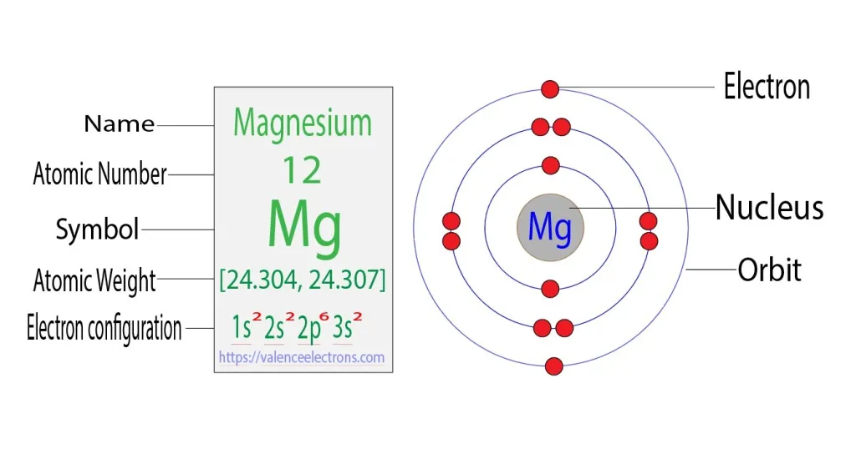
Mg Atom
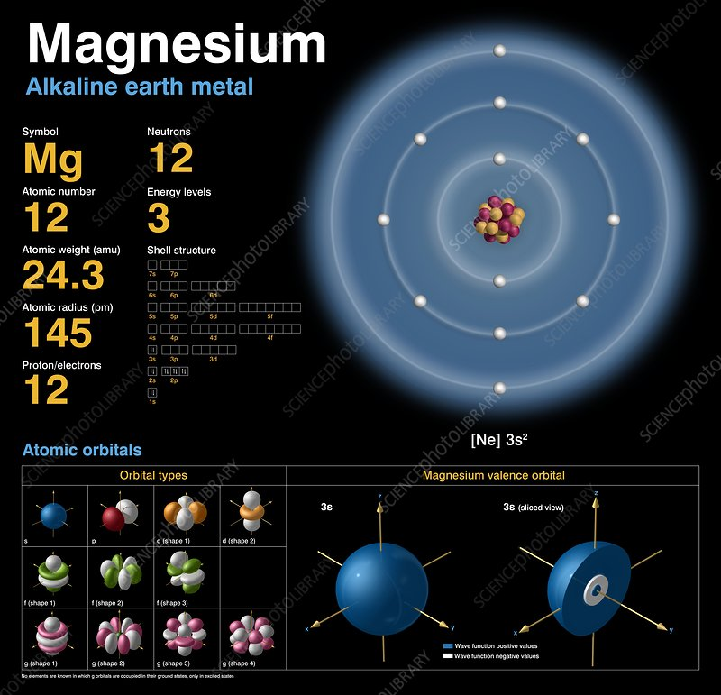

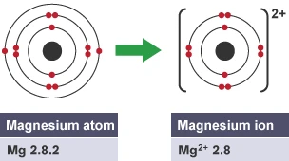
Mg Ion

UVB: A Critical Frequency Range for Genetic {Biochemical} Activation in Cannabis (2021)
By August Dunning
August Dunning is the CEO of Eco Organics and is a physicist, chemist and an inventor. He is the former systems ops designer for the International Space Station and a former regional manager of liquid, solid & electric propulsion systems for Pratt and Whitney space propulsion, Edwards AFB, NAWC and JPL.
Published: January 18, 2019 | Last updated: April 23, 2021
"As research ramps up on how lighting affects cannabis, many are focusing on how UVB affects the final stages of growth. August Dunning takes us to the molecular level to explain how UVB can affect the strength of weed.
Lighting is the means for photonic activation of all photosynthetic plant growth. It’s measured in photosynthetic photon flux density (PPFD). For trichomes, light is one of the three elements—nutrient availability, genetics, and light quality—necessary for the strong synthesis of cannabinolic compounds.
For the optimum production in any genetic strain, nutrient availability and light quality can be provided in any number of ways and with various equipments. I prefer growing in sunlight for both the heat provided by the sun through the infrared [IR] spectrum, as well as the vast flux density of the other frequencies for strong growth, particularly green light. Green light frequencies can penetrate deeper than red or blue light to increase photosynthesis by exciting chloroplasts located deep in the mesophyll. This is extremely important in the dense canopy production techniques seen during vegetative growth in indoor grows. However, the production of cannabis for medical or recreational use is focused in the final stage: calyx formation to produce the terpenophenolic compounds in the glandular trichomes [GTs].
The photo-morphogenesis of these compounds are strictly dependent on divalent ions of mineral elements such as ferrous (Fe++) for cannabidiol (CBD) and manganese (Mn++) for tetrahydrocannabinol (THC). These act as the mineral substrates {?} that deform the synthase molecules that drive the metabolic reactions cannabidiolic acid (CBDA) to CBD and tetrahydrocannabinolic acid (THCA) to THC".
Decarboxylation of acid pCBs is NOT! a enzymatic process. THCAS, CBDAS & CBCAS cannot perform such decarboxylation, only heat does.

Hypothesis: The oxidocyclization of CBGA to THCA, CBDA or CBCA may be affected by UV-B light and Heavy Metal ions.
The Plastid
The plastid (Greek: πλαστός; plastós: formed, molded – plural plastids) is a membrane-bound organelle found in the cells of plants, algae, and some other eukaryotic organisms. They are considered to be intracellular endo-symbiotic cyanobacteria. Examples include chloroplasts (used for photosynthesis), chromoplasts (used for pigment synthesis and storage), and leucoplasts (non-pigmented plastids that can sometimes differentiate).
The event which led to permanent endosymbiosis in the Archaeplastida clade (of land plants, red algae, and green algae) probably occurred with a cyanobiont (a symbiotic cyanobacteria) related to the genus Gloeomargarita, around 1.5 billion years ago. A later primary endosymbiosis event occurred in photosynthetic Paulinella amoeboids about 90–140 million years ago. This plastid belongs to the "PS-clade" (of the cyanobacteria genera Prochlorococcus and Synechococcus). Secondary and tertiary endosymbiosis has also occurred, in a wide variety of organisms; additionally, some organisms sequester ingested plastids in a process that is known as kleptoplasty.
A. F. W. Schimper was the first to name and provide a clear definition of plastids. They often contain pigments used in photosynthesis, and the types of pigments in a plastid determine the cell's color. They are also the site of manufacture and storage of important chemical compounds used by the cells of autotrophic eukaryotes. They possess a double-stranded DNA molecule that is circular, like that of the circular chromosome of prokaryotic cells.
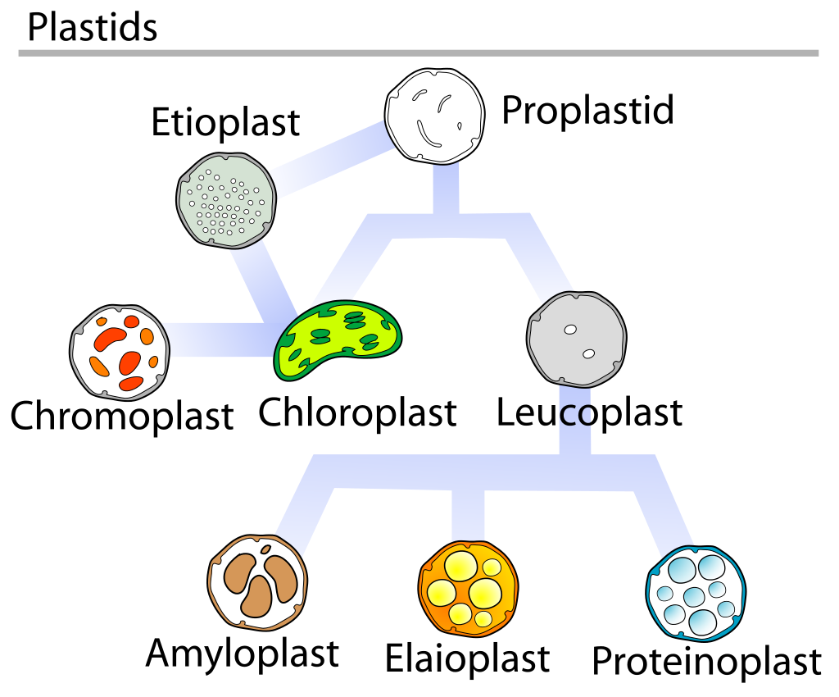
Plastid DNA of maize seedlings is subject to increased damage as the seedlings develop. The DNA is damaged in oxidative environments created by photo-oxidative reactions and photosynthetic/respiratory electron transfer. Some DNA molecules are repaired while DNA with unrepaired damage are degraded to non-functional fragments.
DNA repair proteins are encoded by the cell's nuclear genome but can be trans-located to plastids where they maintain genome stability/integrity by repairing the plastid's DNA. As an example, in chloroplasts of the moss Physcomitrella patens, a protein employed in DNA mismatch repair (Msh1) interacts with proteins employed in recombinational repair (RecA and RecG) to maintain plastid genome stability.
Leucoplast
Leucoplasts (λευκός leukós "white", πλαστός plastós "formed, molded") are a category of plastid and as such are organelles found in plant cells. They are non-pigmented, in contrast to other plastids such as the chloroplast. Lacking photosynthetic pigments, leucoplasts are not green and are located in non-photosynthetic tissues of plants, such as roots, bulbs and seeds. They may be specialized for bulk storage of starch, lipid or protein and are then known as amyloplasts, elaioplasts, or proteinoplasts (also called aleuroplasts) respectively. However, in many cell types, leucoplasts do not have a major storage function and are present to provide a wide range of essential biosynthetic functions, including the synthesis of fatty acids such as palmitic acid, many amino acids, and tetrapyrrole compounds such as heme. In general, leucoplasts are much smaller than chloroplasts and have a variable morphology, often described as amoeboid. Extensive networks of stromules interconnecting leucoplasts have been observed in epidermal cells of roots, hypocotyls, and petals, and in callus and suspension culture cells of tobacco. In some cell types at certain stages of development, leucoplasts are clustered around the nucleus with stromules extending to the cell periphery, as observed for proplastids in the root meristem.
Etioplasts, which are pre-granal, immature chloroplasts but can also be chloroplasts that have been deprived of light, lack active pigment and can be considered leucoplasts. After several minutes of exposure to light, etioplasts begin to transform into functioning chloroplasts and cease being leucoplasts. Amyloplasts are of large size and store starch. Proteinoplasts store proteins and are found in seeds (pulses). Elaioplasts store fats and oils and are found in seeds. They are also called oleosomes.
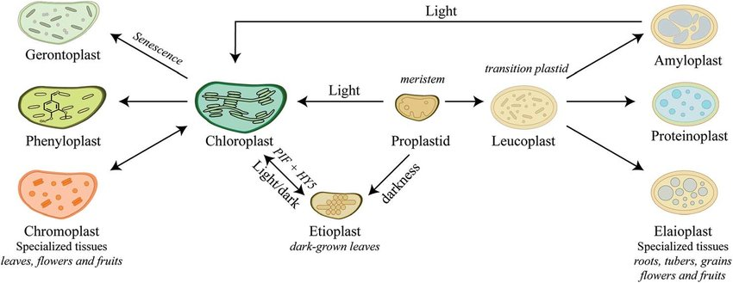
Hypothesis: Cannabis GTs disc (secreting) cells organelles are Proteinoplasts and/or Elaioplasts that are exposed to light but do not become chloroplasts, do not produce chlorophyll and do not perform photosynthesis.
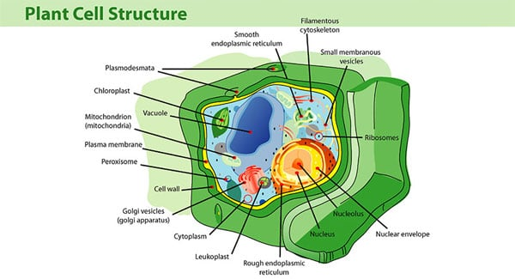
Leukoplasts are located between the cell nucleus and the Golgi vesicles,

Evolution of the protection from UV radiation (2007)
Experimental study of the excited-state properties and photostability of the mycosporine-like amino acid palythine in aqueous solution
Photochemical and Photobiological Sciences 6(6):669-74 - July 2007
Federico Rubén Conde, María Sandra Churio and Carlos Mario Previtali.
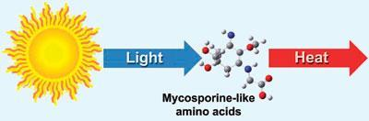
Abstract
Characterization of the excited states of the mycosporine-like amino acid [MAA] palythine (λmax = 320 nm) in aqueous solutions was achieved experimentally. The low value for the photo-degradation quantum yield, (1.2 ± 0.2) × 10−5, confirms that palythine is highly photo-stable in air saturated-aqueous solutions. Laser flash photolysis of acetone in the presence of palythine allowed for the observation of a transient spectrum which is consistent with the triplet–triplet absorption of palythine. The photo-acoustic calorimetry results are consistent with non-radiative decay as the major fate of excited palythine. A comparison of the photo-degradation quantum yields and photo-physical properties of palythine with those previously determined for the other MAAs, shinorine and porphyra-334, suggests that geometrical isomerization around the C [double bond, length as m-dash] N bond may contribute to the rapid deactivation of this group of molecules.
Mycosporine-like amino acids (MAAs) are small secondary metabolites produced by organisms that live in environments with high volumes of sunlight, usually marine environments. The exact number of compounds within this class of natural products is yet to be determined, since they have only relatively recently been discovered and novel molecular species are constantly being discovered; however, to date their number is around 30. They are commonly described as “microbial sunscreens” although their function is believed not to be limited to sun protection. MAAs represent high potential in cosmetics, and biotechnological applications. Indeed, their UV-absorbing properties would allow the creation of products derived from natural photo-protectors, potentially harmless to the environment and efficient against UV damage.
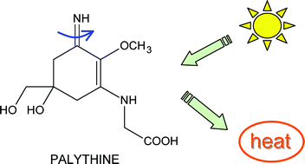
Light causes the rotation{?} of the C=N double bond
And the absorbed energy is released as heat.
Hypothesis: The absorption of UV-B (270 nm) light by pCBs produces heat that help the metabolism inside the secretory cavity on the top of Cannabis plant GTs.
Different MAAs and their Light Absorption Spectra
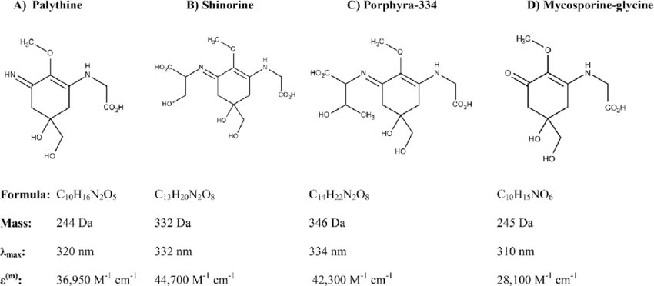
Experimental study of the excited-state properties and photo-stability of the mycosporine-like amino acid [MAA] palythine in aqueous solution.
.
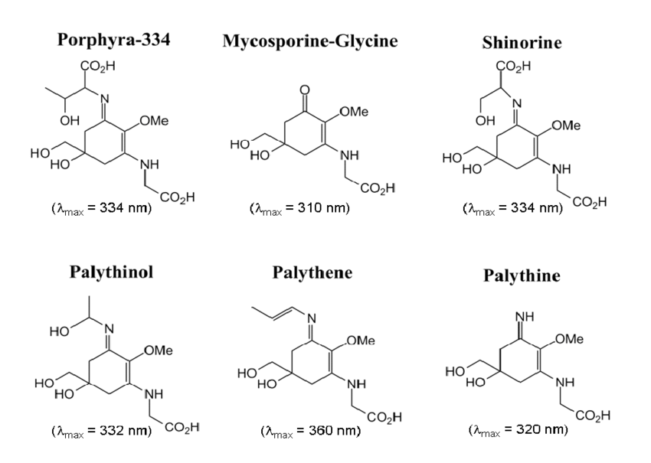
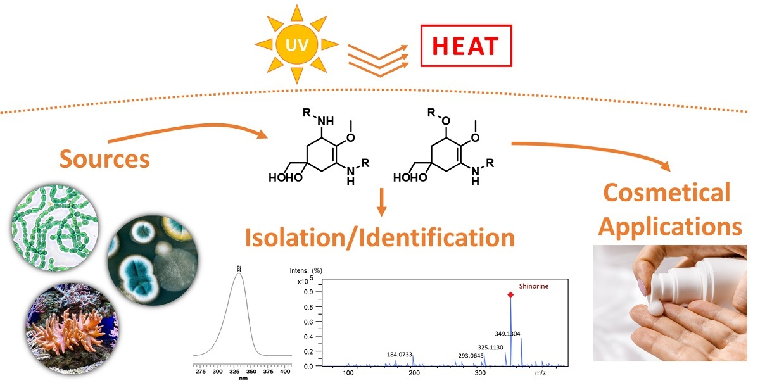
Peak light absorption of Palythine at 325 nm
PHONONE
In physics, a phonon is a collective excitation in a periodic, elastic arrangement of atoms or molecules in condensed matter, specifically in solids and some liquids. Often referred to as a quasiparticle, it is an excited state in the quantum mechanical quantization of the modes of vibrations for elastic structures of interacting particles. Phonons can be thought of as quantized sound waves, similar to photons as quantized light waves. The study of phonons is an important part of condensed matter physics. They play a major role in many of the physical properties of condensed matter systems, such as thermal conductivity and electrical conductivity, as well as play a fundamental role in models of neutron scattering and related effects.
The concept of phonons was introduced in 1932 by Soviet physicist Igor Tamm. The name phonon comes from the Greek word φωνή (phonē), which translates to sound or voice, because long-wavelength phonons give rise to sound. The name is analogous to the word photon.
A phonon is the quantum mechanical description of an elementary vibrational motion in which a lattice of atoms or molecules uniformly oscillates at a single frequency. In classical mechanics this designates a normal mode of vibration. Normal modes are important because any arbitrary lattice vibration can be considered to be a superposition of these elementary vibration modes (cf. Fourier analysis). While normal modes are wave-like phenomena in classical mechanics, phonons have particle-like properties too, in a way related to the wave–particle duality of quantum mechanics.
Optical phonons are out-of-phase movements of the atoms in the lattice, one atom moving to the left, and its neighbor to the right. This occurs if the lattice basis consists of two or more atoms. They are called optical because in ionic crystals, such as sodium chloride, fluctuations in displacement create an electrical polarization that couples to the electromagnetic field. Hence, they can be excited by infrared [IR] radiation, the electric field of the light will move every positive sodium ion in the direction of the field, and every negative chloride ion in the other direction, causing the crystal to vibrate.
Optical phonons have a non-zero frequency at the Brillouin zone center and show no dispersion near that long wavelength limit. This is because they correspond to a mode of vibration where positive and negative ions at adjacent lattice sites swing against each other, creating a time-varying electrical dipole moment. Optical phonons that interact in this way with light are called infrared active. Optical phonons that are Raman active can also interact indirectly with light, through Raman scattering.
When measuring optical phonon energy experimentally, optical phonon frequencies are sometimes given in spectroscopic wavenumber notation, where the symbol ω represents ordinary frequency (not angular frequency), and is expressed in units of cm−1. The value is obtained by dividing the frequency by the speed of light in vacuum. In other words, the wave-number in cm−1 units corresponds to the inverse of the wavelength of a photon in vacuum that has the same frequency as the measured phonon.
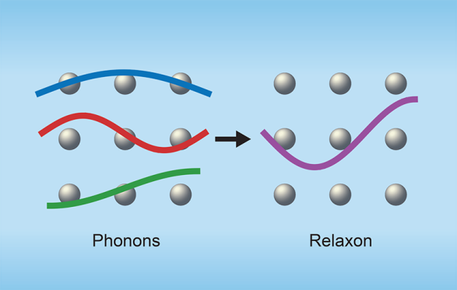
Thermal transport in a dielectric crystal results from atomic vibrations. To model thermal transport, the atomic vibrations can be projected onto plane waves called phonon modes. Cepellotti and Marzari propose a new set of modes called relaxons, which are superposition of phonons; for simplicity, only one relaxon mode is illustrated at the center of the lattice. In all materials, when perturbed from thermal equilibrium, relaxons show an exponential decay back to an equilibrium population such that a lifetime or mean free path is always a well-defined quantity, which is not always true for phonons.
…Back to MMAs
Palythine absorbs light [peak at 320 nm]
in the "border" between UV-B and UV-A
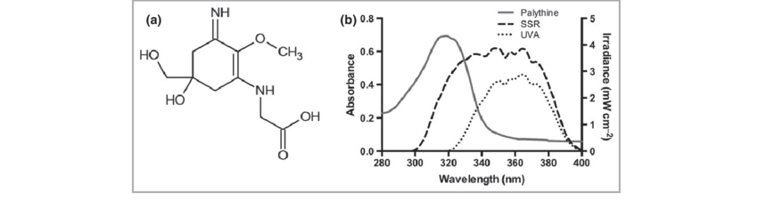
Palythine absorbs UV radiation turning it to heat.
The first thorough description of MAAs was done in cyanobacteria living in a high UV radiation environment. The major unifying characteristic among all MAAs is UV light absorption. All MAAs absorb UV light that can be destructive to biological molecules (DNA, proteins, etc.). Though most MAA research is done on their photo-protective capabilities, they are also considered to be multi-functional secondary metabolites that have many cellular functions. MAAs are effective antioxidant molecules and are able to stabilize free radicals within their ring structure. In addition to protecting cells from mutation via UV radiation and free radicals, MAAs are able to boost cellular tolerance to desiccation, salt stress, and heat stress.
MMAs are rather small molecules (<400 Da). The structures of over 30 MAAs have been resolved and all contain a central cyclohexenone or cyclohexenimine ring and a wide variety of substitutions. The ring structure is thought to absorb UV light and accommodate free radicals. All MAAs absorb ultraviolet wavelengths, typically between 310 and 330 nm. They are considered to be amongst the strongest natural absorbers of UV radiation. It is this light absorbing property that allows MAAs to protect cells from the harmful UV-B and UV-A components of sunlight. Biosynthetic pathways of MAAs depend on the specific MAA molecule and the organism that is producing it. These biosynthetic pathways often share common enzymes and metabolic intermediates with pathways of the primary metabolism. An example is the shikimate pathway that is classically used to produce the aromatic amino acids (phenylalanine, tyrosine and tryptophan); with many intermediates and enzymes from this pathway utilized in MAA biosynthesis.
Protection from UV radiation
Ultraviolet UV-A and UV-B radiation is harmful to living systems. An important tool used to deal with UV exposure is the biosynthesis of small-molecule sunscreens. MAAs has been implicated in UV radiation protection. The genetic basis for this implication comes from the observed induction of MAA synthesis when organisms are exposed to UV radiation. This has been observed in aquatic yeasts, cyanobacteria] marine dinoflagellates] and some Antarctic diatoms. MAAs have also been identified in 572 species of other algae : 45 species in Chlorophyta, 41 species in Phaeophyta, 486 species in Rhodophyta which also present anti-aging, anti-inflammatory, antioxidative and wound healing properties. When MAA absorbs UV light the energy is dissipated as heat. UV-B photoreceptors have been identified in cyanobacteria as the molecules responsible for the UV light induced responses, including synthesis of MAAs. "Helioguard™365" containing Porphyra-334 and Shinorine derived from Porphyra umbilicalis is already a cream on the market were developed by "Mibelle AG biochemistry" and shows preventive effects against UVA. An MAA known as palythine, derived from seaweed, has been found to protect human skin cells from UV radiation even in low concentrations.
MAA, in addition to their environmental benefits, appears to be multifunctional photo-protective compounds," says Dr. Karl Lawrence, lead author of a paper on the research. "They work through the direct absorption of UVR [ultraviolet radiation] photons, much like the synthetic filters. They also act as potent antioxidants, which is an important property as exposure to solar radiation induces high levels of oxidative stress, and this is something not seen in synthetic filters.
At V.V. Group B.V. we'll add Palythine, Shinorin & Porhyra-334 to our natural Cannabis-based broad spectrum {260 – 330 nm} high SPF high PPD SUNSCREEN formulation.
Protection from oxidative damage
Some MAAs protect cells from reactive oxygen species (i.e. singlet oxygen, superoxide anions, hydroperoxyl radicals, and hydroxyl radicals). Reactive oxygen species [ROS] can be created during photosynthesis; further supporting the idea that MAAs provide protection from UV light. Mycosporine-glycine is a MAA that provides immediate antioxidant protection even before oxidative stress response genes and antioxidant enzymes are induced. MAA-glycine (mycosporine-glycine) is able to quench singlet oxygen and hydroxyl radicals very quickly and efficiently. Some oceanic microbial ecosystems are exposed to high concentrations of oxygen and intense light; these conditions (in shallow waters) are likely to generate high levels of ROS. In these ecosystems, MAA-rich cyanobacteria may be providing antioxidant activity.
Cyanobacteria
Cyanobacteria , also known as Cyanophyta, are a phylum of Gram-negative bacteria that obtain energy via photosynthesis. The name cyanobacteria refers to their color (from Ancient Greek κυανός (kuanós) 'blue'), giving them their other name, "blue-green algae", though modern botanists restrict the term algae to eukaryotes and do not apply it to cyanobacteria, which are prokaryotes. They appear to have originated in freshwater or a terrestrial environment. Sericytochromatia, the proposed name of the paraphyletic and most basal group, is the ancestor of both the non-photosynthetic group Melainabacteria and the photosynthetic cyanobacteria, also called Oxyphotobacteria.
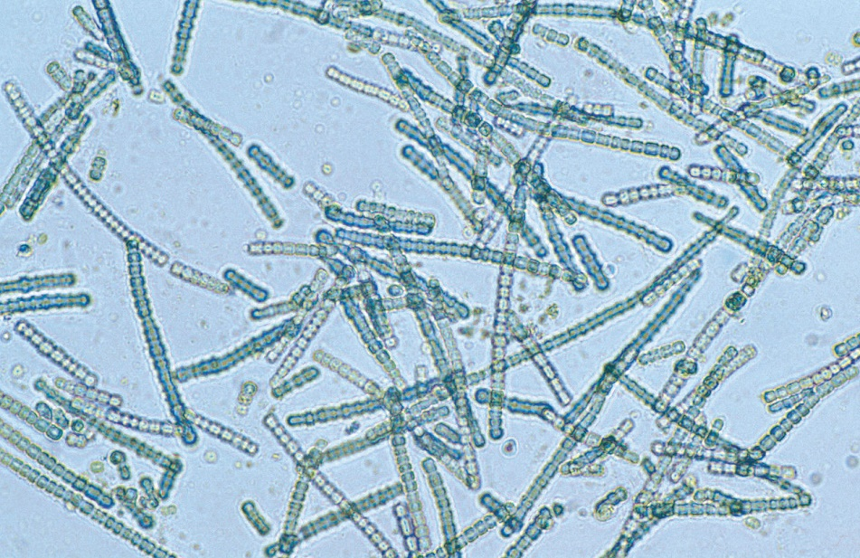
Cylindrospermum, a filamentous genus of cyanobacteria
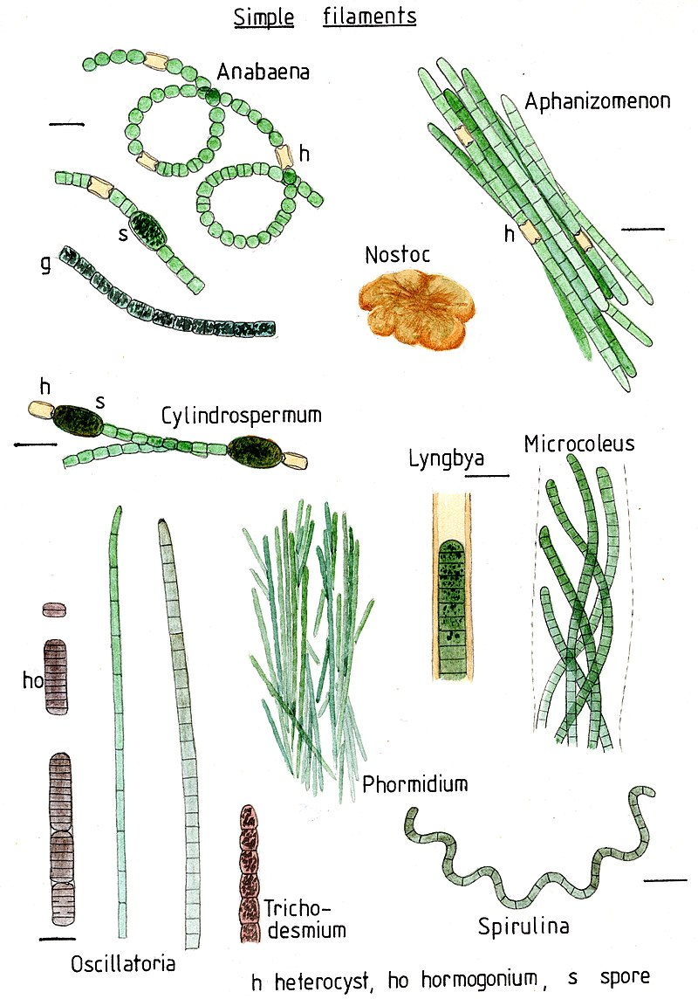
Cyanobacteria use photosynthetic pigments, such as carotenoids, phycobilins, and various forms of chlorophyll, which absorb energy from light. Unlike heterotrophic prokaryotes, cyanobacteria have internal membranes. These are flattened sacs called thylakoids where photosynthesis is performed. Phototrophic eukaryotes such as green plants perform photosynthesis in plastids that are thought to have their ancestry in cyanobacteria, acquired long ago via a process called endosymbiosis. These endosymbiotic cyanobacteria in eukaryotes then evolved and differentiated into specialized organelles such as chloroplasts, etioplasts and leucoplasts.
Diagram of a typical cyanobacterial cell
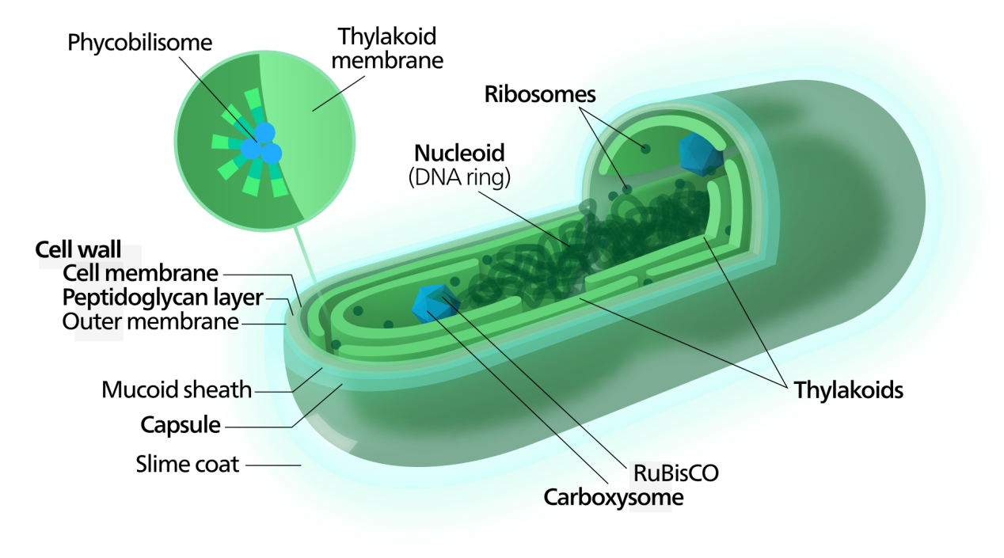
Cyanobacteria are the first organisms known to have produced oxygen. By producing and releasing oxygen as a byproduct of photosynthesis, cyanobacteria are thought to have converted the early oxygen-poor, reducing atmosphere into an oxidizing one, causing the Great Oxidation Event and the "rusting of the Earth", which dramatically changed the composition of the Earth's life forms and led to the near-extinction of anaerobic organisms.
We'll return now to Cannabis…

Cannabis GTs Disc Cells
Cannabinoids and terpenoids are synthesized by a cluster of secretory cells located at the base of the glandular trichome [GT] head, referred to as disc cells. Secondary metabolites & enzymes accumulate in the sub-cuticular cavities (secreting space) located between the disc cells and the cuticle of the GT head.
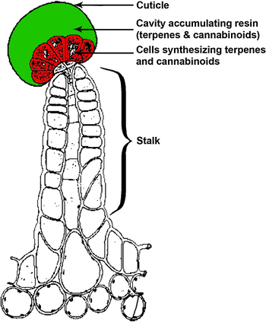
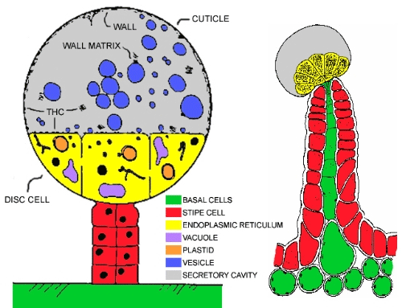
Both the oxidocyclase enzymes and their precursor molecule [CBGA] are produced inside the secretory cells and released to the secretory cavity (marked in black as WALL MATRIX).
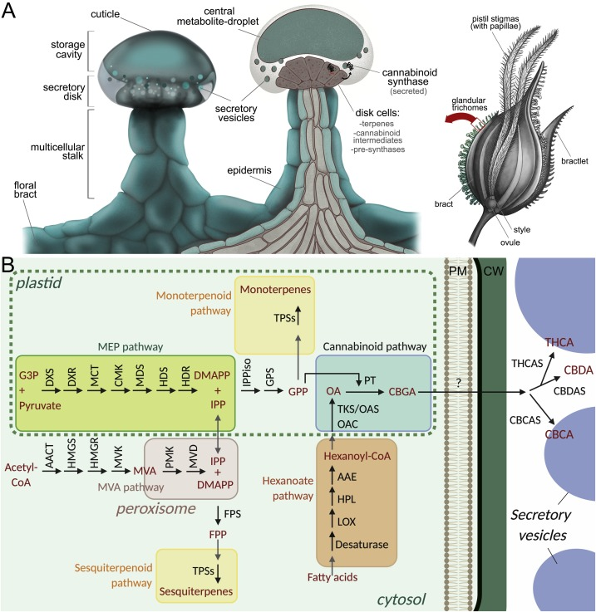
Terpenes from the Plastid + Phenols from the Vacuole are
Combined inside secretory cell [SC] plastid to create CBGA that is released to the secretory cavity.
The enzymes: THCAS, CBCAS & CBDAS are active inside the
Secretory cavity and the products - THCA, CBCA & CBDA, are
Stored inside the secretory vesicles.
Hypothesis: CBGA pass the SC plasma membrane (PM) and is secreted
to the secretory cavity by a special (yet unknown) pCB protein carrier.
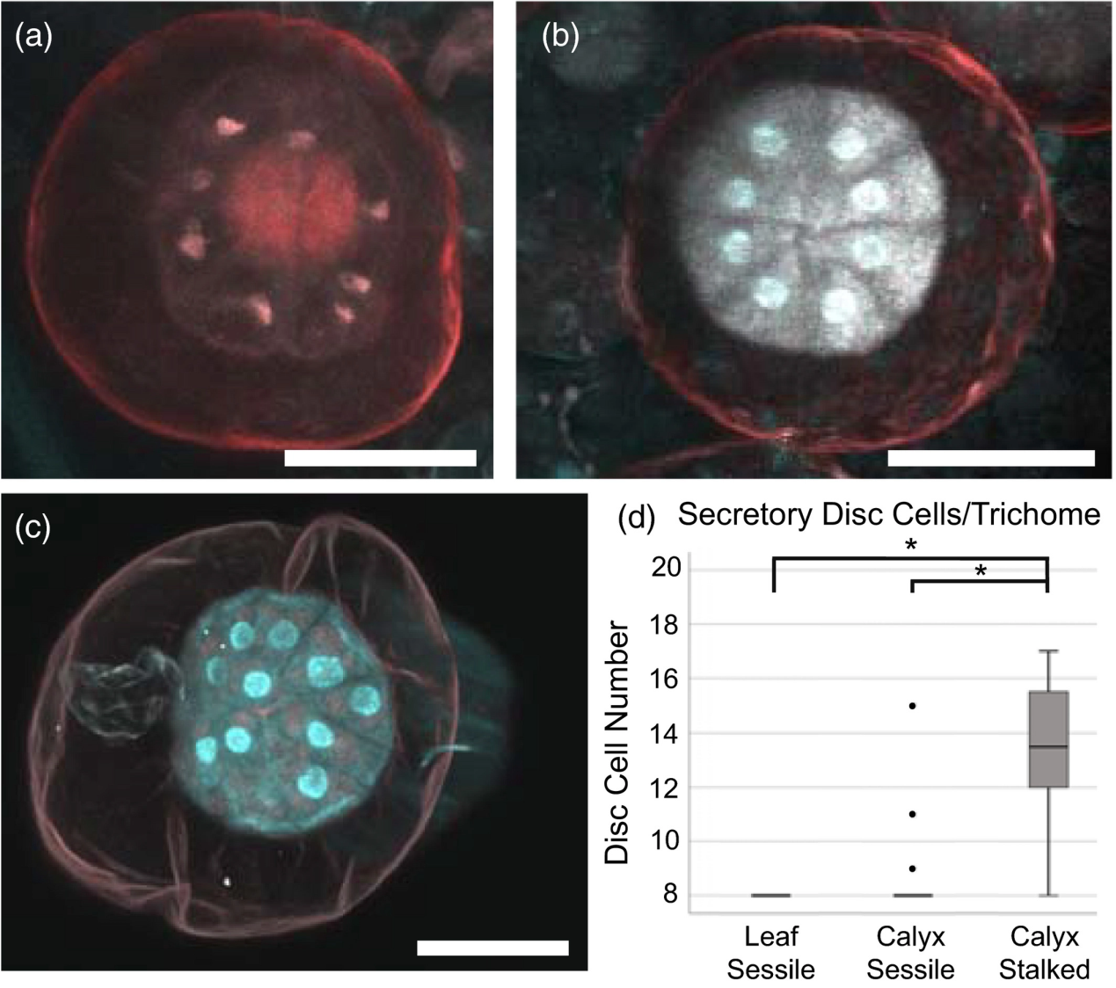
The number of SCs increases as the Cannabis plant matures.
The mature calyx stalked GT contain 14 {12 – 16} SCs.
The V.V. research group will measure the pH values
inside the secretory cavity at different stages of Cannabis
flowers development.
The concentration of Hydrogen Peroxide & the temperature inside the secretory cavity will be also measured by V.V. team.
Tetrahydrocannabinolic Acid Synthase
The THCAS gene encodes a 545-amino acid polypeptide chain. According to Sirikantaramas et al. (2004), a 28 amino acid long signal peptide is cleaved in the processed THCAS, leading to a protein of 517 amino acids. The mature THCAS has a theoretical molecular mass of 59 kDa. An actual mass of about 75 kDa was detected using SDS-PAGE (Taura et al., 1995). This could be explained by posttranslational modifications, since eight possible Asn glycosylation sites were confirmed (Sirikantaramas et al., 2004). Furthermore, deglycosylated THCAS indeed showed a molecular mass of 59 kDa, and remained fully active (Taura et al., 2007). THCAS is a monomeric enzyme with the highest activity between pH 5.5 and pH 6.0 (Taura et al., 1995b). Sequence comparison identified similarities to the berberine bridge enzyme (BBE) of Eschscholzia californica (Shoyama et al., 2012). BBE belongs to the family of oxidoreductases and has a covalently bound FAD (Kutchan & Dittrich, 1995). The THCAS amino acid sequence revealed a flavinylation consensus sequence (Arg110-Ser-Gly-Gly-His114) in which His114 is probably the FAD-binding site (Sirikantaramas et al., 2004). This could be confirmed by X-ray crystallography at a resolution of 2.75Å. The results show that the enzyme is composed of two domains and one FAD binding pocket present in between. Besides His114, a second residue, Cys176, could be identified to be covalently bound to the FAD (Shoyama et al., 2012). Based on X-ray structure data and mutational analysis of THCAS, a possible catalytic reaction mechanism of THCAS was proposed by Shoyama et al. (2012), assigning a central role to Tyr484 in the catalytic mechanism. Nevertheless, since the crystal structure was published without substrate analog, further studies are necessary to verify the suggested mechanism.
Cannabis plants can be divided into two groups: “fiber-type” and “drug-type” plants. Alignment of THCAS coding sequences from “fiber-type” and “drug-type” plants showed 37 major amino acid substitutions. These substitutions seem to be the reason for decreased THCAS activity in “fiber-type” strains (Kojoma, Seki, Yoshida, & Muranaka, 2006). Mini-sequencing of samples from both types of Cannabis plants showed three different single nucleotide polymorphism (SNP) genotypes. “Fiber-type” plants are homozygous for the inactive THCAS form. “Drug-type” plants are either homozygous or heterozygous for the active form of THCAS. It seems that only a single copy of the gene encoding the active THCAS form is necessary for the biosynthesis of THCA (Rotherham & Harbison, 2011(.
CBDAS & THCAS mode of action
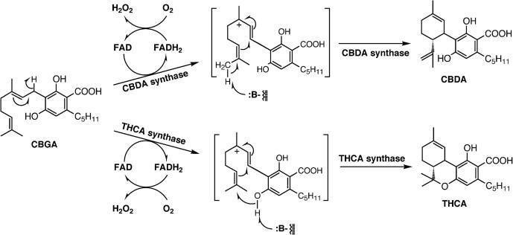
The reaction mechanisms of CBDA synthase and THCA synthase. Two electrons from the substrate [CBGA] are accepted by enzyme-bound FAD cofactor, and then transferred to molecular oxygen to re-oxidize FAD. CBDA and THCA are synthesized from the ionic intermediates via stereo-selective cyclization by the enzymes.
R, the rest of the FAD molecule.
B, the proposed basic residue of the enzyme.

…Back to August Dunning's Theory:
"The photo-morphogenesis of pCBs are strictly dependent on divalent ions of mineral elements such as ferrous (Fe++) for cannabidiol (CBD) and manganese (Mn++) for tetrahydrocannabinol (THC). These act as the mineral substrates {?} that deform the synthase molecules that drive the metabolic reactions cannabidiolic acid (CBDA) to CBD and tetrahydrocannabinolic acid (THCA) to THC. {in fact the oxidocyclization of CBGA to THCA, CBDA or CBCA}.
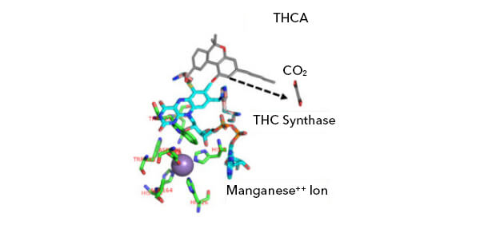
These mineral elements, in combination with irradiation by ultraviolet (UV) light, are necessary for the conversion of the acid forms into the active compounds in late-phase, high-PPFD lighting [600-plus nanometers (nm)], though not as currently thought. In this final phase of growth, the ultraviolet B (UVB) input will lead up to the strength of weed. In University of Maryland studies of indoor-grown cannabis sativa with no UVB compared to plants provided with equatorial sun levels of 385 nm UVB {actually UV-A!} had a 33 percent increase in THC levels. There was no increase in CBD. But 385 nm is not UVB. The UV light used in the university’s testing was at the upper range of UVA, which was why there was no increase in CBD. This is why growers, not lab workers, are better suited to conduct these studies.
Ultraviolet B has wavelengths measuring 280-315 nm. Some level of photosynthesis occurs in this range and although the high PPFD of this frequency is somewhat damaging to a plant’s photosynthesis process, this is not the objective. Protein activation is the objective, and the cannabis plant is protected by a protein called UVR8 in the disc cells of the trichome. This protein is a dimer protein, meaning that it is a combination of two mirror-image structural proteins. A key region of the UVR8 dimer structure is the interface where the two monomers are in contact. This interface is rich in aromatic and charged amino acids that are crucial for both the structure and photoreceptor function of UVR8. When irradiated with UVB, it splits apart and is attracted to the gene plastids in the leucoplasts of the glandular trichomes [GTs] to stimulate cannabis’s production of chemicals via the MEP pathway for terpene synthesis and the polyketide pathway, specifically malonyl-CoA. Why is this important? Because cannabis uses the MEP pathway for the synthesis of geranyl diphosphate (GPP) and malonyl-CoA in the polyketide pathway to make olivetolic acid (OLA). This reaction is catalyzed by a recently discovered polyketide synthase (PKS) enzyme and an olivetolic acid cyclase (OAC). The geranylpyrophosphate[GPP]-olivetolate geranyltransferase catalyzes the alkylation of OLA with GPP leading to the formation of CBGA, the central precursor of various cannabinoids. Many growers believe it is the UVB hitting the cannabinolic compounds in the trichome secretory reservoir that cause the acid conversion, but, in reality, UVB is the genetic activating frequency of light that stimulates the production of these compounds in the colorless, non-photosynthesis leucoplasts of the disc cells to create the chemistry for later enzymatic conversion of acid forms into active neutral forms. The secretory cavity may play a role where it may act as a lens directing UVB to the disc cells at the base of the trichome reservoir to focus the light to where the UVR8 photoactivation takes place. The disc cell ring is where the terpenoids are created and combined with the cannabinoids created from the alkylation of OLA and GPP and found thereafter in the secretory chamber to undergo metabolic conversion by the action of the synthase molecules and micronutrient ions provided by foliar spray or root treatment. This is seen as the secretory chamber turning from clear to cloudy. It’s in the trichome head where the micronutrient substrate ions attract the synthase molecules to deform them so that they can convert the acid forms. This interaction transfers electron charge potential to defeat the carbon dioxide molecular bond on the THCA or CBDA to elevate the bond energy to break the bond and release the carbon dioxide to complete the process of converting acids to active compounds. Sunlight provides this, but weather variability can affect the final product. Indoor growing is a more reliable way to provide the optimal UVB during growth if the lighting is correct. Ultraviolet B is already generated by the mercury found in all high-intensity discharge (HID) light sources, but it’s typically blocked by the bulb’s outer glass jacket. Richard Feynman utilized this knowledge to observe the first atomic bomb test, the Trinity Test, carried out inside a car, without protective goggles, using the glass windshield to protect his retinas from the UVB in the initial flash of the explosion. Ordinary glass blocks more than 90 percent of UVB radiation, so UVB levels will naturally be higher using open fixtures without a glass lens, but the bulbs still have glass jackets. There are lighting systems that are designed to generate ultraviolet in the UVB range. The absence of UVB does not eliminate THC production, but rather reduces the output. It does, however, limit or stop CBD production as seen in the tests at the University of Maryland from the use of the incorrect UV frequency {UV-A} in their tests. I used to use a UVB fluorescent tube from a tanning bed during my guerilla growing days in the past, but now better lights [LED] are on the market".
However, as will be discussed in the next chapters – the results of the single study from the University of Maryland were later questioned.
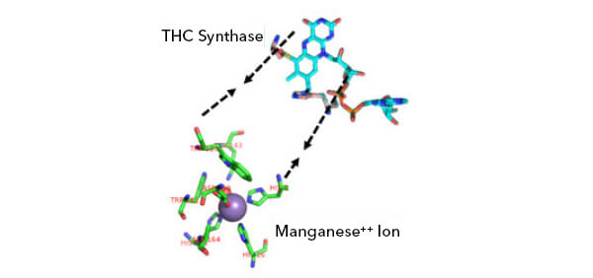
Another recent article of A. Dunning:
How Minerals and Light affect
Terpene Production (2021)
By August Dunning
Published: February 28, 2019 | Last updated: May 25, 2021
Our olfactory sense is hardwired to our immune system. If a fragrance produced by a strain is particularity pleasing, there might be a reason. Fragrance can be a means for identifying strains for medical application, not just recreation. When we’re sick with a cold, we identify certain fragrances, like lemon, for example, to bring us relief. We evolved with this plant to ultimately be able to incorporate the plant cannabinoid compounds in our endocannabinoid [eCB] receptor system {?}.
Cannabinoid (CBD ?) {phytocannabinois} interact with the body’s organs, nerves, and CB1, 2, and 3{?} receptor sites in the brain to mitigate conditions of pain and anxiety and establish a means for the terpenes to get into cells to perform medical functions far greater than sedation or elation, like slowing cancer cells. It’s not the CBD [pCB] that attacks cancer — the CBD opens the cells in a tumor for terpenes to get inside cells to end replication in cancer cells without poisoning the body. With growth halted, the tumor may die.
This is why terpenes are more important than previously thought. It has been proven that terpenes can get inside different types of cancer to stop replication.
Cannabinoid [pCBs] ratios differ greatly in the various strains of weed and are associated with the production of terpenes. High-CBD strains produce high levels of myrcene as CBD synthase converts cannabigerol (CBG) into CBD and the associated terpenes {?}. High-THC strains produce large levels of limonene and pinene as the THC synthase converts tetrahydrocannabinolic acid (THC-A) into THC, tetrahydrocannabivarin (THC-V) {?}, and cannabichromine (CBC) {?}.
These terpenes are mineral dependent for their production in trichomes, so let’s discuss the metal ions necessary for terpene production along with the light frequencies involved for synthesis, as well as those involved with terpene emittance {?} and storage in flowering cannabis. Something many growers are not aware of is that the final fragrance of weed can be made stronger in the last 72 hours before harvest and curing {?}.
Ultraviolet-B is required during flowering phase to stimulate genetic plastids in the trichome disc cells [DCs] to create enzymes required for terpenes and cannabinoid synthesis.
But there are other photosynthetic processes in the phytochromes that can be employed to mediate light/dark signaling that increase terpene content and production.
First off, several metal ions are necessary since most terpene cyclases require a divalent ion such as magnesium (Mg2+) or manganese (Mn2+) for the cyclization of substrates. They are also necessary for THC-A conversion to THC by THC synthase {?}. Moreover, all terpene cyclases, including limonene synthase, require either Mg2+ or Mn2 +.
To explain the roles of Mg2+ and Mn2+ in terpene cyclization, it has been proposed that these metal ions might neutralize the negative charge of the diphosphate moiety and assist in ionization of the allylic diphosphate substrate to create the geranyl diphosphate terpene precursor molecule.
What is clear, however, is that divalent metal ions Fe (iron) and Mn (manganese) have been shown clearly in dispensary bud tests to affect levels of THC and CBD because deficiencies of Mn2+ (for THC) and Fe2+ (for CBD) in fertilizers during growth directly affect synthesis of THC and CBD".
S-limonene synthase is a model monoterpene synthase that cyclizes geranyl pyrophosphate (GPP) to form S-limonene. It is a relatively specific enzyme as the majority of its products are composed of limonene.
Limonene biosynthesis
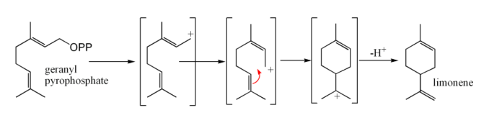
Monoterpene synthases catalyze the first committed step in the biosynthesis of monoterpenes and are in part responsible for the enormous structural diversity among this class of metabolites.
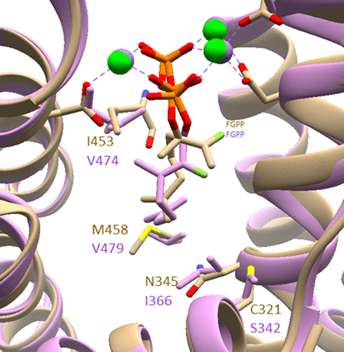
Active site of Limonene synthase
{Metal atoms are shown in green balls?]
Genes that showed similarity to metallothionein-encoding genes were also strongly expressed, accounting for 56 sequences. Metallothioneins are small, cysteine rich proteins that are known from both plants and animals. They function in metabolizing heavy metal ions and by this means protect organisms from free radical and toxic metal damage. Our finding is consistent with the hypothesis that trichomes function in detoxification processes in plants. A high expression of metallothioneins was found to occur on trichomes of Arabidopsis and Vicia.
In genetics, an expressed sequence tag (EST) is a short sub-sequence of a cDNA sequence. ESTs may be used to identify gene transcripts, and were instrumental in gene discovery and in gene-sequence determination. The identification of ESTs has proceeded rapidly, with approximately 74.2 million ESTs now available in public databases (e.g. GenBank 1 January 2013, all species). EST approaches have largely been superseded by whole genome and transcriptome sequencing and metagenome sequencing.
The importance of detoxification for trichomes is further supported by the relatively high abundance of enzymes of the glutathione metabolism (i.e., 20 glutathione transferases and peroxidases) in our EST dataset.
Several of the known enzymes from the pathways leading to bitter acids and prenylflavonoids were detected in the EST dataset. Ten ESTs representing vps were found in the library, and six sequences corresponding to chs_h1 were detected. Surprisingly, chs2 was the most highly represented type III polyketide synthase in the EST dataset, with 18 copies, while only one transcript of chs4 was found. This finding is noteworthy because chs4 was shown to be specifically expressed in hop glandular tissue, while chs2 is also expressed in leaves. No cDNA corresponding to chs3 homolog was found in the library, a fact that is in accordance with the finding that chs3 seems to be disrupted in most of the tested hop cultivars and that it probably is a pseudogene.
An intriguing result was the high number of putative chalcone isomerases (CHIs), which accounted for 3.2% of all ESTs in the library. The CHI-like sequences clustered into 3 contigs and one singleton. Two large contigs are most similar to a putative CHI from tomato, whose expression was shown to be up-regulated in a mutant of the anthocyanin biosynthesis pathway. The predicted hop CHI-like proteins do not possess the conserved residues important for catalysis and substrate binding in CHI. Considering that the prenylflavonoids such as xanthohumol are chalcones, and, therefore, do not require CHI for enzymatic isomerization to flavanones, the function of these hop proteins in hop is not easily discernible. A non-catalytic role for CHI-like proteins has been hypothesized.
Almost all of the enzymes of the MEP pathway, which leads to the formation of IPP and DMAPP, were present in the EST library. The exception to this was the cDNA encoding CDP-ME synthetase (IspD). The MEP pathway also supplies building blocks for monoterpene biosynthesis, and these enzymes participate in essential oil biosynthesis in hop. Several terpene synthase like sequences were detected. Despite the fact that there are several steps in the biosynthesis of hop terpenophenolics that require the transfer of one or more molecules of DMAPP, only one cDNA with similarity to a prenyltransferase was identified in the library. The protein sequence was predicted to contain transmembrane regions by topology prediction programs. This contradicts experiments with hop cone protein extracts, which detected activity in the soluble protein fraction. This cDNA is therefore an unlikely candidate for the aromatic prenyltransferase involved in bitter acid and prenylflavonoid biosynthesis.
To date, no enzyme catalyzing the methylation step in the biosynthesis of xanthohumol has been identified. We consider methylation of the xanthohumol precursor, which contributes to the stabilization of the chalcone, a key step in this pathway. We found 18 ESTs in the hop trichome EST dataset that were annotated as O-methyltransferases, which clustered into four contigs and one singleton. None of the hop enzymes was particularly close in sequence to known chalcone O-methyltransferases of legumes. Further experiments to identify the enzyme assay reaction products and to biochemically characterize these O-methyltransferases from hops are underway.
Transcription factors accounted for a significant number of the ESTs. However, the MYB transcription factor that has been suggested to be involved in hop cone development and the regulation of terpenophenolic biosynthesis was not present.

…Back to August Dunning's hypothesis:
Red Light and Terpene Potency
"As shown earlier, CBD and THC levels are strongly related to mycrene and limonene production. Everything is tied to adequate micronutrient minerals and specific light frequencies to form cannabinoids and terpenes. However, some frequencies that are eliminated at the end of growth can produce very strong terpene potency and subsequent highly fragrant dried buds.
Several light-sensitive photoreceptors outside the trichomes are involved in the processes of production and emission {evaporation?} of terpenes, and different trichomes are dependent upon specific wavelengths of light to be activated or deactivated. Emission of terpenes is a process that is entirely dependent upon phytochromes and red and far-red light cues in most plant species. This is especially useful for growers using LED systems because it has been proven that if red LED light is eliminated during the last 72 hours of growth and only white and blue LEDs are used, the plant continues to synthesize terpenes, but a lack of red light to trigger the phytochrome results in a lack of terpene emission by the plant. This causes the terpenes to accumulate in the maturing trichomes.
"The good news is that eliminating red light at the end of a flowering cycle has almost no effect on the final cannabinoid content of dried and cured buds. For stronger fragrance, medical potency, and higher commercial value of your buds, cut out red light 72 hours prior to harvest".
Mr. A. Dunning is a brilliant, self-educated Cannabis grower that sometimes expresses strange hypothesis. His suggestion that heavy metals atoms cause decarboxylation of acid cannabinoids to their neutral forms is not valid. Only heat turns THCA to THC.
Nevertheless, the effect of Iron, Manganese & Magnesium on THCAS, CBDAS & CBCAS activities as oxidocyclases should be further evaluated.
One scientist discovered a new phenomenon but was mistaken about the implication of his discovery. Others [Peer Reviewers] will use the initial part of the hypothesis [metal ions increase decarboxylation of acid pCBs] and add the correct explanation [activation of oxidocyclases].
Hypothesis: The heavy metal ions affect the efficiency of the FAD cofactor inside pCB biosynthetic enzymes.
Our Main Suggestions at V.V. are:
In order to reduce THCA synthesis:
Chelation of Mn++ (& Mg++) by EDTA
Ethylenediaminetetraacetic acid (EDTA) is an aminopolycarboxylic acid with the formula [CH2N(CH2CO2H)2]2. This white, water-soluble solid is widely used to bind to iron and calcium ions. It binds these ions as a hexadentate ("six-toothed") chelating agent. EDTA is produced as several salts, notably disodium EDTA, sodium calcium edetate, and tetrasodium EDTA.
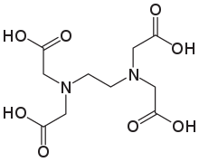
In industry, EDTA is mainly used to sequester metal ions in aqueous solution. In the textile industry, it prevents metal ion impurities from modifying colors of dyed products. In the pulp and paper industry, EDTA inhibits the ability of metal ions, especially Mn2+, from catalyzing the disproportionation of hydrogen peroxide, which is used in chlorine-free bleaching. In a similar manner, EDTA is added to some foods as a preservative or stabilizer to prevent catalytic oxidative de-coloration, which is catalyzed by metal ions. In soft drinks containing ascorbic acid and sodium benzoate, EDTA mitigates formation of benzene (a carcinogen).
The reduction of water hardness in laundry applications and the dissolution of scale in boilers both rely on EDTA and related complexants to bind Ca2+, Mg2+, as well as other metal ions. Once bound to EDTA, these metal complexes are less likely to form precipitates or to interfere with the action of the soaps and detergents.
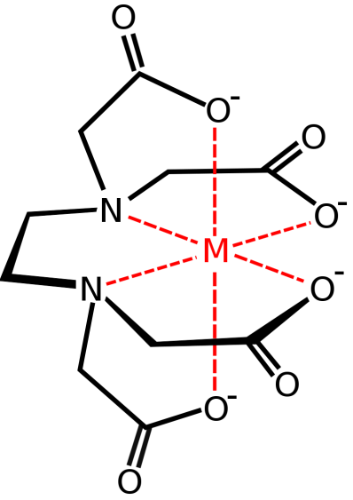
Sodium calcium edetate, an EDTA derivative, is used medically in humans to bind metal ions in the practice of chelation therapy, such as for treating mercury and lead poisoning. It is used in a similar manner to remove excess iron from the body. This therapy is used to treat the complication of repeated blood transfusions, as would be applied to treat thalassaemia.
In coordination chemistry, EDTA4− is a member of the aminopolycarboxylic acid family of ligands. EDTA4− usually binds to a metal cation through its two amines and four carboxylates. Many of the resulting coordination compounds adopt octahedral geometry. Although of little consequence for its applications, these octahedral complexes are chiral. The cobalt(III) anion [Co(EDTA)]− has been resolved into enantiomers. Many complexes of EDTA4− adopt more complex structures due to either the formation of an additional bond to water, i.e. seven-coordinate complexes, or the displacement of one carboxylate arm by water. The iron(III) complex of EDTA is seven-coordinate. Early work on the development of EDTA was undertaken by Gerold Schwarzenbach in the 1940s. EDTA forms especially strong complexes with Mn(II), Cu(II), Fe(III), Pb(II) and Co(III).
Several features of EDTA's complexes are relevant to its applications. First, because of its high denticity, this ligand has a high affinity for metal cations:

Environmental fate
Abiotic degradation
EDTA is in such widespread use that questions have been raised whether it is a persistent organic pollutant. While EDTA serves many positive functions in different industrial, pharmaceutical and other avenues, the longevity of EDTA can pose serious issues in the environment. The degradation of EDTA is slow. It mainly occurs abiotically in the presence of sunlight.
The most important process for the elimination of EDTA from surface waters is direct photolysis at wavelengths below 400 nm. Depending on the light conditions, the photolysis half-lives of iron(III) EDTA in surface waters can range as low as 11.3 minutes up to more than 100 hours. Degradation of FeEDTA, but not EDTA itself, produces iron complexes of the triacetate (ED3A), diacetate (EDDA), and monoacetate (EDMA) – 92% of EDDA and EDMA biodegrades in 20 hours while ED3A displays significantly higher resistance. Many environmentally-abundant EDTA species (such as Mg2+ and Ca2+) are more persistent.
Biodegradation
In many industrial wastewater treatment plants, EDTA elimination can be achieved at about 80% using microorganisms. Resulting byproducts are ED3A and iminodiacetic acid (IDA) – suggesting that both the backbone and acetyl groups were attacked. Some microorganisms have even been discovered to form nitrates out of EDTA, but they function optimally at moderately alkaline conditions of pH 9.0–9.5.
Several bacterial strains isolated from sewage treatment plants efficiently degrade EDTA. Specific strains include Agrobacterium radiobacter ATCC 55002 and the sub-branches of Proteobacteria like BNC1, BNC2, and strain DSM 9103. The three strains share similar properties of aerobic respiration and are classified as gram-negative bacteria. Unlike photolysis, the chelated species is not exclusive to iron(III) in order to be degraded. Rather, each strain uniquely consumes varying metal–EDTA complexes through several enzymatic pathways. Agrobacterium radiobacter only degrades Fe(III) EDTA while BNC1 and DSM 9103 are not capable of degrading iron(III) EDTA and are more suited for calcium, barium, magnesium & manganese(II) complexes. EDTA complexes require dissociation before degradation.
Our goal in V.V. Research Group is to treat the industrial hemp plant with EDTA making sure the chelated complex will be fully degraded and will not hurt the environment.

In order to increase CBDA production:
Foliar Fe++ Spray
Foliar plant feeding is an effective way to add metals [such as Iron] to living plants.
Foliar fertilization for biofortification is a targeted, economic and environment friendly approach rather than soil fertilization. In this study, we identified the appropriate growth stage(s) and right foliar iron (Fe) formulation in enhancing growth and Fe biofortification in soybean. In addition, we studied the physiological mechanism adopted by plants to endure foliar supplied Fe. For this purpose, a field experiment was conducted to evaluate various organic and inorganic Fe formulations such as Fe-citrate, FePO4, humic acid (HA) + Fe, HA alone and nano-Fe along with control (deionized water) in soybean (Glycine max var. DS-2614). Plants were sprayed at flowering (Set I), pod filling (Set II) and at both stages (Set III). Biomass and leaf area were significantly enhanced with application of Fe-citrate and FePO4 followed by HA + Fe. The yield traits (pod number, seed yield, test weight) significantly increased with HA + Fe and nano-Fe application. Enhanced Fe accumulation in seed was observed with HA + Fe followed by Fe-citrate and nano-Fe treatment. Foliar application of Fe at pod filling stage improved growth whereas yield and Fe fortification improved in Set III {mature plants}. This response may be attributed to enhanced activities of antioxidant scavenging enzymes and reduced lipid peroxidation in leaves treated with HA + Fe followed by FePO4. Results suggest foliar application of HA + Fe (organic Fe) and nano-Fe to be promising for soybean in improving growth and seed Fe content.
If a rapid response is needed to correct a chlorotic condition, a foliar spray with iron sulfate or iron chelate solution may be applied when the tree is in full leaf. A rate of five pounds iron sulfate in 100 gallons of water (2.5 ounces iron sulfate in three gallons water) is recommended.

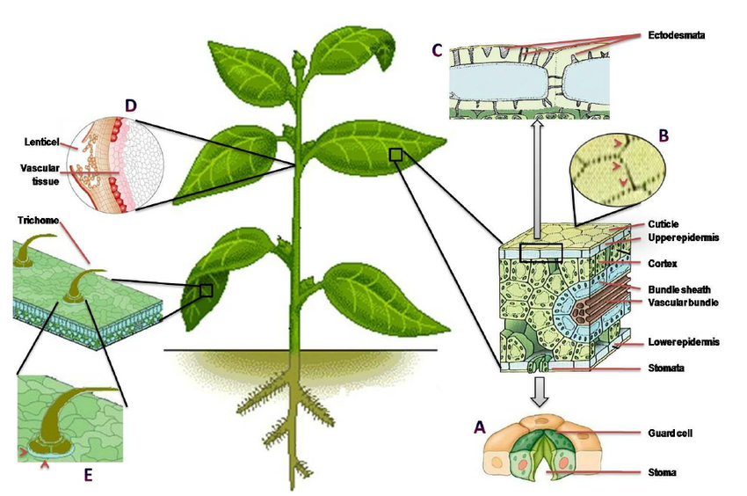
Chelated liquid Iron in water
Chelated Liquid Iron is water soluble iron, supplied as a liquid that the plants in your yard can easily and effectively make use of.
FOLIAR FEEDING GUIDE FOR CANNABIS PLANTS (2021)
Foliar Feeding Guide for Cannabis Plants
Not to be confused with foliar spraying which is basically the same but refers to any solution that can be sprayed, generally used to deal with bug-infested plants by applying an insecticide or fungicide via foliar spray, foliar feeding consists of delivering macro and micronutrients to your plants by spraying the nutrient solution directly onto the leaves, resulting in healthier leaves and allowing you to fix nutrient deficiencies faster.
WHAT IS FOLIAR FEEDING AND FOLIAR SPRAYING?
Foliar feeding involves spraying the leaves, instead of watering the soil, with a nutrient solution and it’s a quick and effective way to deal with nutrient deficiencies, this happens because the leaves can absorb nutrients much faster than the roots, although they’re limited by the size of the stomata, unlike the roots. Foliar feeding became popular in the 1950s when researchers at Michigan State University found that the leaves are a super-efficient organ of absorption. While the amounts they can absorb are relatively small when compared to watering the substrate, the efficiency is higher, reaching about 95%.
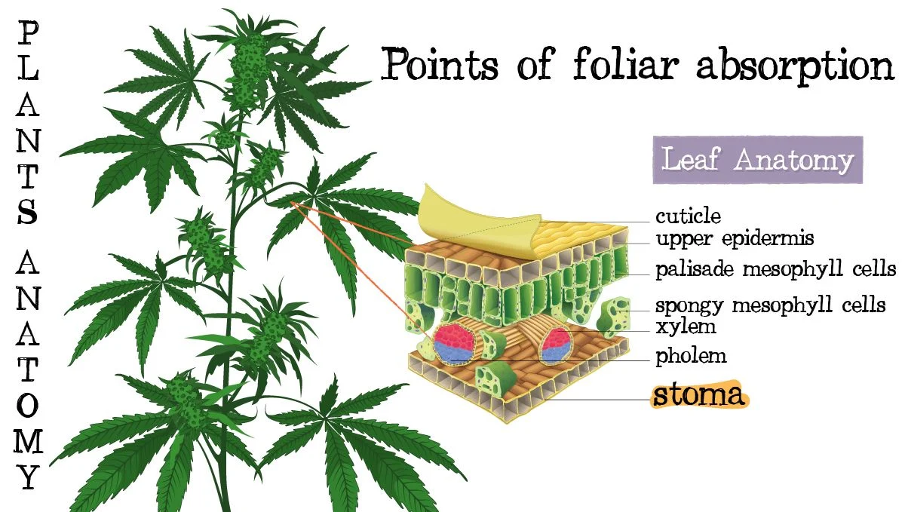
Foliar feeding guide: plant anatomy
It's through the stomata that the leaves absorb foliar sprays.
FOLIAR SPRAYING
Apart from foliar feeding, there’s also foliar spraying which is basically the same method as foliar feeding but it’s used to apply fungicides or insecticides to combat mold, bugs or diseases. There isn’t really a difference between foliar feeding and foliar spraying besides why you’re using it and the frequency you should apply the solution, both of them are basically foliar sprays but one is used to feed your plants while the other is used to combat bugs or mold.
WHEN IS THE BEST TIME TO FOLIAR SPRAY OR FOLIAR FEED?
If you’re growing outdoors, the best time for foliar spraying or feeding is early in the morning or late in the evening because this is when the plant’s pores are fully open; If you’re growing indoors, the best time to spray your plants is 1-2 hrs before the lights turn off or 1-2 hrs before the lights turn on, this is due because at this time the plant’s pores are fully open, which allows for a quicker absorption when compared to spraying during the day (or when the lights are on.
The best time to foliar spray is 1-2 hrs before the lights turn off or 1-2 hrs before the lights turn on.
Keep in mind that it’s not recommended to foliar spray when your plants are getting direct sunlight because, due to the “lens effect” caused by the water droplets, the light can end up burning the leaves and may degrade the nutrients or substances in the solution.
WHEN YOU SHOULD FOLIAR SPRAY
As mentioned, foliar feeding cannot substitute soil applications but under certain conditions, it may have an advantage over regular feeding and there are three main scenarios.
LIMITED NUTRIENT ABSORPTION
Foliar feeding is recommended when something is limiting nutrient absorption by the roots, this may happen when the soil’s pH is high or low, temperature stress, high or low soil moisture, root diseases or a pest infestation that can affect nutrient uptake.
For example, nutrient availability in the soil is reduced when the soil’s pH is too high or too low, so under this condition, foliar feeding might be the best way to deal with this until you can fix the pH.
NUTRIENT DEFICIENCIES
Foliar spraying is a great way to deal with nutrient deficiencies due to the fast absorption, as mentioned, the leave’s nutrient absorption can be as high as 95% which is 8-9 times higher than the root’s absorption efficiency, making it a quick (but temporary) way to deal with nutrient-deficient plants.
FOLIAR FEEDING STIMULANTS AND GROWTH BOOSTERS
Besides providing macro and micronutrients, stimulants and growth boosters will also help the leaves and branches grow healthier, and provide the extra boost your plants need which can improve plant strength, yield, and quality (dense flowers).
FOLIAR SPRAYING AGAINST INSECTS AND MOLD
Foliar sprays are the best way to deal or prevent pests and diseases such as spider mites and powdery mildew. One of the most popular substances used is Neem oil which acts both as treatment and prevention while having the advantage of being 100% natural and also having fungicidal properties.
A lot of growers use Neem oil or similar products and sometimes mix it with aloe Vera juice and an emulsifier like potassium silicate to dissolve the oil and make it easier for the plants to absorb; By applying a solution like this one week during the vegetative stage can result in stronger plants and increase resistance against diseases and pests, but its use it’s not recommended during the flowering stage because it can affect the flavor and aroma of the buds.
Also, a foliar spray made with insecticidal soap such as potassium soap is an excellent way to take care of harmful bugs, and it’s particularly effective against aphids which are very common in cannabis. This means that mixing different products can result in an even more effective solution, for example, mixing Neem oil and potassium soap can get rid of bugs and also prevent future attacks.
Have in mind that you’re not limited to just Neem oil and potassium soap, there are a lot of natural ingredients such as cayenne pepper, cinnamon oil, and garlic which can combat pathogens and insects without harming your plants and, if you don’t want to make your own mix, you can definitely find a natural solution in your local grow shop.
THE LIMITATIONS OF FOLIAR SPRAYING
Now that you know the best time to foliar spray and when to do it, it’s time to know its limitations because despite the high efficiency and quick absorption, foliar spraying has its downsides too and they are:
LIMITED NUTRIENT DOSE
Nutrients applied via foliar spray will not provide the entire nutrient dose your plants need so you will have to water the substrate with a nutrient solution in order to meet the entire nutrient requirements.
LEAF BURN (AKA PHYTOTOXICITY)
Applying a strong nutrient solution via foliar spray can result in leaf burn due to the water evaporating and leaving the nutrients on the leaves.
COST AND APPLICATIONS
In order to avoid leaf burn, for example, you will have to foliar spray smaller nutrient doses more often which is impractical and can cost more than regular feeding.
WHAT TYPE OF SPRAYER SHOULD I USE?
There are two main types of sprayers used for foliar spraying and both are useful depending on the situation. The first type is the regular hand sprayer that you can easily find everywhere, this type can take between 500 ml to 11 L of solution and are small yet handy sprayers that will work great if you need to spray just a couple of plants or need to be more precise and not spray the buds.
The second type is pump sprayers which can be a bit harder to find but are super convenient because it usually comes with a “sprayer wand” which allows you to spray your plants from all sides without much effort.
HOMEMADE FOLIAR SPRAY RECIPES – For Organic Cannabis Growers
In case you don’t want to spend but still want to take advantage of the benefits of foliar spraying and foliar feeding, here are a couple of natural homemade recipes to help you get the best results:
NATURAL GROWTH STIMULANT RECIPE
For this natural growth stimulant you will need:
10 g of Kelp meal, 0.5 g of liquid Silica (optional)
5 g of Aloe Vera juice, 5-10 g of Alfalfa meal (optional)ץ
Soak 10 grams of Kelp meal in 1 liter of water for around 3-5 days; Kelp meal contains almost every macro and micronutrient your plants need as well as organic PGR’s (plant growth regulators). Once 3-5 days pass, add 5 grams of Aloe Vera juice which works as a surfactant and also contains many micronutrients, mix well and the foliar spray is ready for use. You can also add 0.5 grams of liquid silica to the spray which will help strengthen the cell walls, resulting in stronger branches and increasing resistance to pests and diseases. Alfalfa meal is another great option because it contains Triacontanol which is another growth stimulant. Keep in mind that this recipe should be used when the lights turn off and you should stop using it 2-3 weeks before your plants enter the pre-flowering stage.
NATURAL INSECTICIDE RECIPE
If you’re dealing with a bug infestation or want to prevent one, here’s a great recipe, You’ll need:
100% natural Neem oil; Peppermint oil, castile soap; and warm water.
Fill a sprayer with 1 L of warm water, add 0.6-1 ml of castile soap and gently mix the solution. Once the solution is properly mixed, add 1 teaspoon of Neem oil, then close the sprayer and shake until the Neem oil is combined. Once the soap and oil are properly combined the mixture is ready for use, just remember to always shake the bottle before spraying. If you’re dealing with a bug infestation, spray once a week until the bugs are gone and if you’re using it as a prevention measure, spray every 2 weeks, remember that you should not spray the buds!
NATURAL FUNGICIDE RECIPE
If instead of dealing with bugs (or preventing them) your goal is to get rid of mold, here’s what you’ll need:
Ingredients:
1 L of warm water 1 ml of Rosemary oil 3.5 ml of 100% natural Neem oil 0.6-1 ml of castile soap 1 ml of Peppermint oil 3.5 ml of olive or almond oil.
The process is basically the same as the recipe mentioned before with the exception of the extra ingredients. So first of all, fill the sprayer with warm water then add the castile soap and gently stir. Once the soap is mixed in, add the rosemary oil, peppermint oil, neem oil, and olive or almond oil and shake until everything is well combined and the spray is ready. This foliar spray’s use is the same as the one mentioned before, so remember, spray once every 7 days if you’re fighting mold and once every 14 days as a preventive measure but never apply this foliar spray on the buds because it will alter their taste and aroma.
7. TOP TIPS TO IMPROVE THE EFFICIENCY OF FOLIAR SPRAYING
There are several factors that can affect the effectiveness of foliar feeding or foliar spraying, so it’s important you keep the following factors in mind in order to foliar spray more effectively:
DON’T FORGET ABOUT SURFACTANTS
Surfactants are compounds that can act as wetting agents that help a liquid spread more easily and when talking about foliar sprays, they contribute to a more uniform coverage of the leaves while also increasing the retention so, in order to avoid wasting any product that you wish to apply as a foliar spray, it’s highly recommended to mix a surfactant into the solution.
FIND THE BEST TIME OF THE DAY
Avoid spraying when it’s too hot or too cold. As mentioned, it’s not recommended to foliar spray when the plants are getting direct sunlight but you also have to have the temperature in mind, so never spray when the temperature is above 26°C.
In hot temperatures the pores [stomata] on the leaves will be almost closed, making foliar sprays less effective and, when it’s too cold, foliar sprays may promote mold so it’s recommended that you spray a couple of hours before the lights are on or a couple of hours before the lights are off; It can also be a good idea to turn off the fans for an hour or two for your plant to better absorbs the solution.
When growing outdoors, do not spray if you’re expecting rain or strong wind because it can wash away the spray solution, so make sure the weather is fine or wait for the stormy weather to pass to avoid any major disturbances.
SPRAY WITH THE APPROPRIATE DROPLET SIZE
You should use a nozzle that sprays medium-sized droplets to cover a larger area and increase efficiency; this means that if you want to improve efficiency, the droplets should not be smaller than 100 microns or bigger than 175 microns. [100-175 microns].
ALWAYS FOLLOW THE MANUFACTURER'S INSTRUCTIONS
Some commercial products may be safer to use than others so always follow the guidelines to avoid harming your plants. Also, make sure that you use protection such as gloves, mask, and eye gear if needed. You should also make sure that the product is safe for consumption because some products may be safe for ornamental plants but may not be safe for consumption.
ADJUST THE PH OF THE FOLIAR SPRAY SOLUTION
Nutrients in the foliar spray must be in their soluble form for the plant to be able to absorb them and the pH not only affects the nutrients’ solubility but also their interaction with other components of the water, so it’s essential you adjust the pH of the solution. According to the nutrients or substances it contains.
CONCLUSION
Foliar spraying your cannabis plants can be a great way to combat mold, bugs and pathogens, and it’s also a great way to correct minor nutrient deficiencies.


Suggested product to use in our experiments
Dyna Green Organics Iron is a liquid foliar formulation designed to correct and prevent iron deficiencies in most crops. If added to the spray tank first, it will aid in lowering the water pH. The addition of a non-ionic surfactant will aid in uptake. Do not use this product in aerial applications in combination with Magnesium nitrate on spinach or other iron-sensitive crops. Application of only Iron at: 1 to 2 pints per acre.
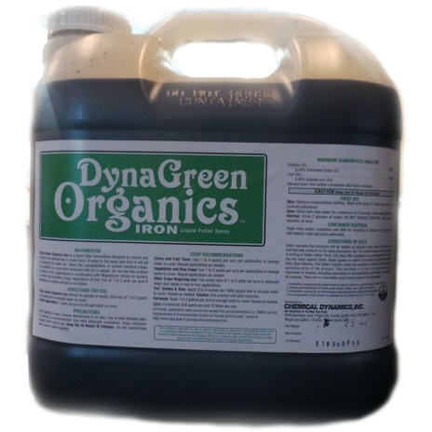
Summary
Adding Fe++ to Hemp plants by foliar spray will increase the expression of CBDAS, causing the production of a lot of CBDA.
Chelating Mn++ (or Mg++) by EDTA will inactivate THCAS as a result of the interaction with the FAD cofactor. Inactivating THCAS will cause the reduction of THCA content in industrial hemp under 0.2% - the legal limit in the USA & Europe.
Suggested Experimental Design for V.V. R&D
In an organic outdoor Hemp farm, we'll create few experimental groups of identical plants [n= 100]: A. Control, untreated; B. Iron Foliar spray during vegetative stage; C. Iron Foliar spray during flowering stage; D. EDTA-treated during vegetative stage; E. EDTA-treated during flowering stage.
All experimental groups will be grown in identical field conditions. We'll leave an empty ground between the groups.
After harvest, we'll analyze phytocannabinoid acids content (especially THCA & CBDA) by means of HPLC assays.
Hopefully the Iron treatment will increase CBDA content, while EDTA treatment (that removes Manganese from the plant tissues) will reduce the concentrations of THCA.

Cannabis Domestication
From a DNA analysis, researchers build phylogenetic trees that show the relationships between and evolution of four genetically distinct groups of cannabis:
Basal cannabis — This group is “sister to all other cannabis” categories, including all human-grown or “cultivated” hemp and psychoactive cannabis in the world. It includes wild plants and traditional cannabis hybrids, known as “landraces,” found in modern China.
Hemp — This group includes all hemp varieties found around the world. Hemp is a variety of Cannabis sativa that is distinguished from other cannabis strains by its lower levels of tetrahydrocannabinol (THC) — the psychoactive ingredient that makes cannabis such a potent drug. Hemp, unlike its psychoactive counterpart, is not typically considered a drug and was traditionally used to make fiber for clothing and other materials.
The first group of “drug” cannabis — This group includes wild strains of cannabis with drug-like properties similar to marijuana from China, India, and Pakistan, as well as one cultivated cannabis variety from India.
The second group of “drug” cannabis — This group includes varieties of cannabis with drug-like properties that have been cultivated around the world.
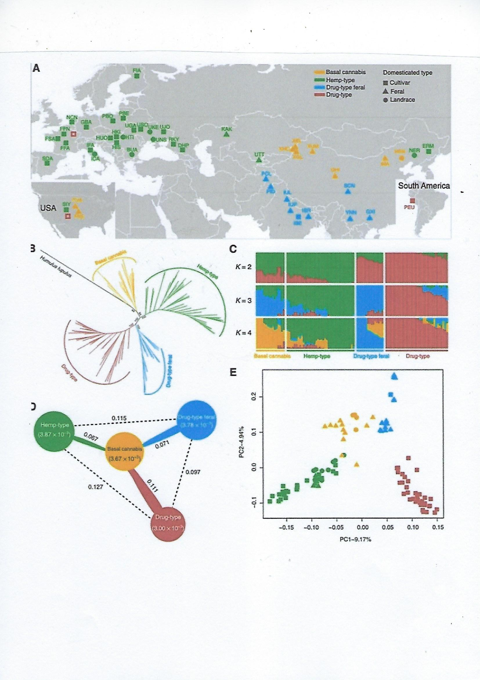
Map of cannabis distribution
A map from the study showing the historical distribution of different groups of cannabis around the globe.
Humulus --> Basal cannabis Hemp Drug group 1 Drug group 2
Ozonization of THCA & THC
Ozone breaks down THC deposited on surfaces from third-hand cannabis smoke
American Chemical Society December 2, 2020
Aaron Wylie and Jonathan Abbatt
Researchers have discovered that ozone -- a component of outdoor and indoor air -- can react with tetrahydrocannabinol (THC), the psychoactive component of cannabis, on glass or cotton surfaces to produce new compounds, which they characterized for the first time.
Second- and third-hand tobacco smoke, have received lots of attention, but much less is known about the compounds deposited on surfaces from cannabis smoke. Now, researchers reporting in ACS' Environmental Science & Technology have discovered that ozone -- a component of outdoor and indoor air -- can react with tetrahydrocannabinol (THC), the psychoactive component of cannabis, on glass or cotton surfaces to produce new compounds, which they characterized for the first time.
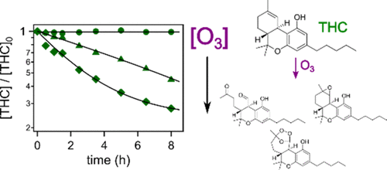
Smoking emits reactive chemicals that remain in the air (so-called secondhand smoke) or deposit onto surfaces, including walls, windows, clothing and upholstery (third-hand smoke). Unlike the secondhand variety, thirdhand smoke lingers long after a person stops smoking. Nicotine is semi-volatile and reacts with other chemicals on surfaces, producing new compounds that, if volatile, can also become airborne. Because cannabis smoke is chemically distinct from tobacco smoke, wanted to characterize the compounds formed when THC, by itself or in cannabis smoke, on surfaces reacts with ozone in the air.
The researchers coated glass and cotton cloth, to simulate windows and clothing, with a THC solution. Then, they exposed the surfaces to concentrations of ozone that could exist in indoor air [100 ppm]. In their analysis, they found that over time, the amount of THC on glass and cotton decreased, while the quantities of three THC oxidation products increased. In other experiments, the team used a smoking machine to deposit cannabis smoke onto cotton. Upon exposure to ozone, the same three compounds formed at roughly the same rate as observed for the THC-coated cloth. Because of the low volatility of THC and its oxidation products, the compounds are unlikely to be emitted to the air where they could be inhaled in as large amounts as nicotine, the researchers say. They say that somebody could still be exposed to THC and its derivatives, whose health effects are unknown, if they, for example, lick their fingers after touching a surface contaminated by cannabis smoke.
An environmental study discovered 3 new THC metabolites, completely unknown to science. There is no research about the biological effects of these novel pCB metabolites. The THC Epoxide id produced in the human body after ingestion of THC was reported.
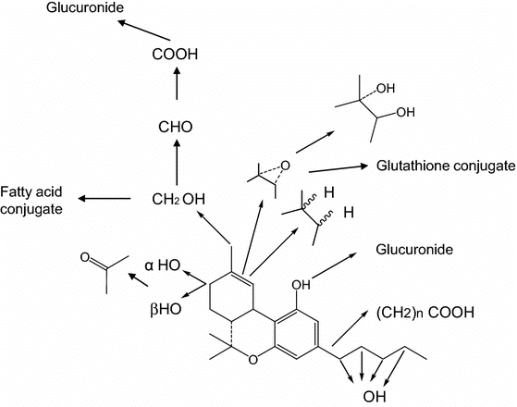
Metabolic pathway of ∆⁹-THC (Harvey and Paton 1986).
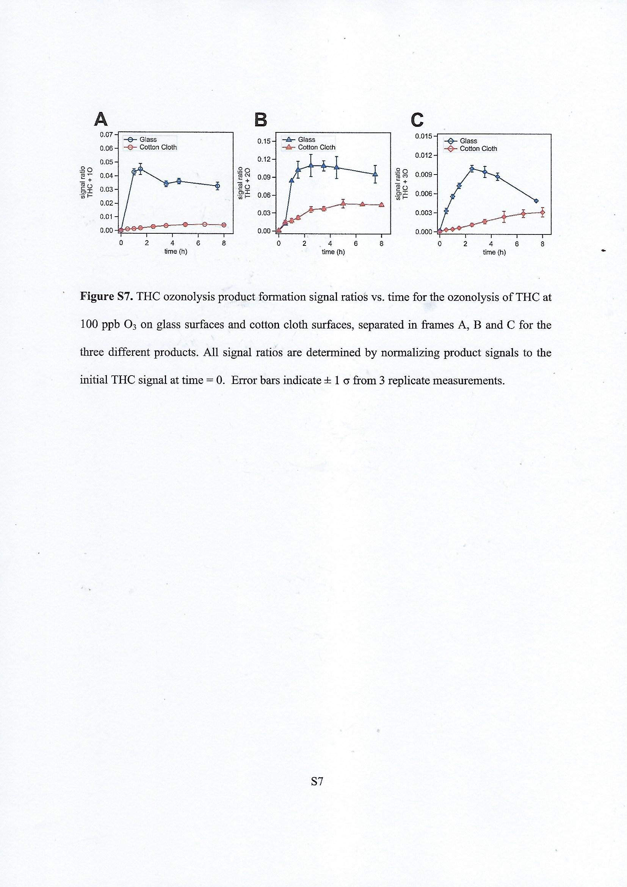
A = THC +2O [Dicarbonyl]; B = THC + O [Epoxide]; C = THC + 3O [SOZ]
SOZ = Secondary Ozonide
Compound B is produced in much larger amounts compared to A & C.
B > A >> C
Signal Ratio: 0.12 (B) : 0.05 (A) : 0.01 (C).
A & B are produced after 1-2 hours of Ozone gas exposure and stay stable (high) for 8 hours.
C is produced latter, after about 3 hours, in a very low quantity and is not stable (rapidly disappears / metabolizes).
A B C
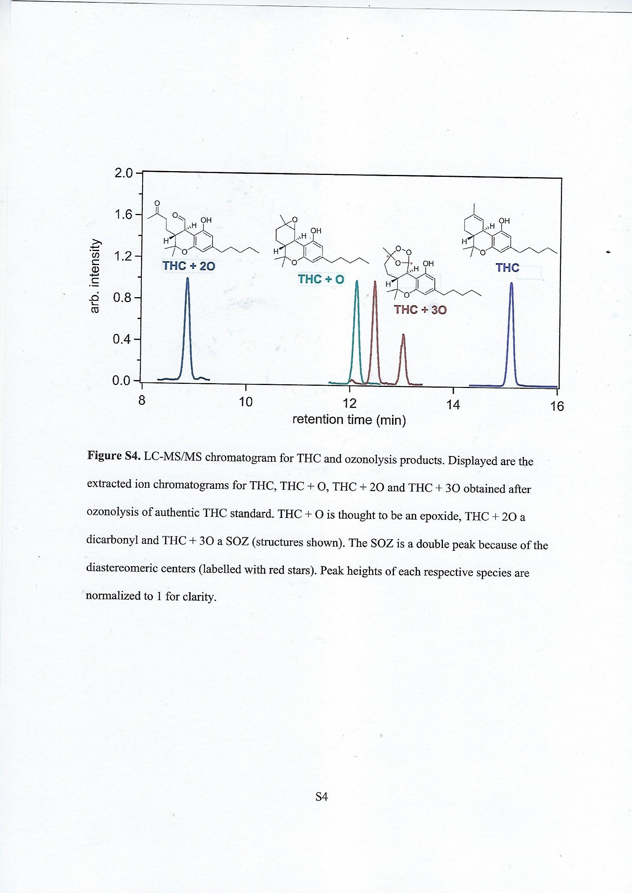
Interestingly, SOZ [Secondary Ozonide] can be produced from Ethene:
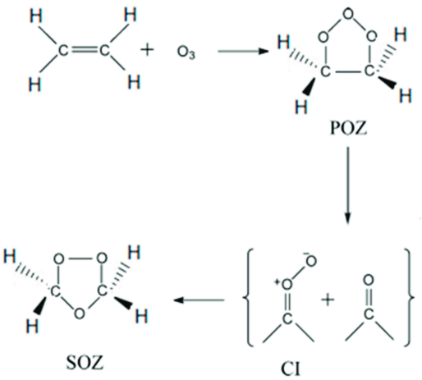
The formation of secondary ozonide (SOZ) in the ozonolysis of Ethene
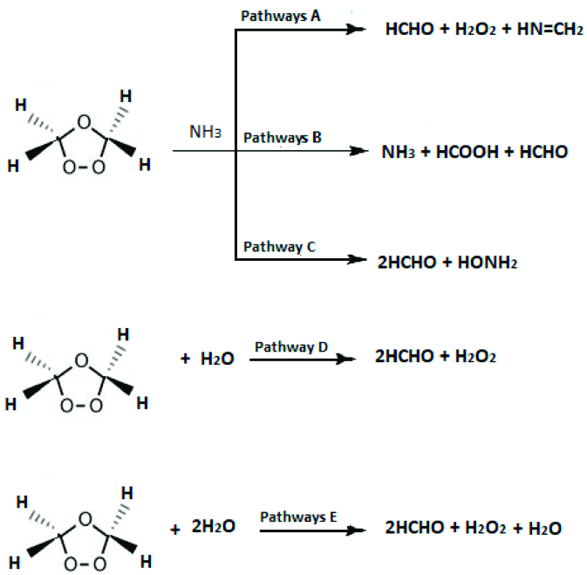
Proposed reactions of SOZ with: NH₃, H₂O, and 2H₂O.
The 3 new ozone metabolites of THC should be further studied by V.V. labs. The HHC Epoxide [B] is the most interesting one, as it is can be found in human liver and is metabolized by CYP3A4. Epoxide-HHC was also found in highly psychoactive Cannabis sativa flowers & extracts, such as traditional Hashish.
Can Ozone gas treatment also degrade CBDA & CBCA?
Do the new compounds display any biological activities?
In order to eliminate any THC (and THCA) produced by industrial Hemp, the research team of V.V. will treat organic Hemp plants with Ozone gas [100 ppm, 4 hours] of pure O₃. Pure Ozone is produced by UV irradiation [<242 nm] of O₂ in dry & clean environment, not by electrical "corona" discharge.
An experiment - aimed to disinfect dry Cannabis flowers from bacteria & fungi spores contaminations, was performed about one year ago in Israel (in which I was a scientific advisor) - found surprising results. Dry flowers were treated with pure Ozone gas [100 ppm, 4 hours at RT] and the content of terpenes & cannabinoids was compared to control. The terpene content was reduced by 10% but the THC content was reduced by half [from 24 to 13%!]. Interestingly, no CBN was produced by Ozone treatment.
9 alpha, 10 alpha-Epoxy HHC should be better studied in vitro & in vivo.

Difference in epoxides formation and their further metabolism between delta 9- and delta 8-tetrahydrocannabinols by human liver microsomes (1984)
I Yamamoto, S Narimatsu, T Shimonishi, K Watanabe, H Yoshimura
J Pharmacobiodyn. Apr;7(4):254-62, 1984.
Abstract
In vitro metabolism of delta 9- and delta 8-tetrahydrocannabinols (THCs) was studied using human liver microsomes. Delta 9- or delta 8-THC was incubated with microsomes in the presence of an NADPH-generating system. The metabolites formed were extracted with ethyl acetate, separated by preparative thin-layer chromatography, and identified as trimethylsilyl derivatives by gas chromatography-mass spectrometry.
9 alpha, 10 alpha-Epoxyhexahydrocannabinol (EHHC) together with four monohydroxylated metabolites was formed from delta 9-THC. The epoxide was found to resist the hydrolysis by epoxide hydrolase, and was further converted to several metabolites by monooxygenase system involving cytochrome P-450. On the other hand, 8 beta, 9 alpha-dihydroxyhexahydrocannabinol (diOH-HHC) instead of epoxy metabolites was formed from delta 8-THC under the conditions for monooxygenase. When 1,1,1-trichloropropene-2,3-oxide was further added to the incubation mixture, both of 8 alpha, 9 alpha-EHHCs were found to be formed from delta 8-THC. These epoxides of delta 8-THC were preferentially hydrolyzed to 8 beta, 9 alpha-diOH-HHC by epoxide hydrolase. These results indicate that 9 alpha, 10 alpha-EHHC formed from delta 9-THC is further metabolized not by epoxide hydrolase but by monooxygenase system involving cytochrome P-450, and that, on the contrary, 8 alpha, 9 alpha- and 8 beta, 9 beta-EHHCs derived from delta 8-THC may be metabolized by epoxide hydrolase rather than cytochrome P-450 in the human liver, forming 8 beta, 9 alpha-diOH-HHC.
HHC Formation
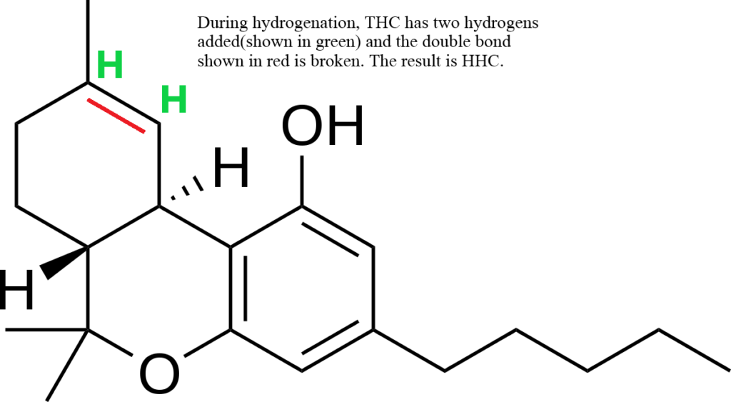
Showing a delta-9 THC molecule and how HHC is different chemically.
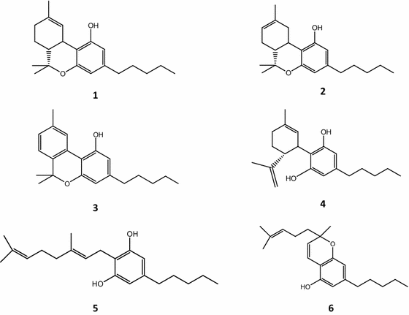
Chemical structures of major cannabinoids
1: ∆⁹-Tetrahydrocannabinol
2: ∆⁸-Tetrahydrocannabinol
3: Cannabinol [CBN] = Tricyclic
4: Canabidiol [CBD] = Dicyclic
5: Cannabigerol [CBG] = Monocyclic
6: Cannabichromene [CBC] = Dicyclic
Cannabinoids are terpenophenolic compounds consisting of an aromatic polyketide and derived from the geranyl diphosphate [GPP] C10 terpenoid unit. They are the active constituents in Cannabis sativa. Biotransformation of pCBs is an important field of xenobiochemistry and toxicology and the study of the metabolism of these compounds can lead to the discovery of new compounds, unknown metabolites with unique structures and new therapeutic entities. Different fungi, bacteria, plants and animal cells have been used for the regio- and stereo-selective transformation of pCBs. All of the above mentioned organisms have distinct enzymes which catalyze the conversion of a specific cannabinoid at different positions and thus provide a variety of derivatives. All organisms are able to transform the alkyl side chain whereas mammalians are unique in the formation of the carboxy derivatives.
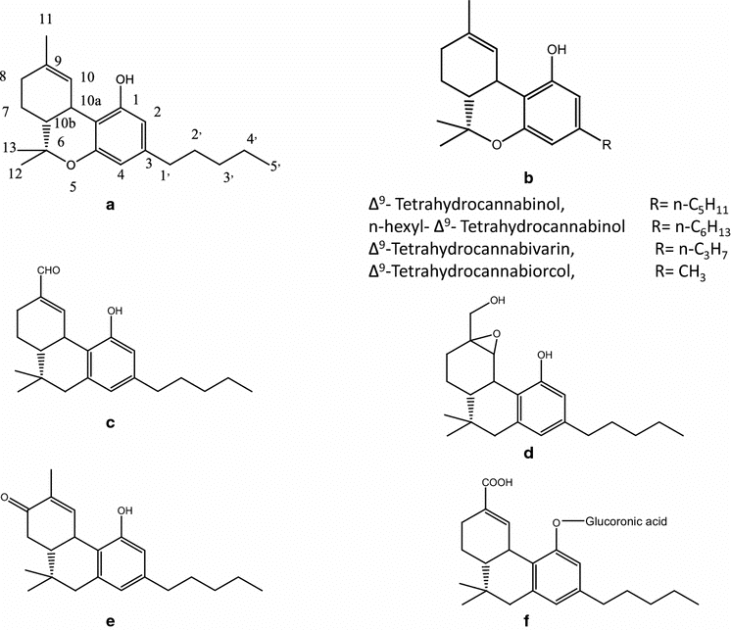
a; ∆⁹-THC (Benzopyran numbering system),
b; Derivatives of THC,
c, 11-oxo-∆⁹- THC,
d; 10-hydroxy-EHHC [Epoxyhexahydrocannabinol],
e; 8-keto-∆⁹-THC,
f; Δ⁹-THC-11-oic acid glucoronide.
Creation of Ozone:
an oxygen molecule is split (photolyzed) by higher frequency UV light (top end of UV-B, UV-C and above) into two oxygen atoms (see figure):
O₂ + ℎν(<242 nm) → 2 O
Each oxygen atom then quickly combines with an oxygen molecule to form an ozone molecule: O + O₂ → O₃
The ozone–oxygen cycle: the ozone molecules formed by the reaction above absorb radiation having an appropriate wavelength between UV-C and UV-B. The triatomic ozone molecule becomes diatomic molecular oxygen plus a free oxygen atom (see figure):
O₃ + ℎν(240–310 {330} nm) → O₂ + O
The atomic oxygen produced quickly reacts with another oxygen molecule to reform ozone: O + O₂ + A → O₃ + A
Where A denotes another molecule or atom, like N₂ or O₂ which is needed in the reaction as otherwise energy and momentum wouldn't be conserved: There is an excess energy of the reaction which is manifested as extra kinetic energy. These two reactions form the ozone–oxygen cycle, in which the chemical energy released when O and O₂ combine is converted into kinetic energy of molecular motion. The overall effect is to convert penetrating UV-B light into heat, without any net loss of ozone. This cycle keeps the ozone layer in a stable balance while protecting the lower atmosphere from UV radiation, which is harmful to most living beings. It is also one of two major sources of heat in the stratosphere (the other being the kinetic energy released when O₂ is photolyzed into O atoms).
The difference between the wavelengths that destroys Ozone and the wavelength of light that produces it - is about 90 nm {30 X 3}.
330 – 242 = 88 {90}nm -- "Spectral Physical Lines"
Removal of Ozone:
If an oxygen atom and an ozone molecule meet, they recombine to form two oxygen molecules: O₃ + O → 2 O₂
And if two oxygen atoms meet, they react to form one oxygen molecule:
2 O → O₂
The overall amount of ozone in the stratosphere is determined by a balance between production by solar radiation and removal. The removal rate is slow, since the concentration of free O atoms is very low.
In addition to the reactions just mentioned, certain free radicals, the most important being hydroxyl (OH), nitric oxide (NO) and atoms of chlorine (Cl) and bromine (Br), catalyze the recombination reaction, leading to an ozone layer that is thinner than it would be if the catalysts were not present. Most of the OH and NO are naturally present in the stratosphere, but human activity, especially emissions of chlorofluorocarbons (CFCs) and halons, has greatly increased the Cl and Br concentrations, leading to ozone depletion. Each Cl or Br atom can catalyze tens of thousands of decomposition reactions before it is removed from the stratosphere.
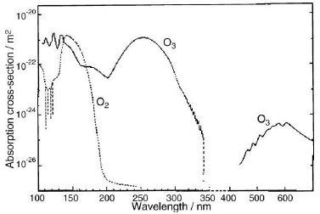
Peak light absorption of O₂ is: 150 nm;
Of O₃ is: 250 & 600 nm.
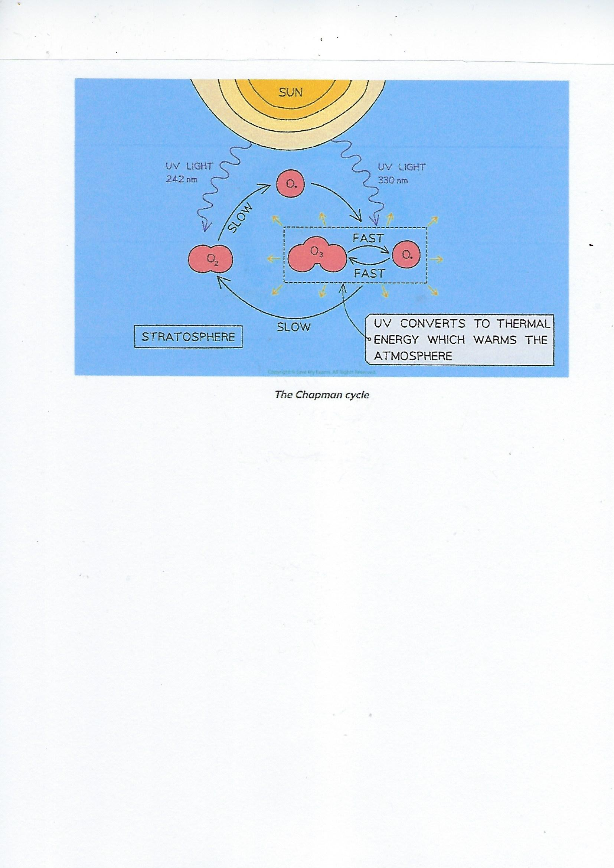
242 nm [UV-C] produces 2XO. from O₂ molecule
330 nm [UV-B] produces O₃ from O₂ + O.
Absorption of UV-B light by O₃ produces HEAT in the Atmosphere.
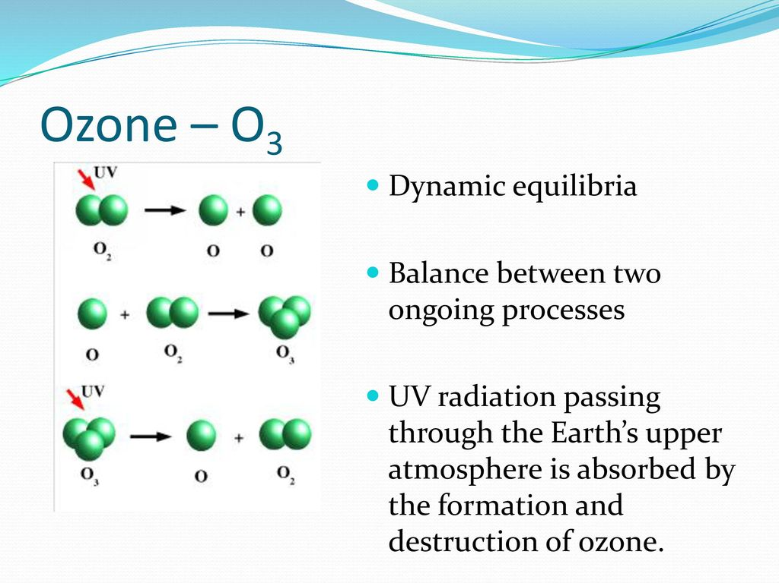

UV-B [330 nm] light converts ozone to O₂ + O.
That releases thermal energy.
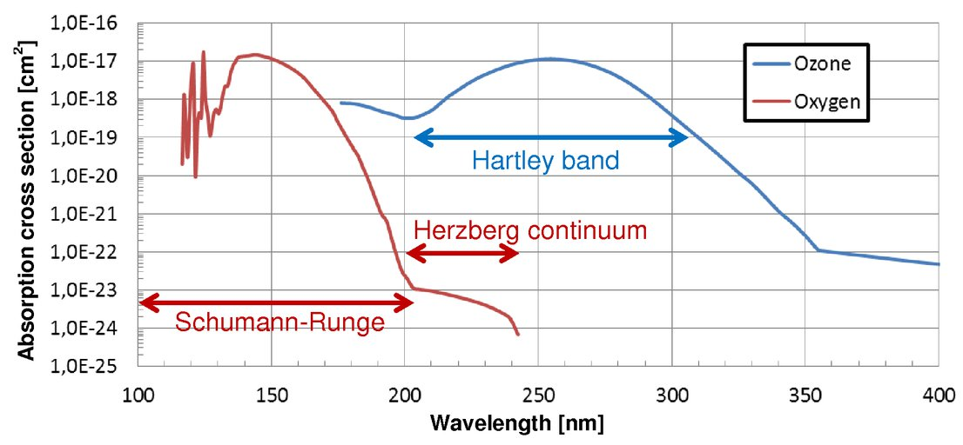
Hypothesis: The absorption of UV-B light by pCBs elevates
The temperature inside the secretory space of TG to 50 degrees Celsius
The thermal optimum of THCAS, CBDAS & CBCAS enzymes activities.

The V.V. research group will make an effort to measure the inner temperature in the secretory space during pCBs biosynthesis.

Light Absorption & Heat generation
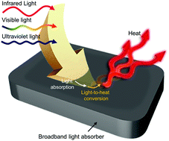
Absorption of light creates heat
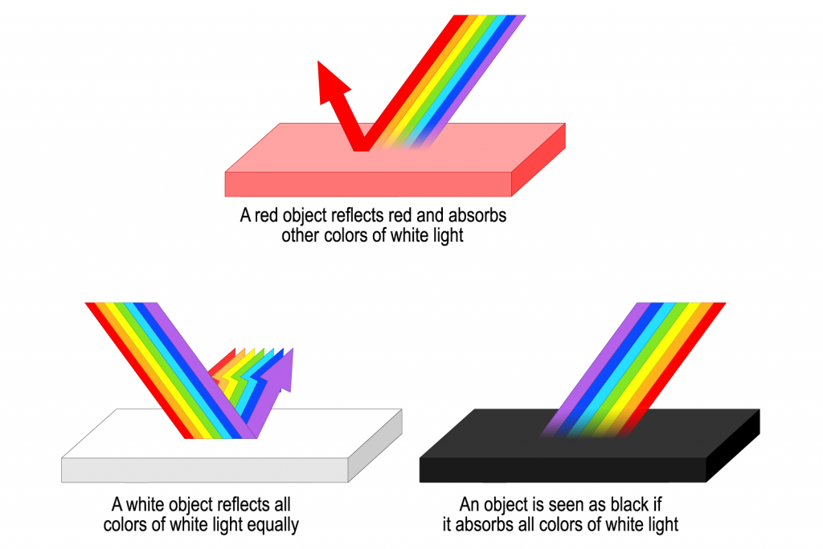
The meaning of Color we see
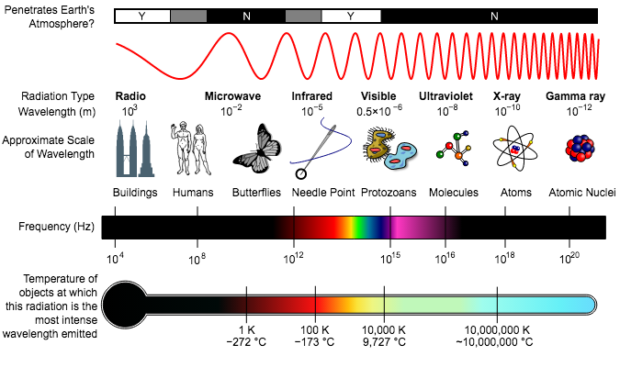
UV light has a frequency of 10¹⁶ Hz, wavelength of 10⁻⁸ meters and approximated scale of Molecules.

Hydrogenation of THC to HHC
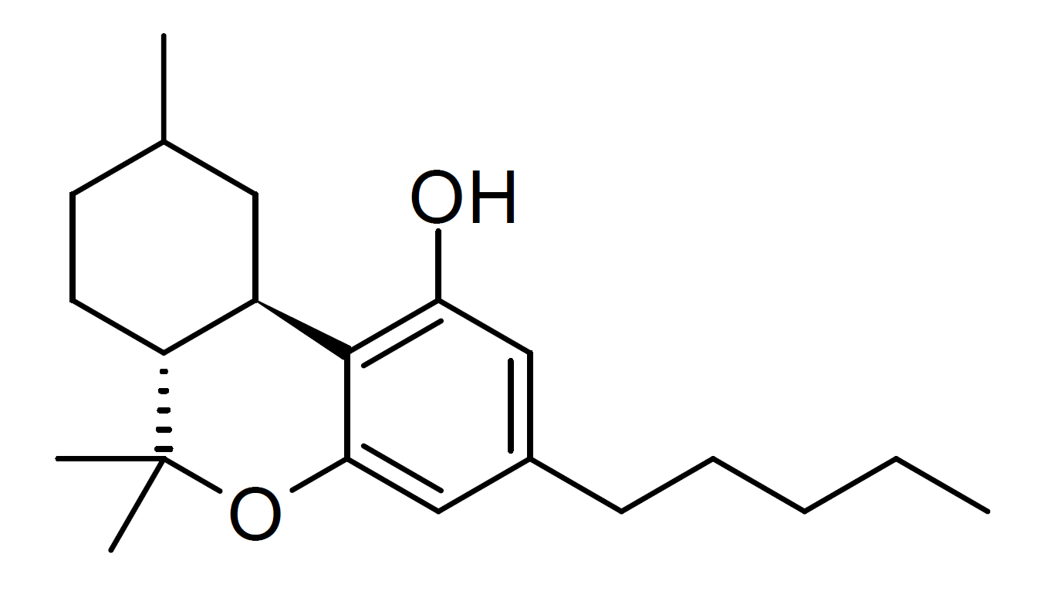
Hexahydrocannabinol (HHC) is a hydrogenated derivative of tetrahydrocannabinol [THC]. It is a naturally occurring pCB that has rarely been identified as a trace component in Cannabis sativa, but can also be produced synthetically by hydrogenation of cannabis extracts. HHC was first synthesized in 1947 by Roger Adams using natural THC found in Cannabis sativa. Several research groups have successfully synthesized (+)-HHC and (-)-HHC using citronellal and olivetol, as well as other related compounds. While similar compounds have previously been identified in cannabis, hexahydrocannabinol itself has rarely been isolated from the plant.
Citronellal
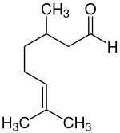
Citronellal or rhodinal (C10H18O) is a monoterpenoid aldehyde, the main component in the mixture of terpenoid chemical compounds that give citronella oil its distinctive lemon scent.
Citronellal is a main isolate in distilled oils from the plants Cymbopogon (excepting C. citratus, culinary lemongrass), lemon-scented gum, and lemon-scented teatree. The (S)-(−)-enantiomer of citronellal makes up to 80% of the oil from kaffir lime leaves and is the compound responsible for its characteristic aroma.
Citronellal has insect repellent properties, and research shows high repellent effectiveness against mosquitoes. Another research shows that citronellal has strong antifungal qualities.
The de Las Heras group in 2020 took lipid extract from Cannabis sativa seeds and discovered 43 cannabinoids in the crude extract; one of them being hexahydrocannabinol. It has two diastereomers at the methyl (9) position. HHC is typically made from CBD, Δ8-THC, or Δ9-THC. There are no double bonds in the cyclohexyl ring like D8/D9— they have been removed from the structure and hydrogen atoms have been added to the compound. Similar structural analogs of HHC has been demonstrated to bind to the CB1 receptor and produces cannabinoid effects in animals, with the 9β-HHC enantiomer being much more active than 9α-HHC. While HHC has been shown to bind to the CB1 receptor, it binds with weaker affinity than THC, which has typically been an indication that it is not as intoxicating as a typical THC. Since HHC is found naturally in the cannabis plant, humans have likely been unknowingly consuming small amounts of this cannabinoid for centuries.
9-hydroxy HHC
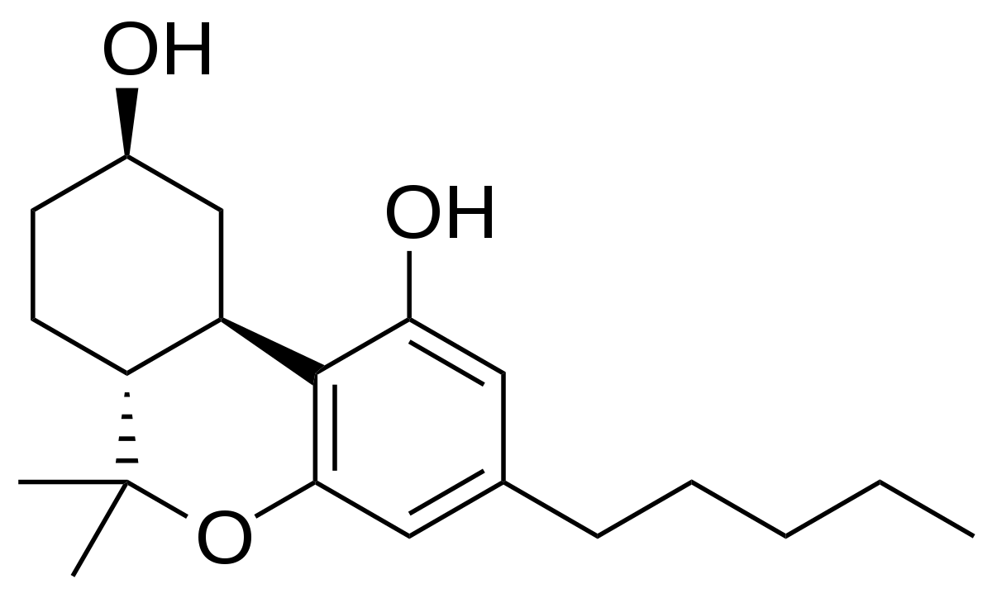
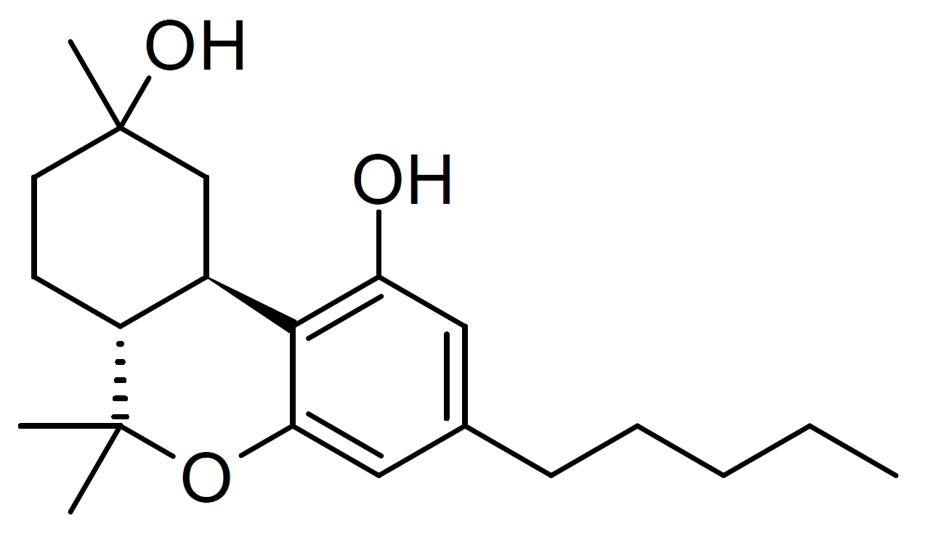
11-Nor-9β–hydoxy HHC
9-Nor-9β-hydroxyhexahydrocannabinol (9-Nor-9beta-HHC, sometimes incorrectly confused with 11-nor-9β-hydroxyhexahydrocannabinol),is a cannabinoid first discovered from early modifications to the structure of THC, in a search for the simplest compound that could still fulfill the binding requirements to produce cannabis-like activity.
11-Hydroxyhexahydrocannabinol is the structurally related methylene homologue of 11-Nor-9β-hydroxyhexahydrocannabinol that has been found as a minor active metabolite of THC, and also a metabolite of the trace cannabinoid hexahydrocannabinol [HHC].

Several structurally related HHC analogs have been found to be naturally occurring in Cannabis including Cannabiripsol, 9α-hydroxyhexahydrocannabinol, 7-oxo-9α-hydroxyhexa-hydrocannabinol, 10α-hydroxyhexahydrocannabinol, 10aR-hydroxyhexahydrocannabinol and 1′S-hydroxycannabinol, 10α-hydroxy-Δ(9,11)-hexahydrocannabinol and 9β,10β-epoxyhexahydrocannabinol.
HHC itself has been found as a degradation byproduct of THC in a similar way that Cannabinol [CBN] and Delta-8-THC can be formed by the Cannabis plant from Delta-9-THC degradation. The degradation of D9-THC that forms HHC is the reduction of the double carbon bonds that would typically make up the delta isomer position on THCs structure.
Delta-9-THC was discovered to partly metabolize into 11-Hydroxy-THC and alpha,10 alpha-epoxy-hexahydrocannabinol along with 1,2-epoxy-hexahydrocannabinol.
Cannabidiol [CBD] was discovered to partly metabolize into 9α-hydroxy-HHC and 8-hydroxy-iso-HHC inside the human body.
No information about the hydrogenation (or ozonization) of Cannabichromene [CBC] is currently available.
In the presence of alcohol, the methoxy or ethoxy analogs such as 9-methoxy-HHC, 10-methoxy-HHC, 9-ethoxy-HHC and 10-ethoxy-HHC can be formed in the human body.

Isolation and Pharmacological Evaluation of Minor Cannabinoids from High-Potency Cannabis sativa (2015)
Mohamed M. Radwan, Mahmoud A. ElSohly, Abir T. El-Alfy, Safwat A. Ahmed, Desmond Slade, Afeef S. Husni, Susan P. Manly, Lisa Wilson, Suzanne Seale, Stephen J. Cutler, and Samir A. Ross.
J. Nat. Prod. 2015, 78, 6, 1271–1276.
Seven new naturally occurring hydroxylated cannabinoids , along with the known cannabiripsol, have been isolated from the aerial parts of high-potency Cannabis sativa. The structures of the new compounds were determined by 1D and 2D NMR spectroscopic analysis, GC-MS, and HRESIMS as 8α-hydroxy-Δ9-tetrahydrocannabinol, 8β-hydroxy-Δ9-tetrahydrocannabinol, 10α-hydroxy-Δ8-tetrahydrocannabinol, 10β-hydroxy-Δ8-tetrahydrocannabinol, 10α-hydroxy-Δ9,11-hexahydrocannabinol, 9β,10β-epoxyhexahydrocannabinol, and 11-acetoxy-Δ9-tetrahydrocannabinolic acid A. The binding affinity of isolated compounds 1–8, Δ9-tetrahydrocannabinol, and Δ8-tetrahydrocannabinol toward CB1 and CB2 receptors as well as their behavioral effects in a mouse tetrad assay were studied. The results indicated that compound 3, with the highest affinity to the CB1 receptors, exerted the most potent cannabimimetic-like actions in the tetrad assay, while compound 4 showed partial cannabimimetic actions. Compound 2, on the other hand, displayed a dose-dependent hypolocomotive effect only.
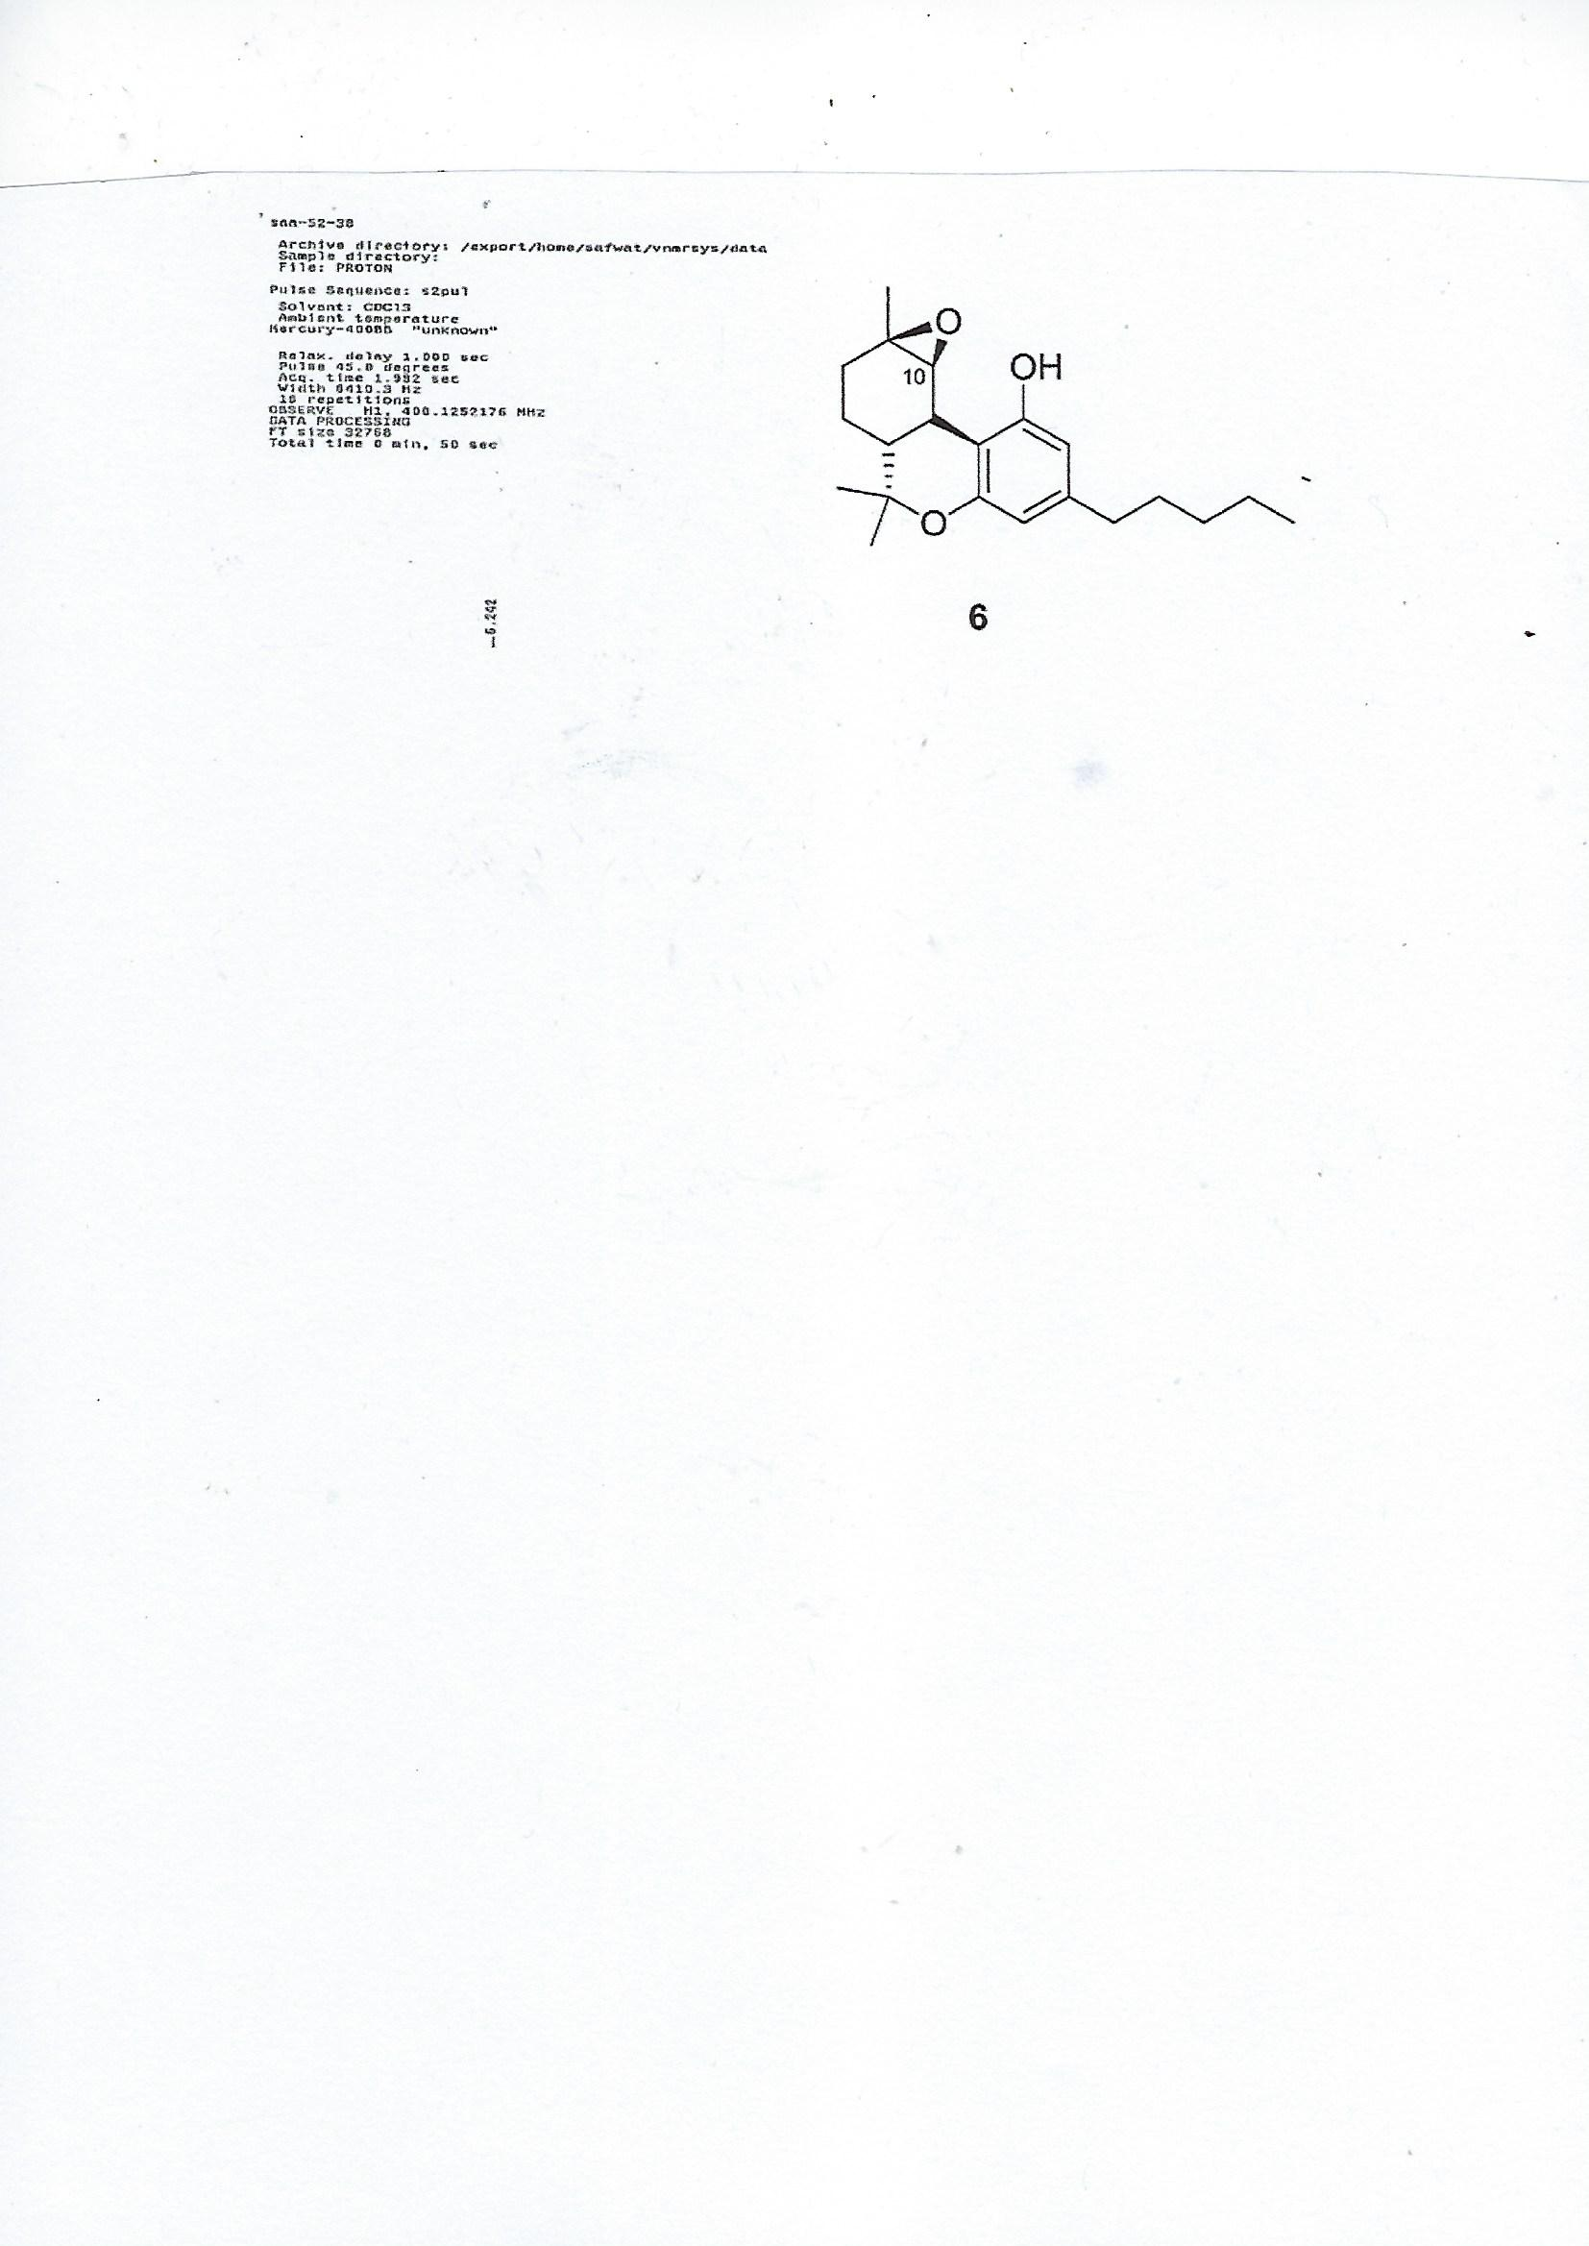
Although, Epoxy HHC does not bind cannabinoid receptors, it still can bind & activate (or inactivate) other protein targets in the human body.
The Tetrad assay
The tetrad test is a series of behavioral paradigms in which rodents treated with cannabinoids such as THC show effects. It is widely used for screening drugs that induce cannabinoid receptor-mediated effects in rodents. The four behavioral components of the tetrad are spontaneous activity, catalepsy, hypothermia, and analgesia. Common assays for these behavioral paradigms are as follows:
Spontaneous activity (or hypomotility) is determined by an open field test, in which a mouse is placed in a cage with perpendicular grid lines, usually spaced by approx. 1 inch. An experimenter counts the number of line crossings by the mouse in a given amount of time. Catalepsy is determined by the bar test. The mouse is placed on a bar oriented parallel to and approximately 1 inch off of the ground. If the mouse remains immobile on the bar for typically more than 20 seconds, it is considered cataleptic. Hypothermia (reduced body temperature) is determined by using a rectal probe to measure the rectal temperature.
Analgesia is usually determined by the hot plate or tail immersion test. In the hot plate test, the mouse is placed on a heated plate, typically between 54 and 58°C. An experimenter measures the time it takes for the animal to raise its feet or jump off of the hot plate. In the tail immersion test, the mouse is immobilized and its tail is placed into a warm water bath, typically also between 54 and 58°C. An experimenter measures the time it takes for the mouse to remove its tail from the water bath. Direct CB1 agonists, such as THC (the psychoactive component of marijuana), HU-210 or WIN 55,212-2, have effects in all components of the tetrad and induce hypomotility, catalepsy, hypothermia, and analgesia in rodents. Accordingly, all true "tetrad effects" are not observed following treatment with antagonists or inverse agonists of CB1 such as "Rimonabant". Data have shown that also CB2 receptors are involved in the tetrad effects induced by cannabinoids, and other, associated with CB1 agonism.
As for 2015 - 125 pCBs were identified
In Cannabis sativa
Cannabis plants can exhibit wide variation in the quantity and type of cannabinoids they produce. The mixture of cannabinoids produced by a plant is known as the plant's cannabinoid profile. Selective breeding has been used to control the genetics of plants and modify the cannabinoid profile. For example, strains that are used as fiber (commonly called hemp) are bred such that they are low in psychoactive chemicals like THC. Strains used in medicine are often bred for high CBD content, and strains used for recreational purposes are usually bred for high THC content or for a specific chemical balance.
Quantitative analysis of a plant's cannabinoid profile is often determined by gas chromatography (GC), or more reliably by gas chromatography combined with mass spectrometry (GC/MS). Liquid chromatography (LC) techniques are also possible and, unlike GC methods, can differentiate between the acid and neutral forms of the cannabinoids.

Cannabinodiol (CBND) Type (Two Cannabinoids)
Only two cannabinodiol (CBND) type cannabinoids have been reported. In 1972, cannabinodivirin (CBND-C3) was detected in hashish by GC-MS analysis. In 1977, cannabinodiol (CBND-C5) was isolated from Lebanese hasish, using silica-gel column chromatography. The structure of CBND-C5 was determined by 1H-NMR and confirmed by the photochemical transformation of cannabinol [CBN] into cannabinodiol {CBND].
CBND, also known as cannabidinodiol, is a cannabinoid that is present in the plant Cannabis sativa at low concentrations. It is the fully aromatized derivative of cannabidiol (CBD) and can occur as a product of the photochemical conversion of cannabinol (CBN).
CBN CBND
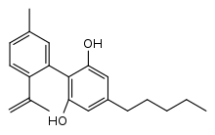
Cannabielsoin (CBE) Type (Five compounds)
In 1973, cannabielsoin (CBE-C5) was detected in the ethanolic extract of Lebanese hashish. The extract was subjected to counter current distribution followed by GCMS analysis. In 1974, its configuration was determined to be 5aS, 6S, 9R, 9aR]. Both cannabielsoin acid A (CBEAA) and cannabielsoin acid B (CBEAB) were isolated from hashish; the structural elucidation was carried by NMR spectroscopy and chemical transformations. Cannabielsoin-C3 (CBE-C3) and Cannabielsoic acid B-C3 CBE. CBE is a metabolite of cannabidiol [CBD].
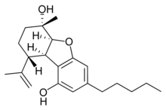
CBD CBE
Cannabicyclol (CBL) Type (Three compounds(
Krote and Sieper isolated cannabicyclol (CBL) from hashish by thin layer chromatography, but its structure was correctly elucidated by Mechoulam and Gaoni in 1967, based on spectral data. The relative configuration of CBL was determined by X-ray analysis in 1970 . Cannabicyclolic acid (CBLA) was obtained from the benzene extract of cannabis. The benzene extract was chromatographed on a polyamide column using methanol water as a mobile phase. CBLA was isolated as a methylated derivative and considered to be an artifact formed when CBCA is naturally irradiated during storage. Cannabicyclovarin (CBLV) was detected in the ether extract of Congo marihuana and was identified by GLC and GCMS. CBLA was determined to be produced during the natural irradiation of cannabichromenic acid (CBCA), proving that CBLA is not a natural cannabinoid.
CBCA CBLA
CBL is a non-psychoactive cannabinoid found in Cannabis. CBL is a degradative product like cannabinol, with cannabichromene [CBC] degrading into CBL through natural irradiation or under acid conditions.
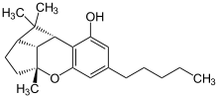
Cannabichromene (CBC) Type (Nine compounds)
Cannabichromene (CBC) was isolated from the hexane extract of hashish, using column chromatography (florisil column) in 1966 . The carboxylic acid derivative of CBC, cannabichromenic acid (CBCA) was isolated from the benzene extract of hemp, using silica-gel column chromatography. The chemical structure of CBCA was determined using IR, NMR, and UV spectroscopies. Cannabivarichromene (± CBCV) was identified through GC-MS analysis, and both cannabichromevarin (+ CBCV) and cannabichromevarinic acid (CBCVA) were isolated from a benzene extract of the “Meao” variant of cannabis from Thailand. Three cannabichromene derivatives, (±)-4-acetoxycannabichromene, (±)-3”-hydroxy-Δ4”-cannabichromene and (–)-7-hydroxycannabichromane , were isolated from high potency C. sativa using silica-gel VLC, normal-phase silica HPLC, and reverse-phase silica HPLC. These derivatives were chemically identified using 1D and 2D NMR spectroscopic techniques. In 1984, the CBC-C3 derivative was reported, and using mass spectral analysis, the chemical structure of the CBC-C3 derivative was determined to be 2-methyl-2-(4-methyl-2-pentyl)-7-propyl-2H-1-benzopyran-5-ol.
CBC is a selective CB2 receptor agonist displaying higher efficacy than THC in hyperpolarizing AtT20 cells. CBC can also recruit CB2 receptor regulatory mechanisms. CBC may contribute to the potential therapeutic effectiveness of some cannabis preparations, potentially through CB2 receptor‐mediated modulation of inflammation.
Cannabinol (CBN) Type (Eleven compounds)
The chemical structure and the isolation details of seven cannabinol derivative have been reported in 1980. Both 8-hydroxycannabinol and 8-hydroxy cannabinolic acid A were isolated from the high potency variety of C. sativa and chemically identified based on NMR and high-resolution mass (HR-MS) analysis in 2009. The compounds 1′S-hydroxy-cannabinol and 4-terpenyl cannabinolate were isolated from the same cannabis variety, and their chemical structures were confirmed by GC-MS analysis. UV-B light + Oxygen metabolize THC to CBN.
THC CBN
Cannabitriol (CBT) Type (Nine compounds)
Nine CBT-type cannabinoids, including (−)-trans-CBT-C5, (+)-trans-CBT-C5 (88), (±)-cis-CBT-C5, (±)-trans-CBT-C3, CBT-C3-homologue, (−)-trans-CBT-OEt-C5, (–)-trans-CBT-OEt-C3, 8,9-Di-OH-CBT-C5, and CBDA-C5 9-OH-CBT-C5 ester, have been isolated from cannabis. Cannabitriol was originally reported in 1966 from Japanese hemp, but its chemical structure was elucidated in 1976. The configuration of this compound was later determined by X-ray analysis. The compounds (+)-trans-CBT-C5 and (–)-trans -CBT-OEt-C5 were isolated by ElSohly et al. from the ethanolic extract of cannabis, which was chromatographed on a silica gel column and identified by GCMS. The two ethoxy cannabitriols are most likely artifacts, since ethanol was used in their isolation from Cannabis.
Cannabitriol ((+)-CBT, (S,S)-9,10-Dihydroxy-Δ6a(10a)-THC) is a pCB first isolated in 1966, an oxidation product of THC which has been identified both as a trace component of cannabis and as a metabolite in cannabis users. Its pharmacology has been little studied, though it has been found to act as an antiestrogen and aromatase inhibitor.
THC CBT
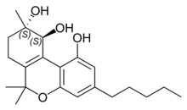
Miscellaneous Types Cannabinoids (30 compounds)
A total of thirty miscellaneous type cannabinoids have been isolated from cannabis, including dehydrocannabifuran (DCBF-C5), cannabifuran (CBF-C5), 8-hydroxy-isohexahydrocannabivirin (OH-iso-HHCV-C3), 10-oxo-Δ6a(10a)-tetrahydro-cannabinol (OTHC), cannabicitran, (–)-Δ9-cis-(6aS,10aR)-tetrahydro-cannabinol (cis-Δ9-THC), cannabicoumaronone (CBCON-C5), cannabiripsol (CBR),
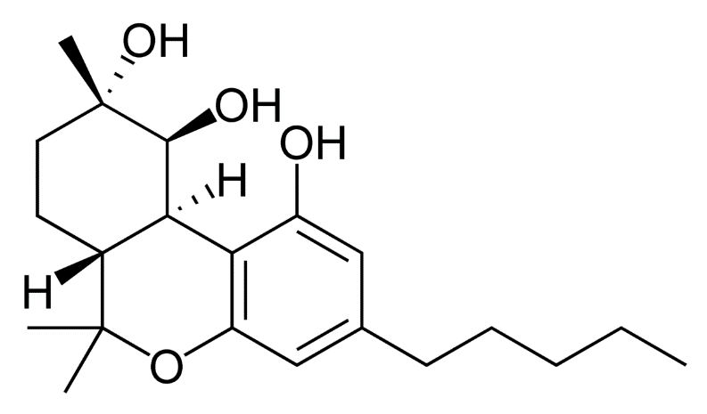
cannabitetrol (CBTT), cannabichromanone-C5 (CBCN-C5), cannabichromanone-C3 (CBCN-C3),(±)-Δ7-cis-isotetrahydrocannabivarin-C3 (cis-iso-Δ7-THCV), (–)-Δ7-trans-(1R,3R,6R)-isotetrahydrocannabi- varin-C3 (trans-iso-Δ7-THCV), and (–)-Δ7-trans-(1R,3R,6R)-isotetrahydrocannabinol-C5 (trans-iso-Δ7-THC). The cyclohexane-methanol extract of Afghan hashish afforded dehydrocannabifuran (DCBF-C5), cannabifuran (CBF-C5), OTHC, and cannabichromanone-C5 (CBCN-C5) after micropreparative GC and TLC. Their chemical structures were determined by mass and NMR spectroscopic analysis. Cannabicitran (CBT {CBCT}) was isolated from an ethanolic extract of Lebanese hashish. It was purified by counter-current distribution and silica gel chromatography. Its chemical structure was determined by GCMS, IR and 1H NMR analyses.
Cannabicitran (CBTC) is a pCB first isolated in 1974 as a trace component of Cannabis sativa. Structurally related compounds can be found in some other plants. It is not psychoactive, but was found to reduce intraocular pressure [IOP] in tests on rabbits, which may reflect agonist activity at the NAGly receptor (formally GPR18) that is known to be a target of many structurally related cannabinoids.
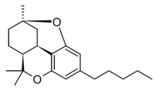
Cannabiripsol (CBR) was isolated from a South African cannabis variant after hexane extraction and chromatography on silica and polyamide columns. Its chemical structure was determined by spectral means (IR, GCMS, UV, 1H NMR) and by synthesis.
Cannabitetrol (CBTT) was obtained and identified from the hexane extract of Mexican marijuana grown in Mississippi using silica gel column chromatography.
From a high potency variety of C. sativa, three cannabichromanones were isolated, namely cannabichromanone B, C, and D. The absolute configurations of these three cannabinoids were assigned on the basis of the Mosher ester and inspection of their circular dichroism spectra. The isolation of these compounds was performed using semi-preparative C18 HPLC. Additionally, (–)-(7R)-cannabicoumarononic acid, 4-acetoxy-2-geranyl-5-hydroxy-3-n-pentylphenol, and 2-geranyl-5-hydroxy-3-n-pentyl-1,4-benzoquinone were isolated from the buds and leaves of the same variety of cannabis (high potency C. sativa) using several chromatographic techniques, including silica-gel VLC, solid-phase extraction, reverse-phase columns (C18 SPE), and normal-phase HPLC. In addition, 5-acetoxy-6-geranyl-3-n-pentyl-1,4-benzoquinone was isolated on silica gel column chromatography followed by normal-phase HPLC.
In 2010, a new cannabinoid named Cannabimovone (CBM) was isolated from a non-psychotropic variety of C. sativa. This unusual metabolite is presumably formed from CBD and was isolated from a polar fraction of hemp by using flash chromatography over reverse-phase C18 silica gel followed by normal-phase HPLC. The chemical identity of CBM was revealed by a combination of 1D and 2D NMR along with ESI-MS spectroscopic techniques.
Cannabimovone (CBM) is a pCB first isolated from a non-psychoactive strain of Cannabis sativa in 2010, which is thought to be a rearrangement product of cannabidiol [CBD]. It lacks affinity for cannabinoid receptors, but acts as an agonist at both TRPV1 and PPARγ.
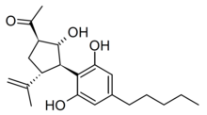
CBD CBM
A tetracyclic cannabinoid, cannabioxepane, (CBX or CBO) was isolated in 2011 from a cannabis variety called "Carmagnola" by applying many chromatographic techniques including RP-18 column, silica gel column chromatography, and NP-HPLC chromatography. Its chemical structure was established using MS and NMR data.
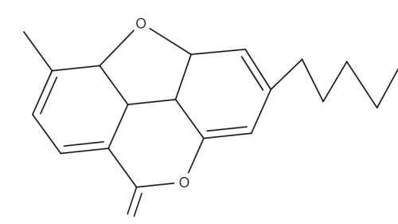
A fiber cultivar of Cannabis sativa derived from the historical Carmagnola variety gave the novel spiranic stilbenoid isocannabispiradienone and the biphenyl-type cannabinoid cannabioxepane (CBX), a tetracyclic compound characterized by an unprecedented C-5/C-8′ oxygen bridge and devoid of cannabinoid activity.
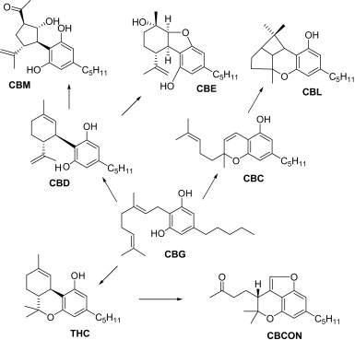
CBCON = Cannabichromanone
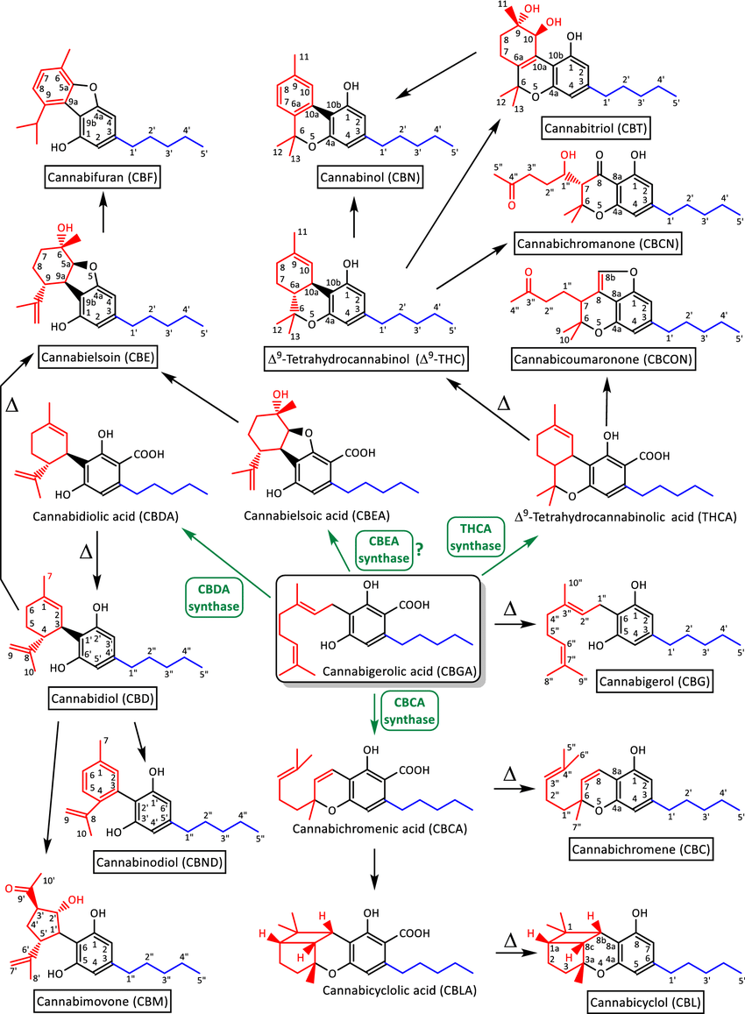
Proposal for the biogenetic relationships of cannabinoid classes. The system used in this article for the numbering of atoms forming the carbon backbone of each class is shown. Trivial names and common abbreviations are given. Reactions catalyzed by enzymes with known functions have a green arrow. Note that the existence of a CBEA synthase has not been established in cannabis but has been shown to occur in other plant species. Thermal breakdown reactions are indicated with the Greek letter Δ. The Terpene moiety is colored in red, the Phenol in black and the hydrophobic Tail in blue.
CBE, CBF & CBCON do not have a phenol moiety in their molecules – do they absorb UV light?
Cannabifuran (CBF)
Recently, researcher reported a strategy to prepare several structurally diverse minor cannabinoids deriving synthetically from readily available cannabidiol [CBD]. They examined the ability of those minor pCBs to polarize activated microglia toward an anti-inflammatory phenotype using LPS-stimulated BV2 microglial cells. The minor cannabinoids studied, especially cannabielsoin [CBE], dehydrocannabielsoin, cannabimovone (CBM), and 3′-epicannabimovone, inhibited the production of prototypical pro-inflammatory biomarkers. This study represents the beginning of a systematic mapping of the roles minor cannabinoids may play in the medicinal properties of cannabis used for the treatment of pain and inflammation.
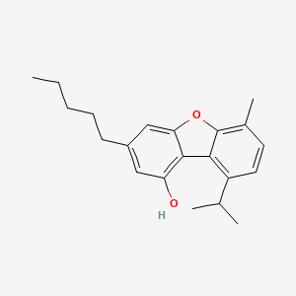
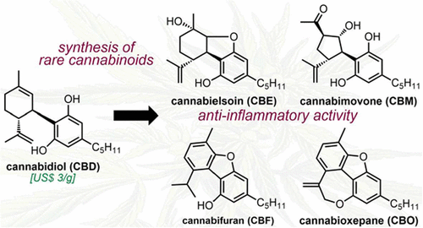
Cannabioxepane (CBO = CBX)
Cannabicoumaronone (CBCON)
Cannabicoumaronone [4-(4,4-Dimethyl-7-pentyl-3,4-dihydrofuro[4,3,2-de]chromen-3-yl)-2-butanone] is a natural product found in Cannabis sativa.
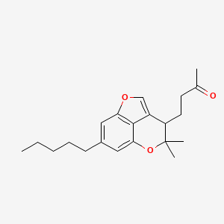

Seven more cannabinoids were isolated from a high potency variety of C. sativa and chemically elucidated by 1D & 2D NMR & HRMS analyses as:
10α-hydroxy-Δ9,11-hexahydrocannabinol [Hydroxy HHC],
9β,10β-epoxyhexahydrocannabinol [Epoxy HHC],
9α-hydroxyhexahydrocannabinol [Hydroxy HHC],
7-oxo-9α-hydroxyhexahydrocannabinol {Oxo HHC],
10α-hydroxyhexahydrocannabinol [Hydroxy HHC],
10aR-hydroxyhexahydrocannabinol [Hydroxy HHC],
and 9α-hydroxy-10-oxo-Δ6a,10a-THC.
Inside the secretory cavity of cannabis GT, a complex "Natural Pharmacy" is producing more than 100 pCBs from GBGA.
Hypothesis: Minor, scares pCBs, make a potent cannabis highly psychoactive and add to its medicinal properties.
The V.V. research team will focus on metabolites (especially, photochemical [light-induced]) of THC, CBN, CBD & CBC:
THC to CBN or CBT
CBD to CBE, CBF, CBO (CBX) or CBM
CBC to CBL
CBN to CBND.
Optics
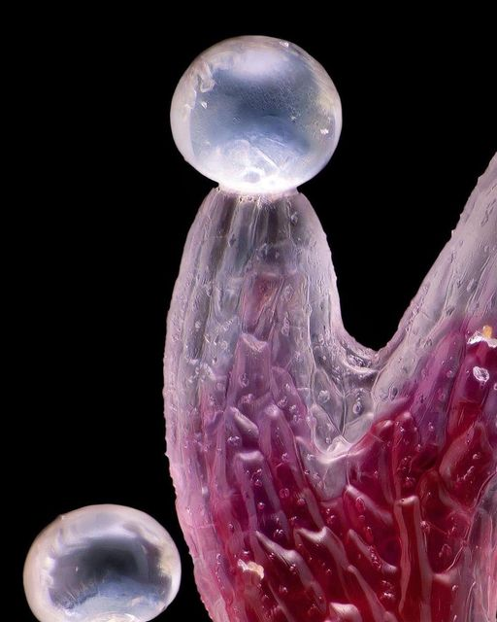
Clear Crystal Ball, Convex Lens & Prism
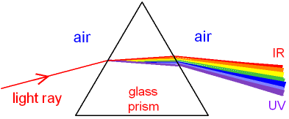
Light Refraction
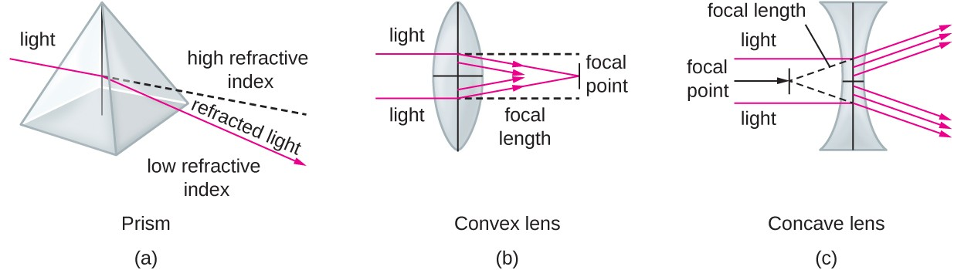
UV light has the lowest refractive index
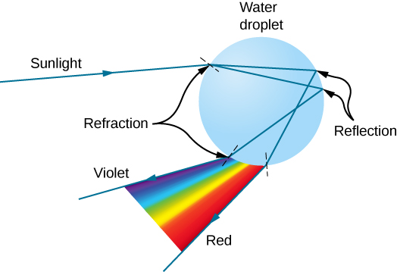
Light Refraction & Reflection in a crystal ball
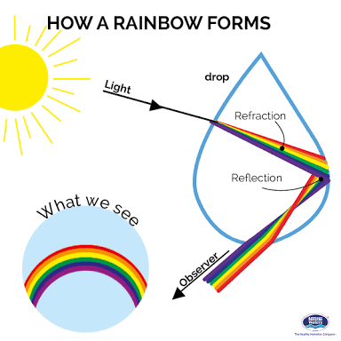
Hypothesis: The clear crystal ball in the head of the GT, condenses UV light inside the secretory cavity, reduces FAD cofactor of THCAS and increases the enzymatic efficiency.

