Minor Cannabinoids - general overview
Isolation and Pharmacological Evaluation of Minor Cannabinoids from High-Potency Cannabis sativa (2015)
Mohamed M. Radwan, Mahmoud A. ElSohly, Abir T. El-Alfy, Safwat A. Ahmed, Desmond Slade, Afeef S. Husni, Susan P. Manly, Lisa Wilson, Suzanne Seale, Stephen J. Cutler, and Samir A. Ross
J. Nat. Prod. 2015, 78, 6, 1271–1276
Seven new naturally occurring hydroxylated cannabinoids, along with the known cannabiripsol, have been isolated from the aerial parts of high-potency Cannabis sativa. The structures of the new compounds were determined by 1D and 2D NMR spectroscopic analysis, GC-MS, and HRESIMS as 8α-hydroxy-Δ9-tetrahydrocannabinol, 8β-hydroxy-Δ9-tetrahydrocannabinol, 10α-hydroxy-Δ8-tetrahydrocannabinol, 10β-hydroxy-Δ8-tetrahydrocannabinol, 10α-hydroxy-Δ9,11-hexahydrocannabinol, 9β,10β-epoxyhexahydrocannabinol, and 11-acetoxy-Δ9-tetrahydrocannabinolic acid A. The binding affinity of isolated compounds 1–8, Δ9-tetrahydrocannabinol, and Δ8-tetrahydrocannabinol toward CB1 and CB2 receptors as well as their behavioral effects in a mouse tetrad assay were studied.
The results indicated that compound 3, with the highest affinity to the CB1 receptors, exerted the most potent cannabimimetic-like actions in the tetrad assay, while compound 4 showed partial cannabimimetic actions. Compound 2, on the other hand, displayed a dose-dependent hypo-locomotive effect only. Although, Epoxy HHC does not bind cannabinoid receptors, it still can bind & activate (or inactivate) other protein targets in the human body and should be studied in vitro & in vivo.

As for 2015 - 125 pCBs were identified In Cannabis sativa L.
Cannabis plants can exhibit wide variation in the quantity and type of cannabinoids they produce. The mixture of cannabinoids produced by a plant is known as the plant's cannabinoid profile. Selective breeding has been used to control the genetics of plants and modify the cannabinoid profile. For example, strains that are used as fiber (commonly called hemp) are bred such that they are low in psychoactive chemicals like THC. Strains used in medicine are often bred for high CBD content, and strains used for recreational purposes are usually bred for high THC content or for a specific chemical balance.
Quantitative analysis of a plant's cannabinoid profile is often determined by gas chromatography (GC), or more reliably by gas chromatography combined with mass spectrometry (GC/MS). Liquid chromatography (LC) techniques are also possible and, unlike GC methods, can differentiate between the acid and neutral forms of the cannabinoids.
Cannabinodiol (CBND) Type (Two Cannabinoids)
Only two cannabinodiol (CBND) type cannabinoids have been reported. In 1972, cannabinodivirin (CBND-C3) was detected in hashish by GC-MS analysis. In 1977, cannabinodiol (CBND-C5) was isolated from Lebanese hashish, using silica-gel column chromatography. The structure of CBND-C5 was determined by 1H-NMR and confirmed by the photochemical transformation of cannabinol [CBN] into cannabinodiol {CBND].
CBND, also known as cannabidinodiol, is a cannabinoid that is present in the plant Cannabis sativa at low concentrations. It is the fully aromatized derivative of cannabidiol (CBD) and can occur as a product of the photochemical conversion of cannabinol (CBN).
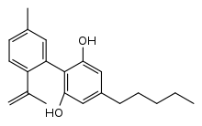
CBN 🡪 CBND
Cannabielsoin (CBE) Type (Five compounds)
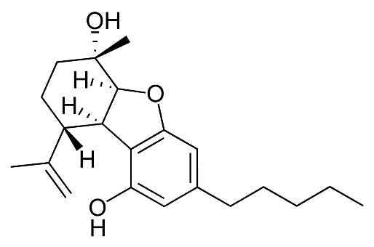
In 1973, cannabielsoin (CBE-C5) was detected in the ethanolic extract of Lebanese hashish. The extract was subjected to counter current distribution followed by GCMS analysis. In 1974, its configuration was determined to be 5aS, 6S, 9R, 9aR]. Both cannabielsoin acid A (CBEAA) and cannabielsoin acid B (CBEAB) were isolated from hashish; the structural elucidation was carried by NMR spectroscopy and chemical transformations. Cannabielsoin-C3 (CBE-C3) and Cannabielsoic acid B-C3 CBE. CBE is a metabolite of cannabidiol [CBD].
CBD 🡪 CBE
Cannabicyclol (CBL) Type (Three compounds)
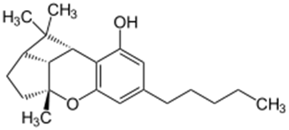
Krote and Sieper isolated cannabicyclol (CBL) from hashish by thin layer chromatography (TLC), but its structure was correctly elucidated by Mechoulam and Gaoni in 1967, based on spectral data. The relative configuration of CBL was determined by X-ray analysis in 1970. Cannabicyclolic acid (CBLA) was obtained from the benzene extract of cannabis. The benzene extract was chromatographed on a polyamide column using methanol water as a mobile phase. CBLA was isolated as a methylated derivative and considered to be an artifact formed when CBCA is naturally irradiated during storage. Cannabicyclovarin (CBLV) was detected in the ether extract of Congo marihuana and was identified by GLC and GC/MS. CBLA was determined to be produced during the natural irradiation of cannabichromenic acid (CBCA), proving that CBLA is not a natural cannabinoid.
CBCA 🡪 CBLA
CBL is a non-psychoactive cannabinoid found in cannabis. CBL is a degradative product like cannabinol, with cannabichromene [CBCM] degrading into CBL through natural irradiation or under acid conditions.
CBC 🡪 CBL
Cannabichromene (CBC) Type (Nine compounds)
CBC was isolated from the hexane extract of hashish, using column chromatography (florisil column) in 1966. The carboxylic acid derivative of CBC, cannabichromenic acid (CBCA) was isolated from the benzene extract of hemp, using silica-gel column chromatography. The chemical structure of CBCA was determined using IR, NMR, and UV spectroscopies. Cannabivarichromene (± CBCV) was identified through GC/MS analysis, and both cannabichromevarin (+ CBCV) and cannabichromevarinic acid (CBCVA) were isolated from a benzene extract of the “Meao” variant of cannabis from Thailand. Three cannabichromene derivatives, (±)-4-acetoxycannabichromene, (±)-3”-hydroxy-Δ4”-cannabichromene and (–)-7-hydroxycannabichromane , were isolated from high potency C. sativa using silica-gel VLC, normal-phase silica HPLC, and reverse-phase silica HPLC. These derivatives were chemically identified using 1D and 2D NMR spectroscopic techniques. In 1984, the CBC-C3 derivative was reported, and using mass spectral analysis, the chemical structure of the CBC-C3 derivative was determined to be 2-methyl-2-(4-methyl-2-pentyl)-7-propyl-2H-1-benzopyran-5-ol. CBC is an anti-inflammatory which may contribute to the pain-killing effect of cannabis. It is more common in tropical cannabis varieties. CBC and its derivatives are as abundant as cannabinols in cannabis. It is not scheduled by the Convention on Psychotropic Substances. CBC is a selective CB2 receptor agonist displaying higher efficacy than THC in hyperpolarizing AtT20 cells. CBC can also recruit CB2 receptor regulatory mechanisms. CBC may contribute to the potential therapeutic effectiveness of some cannabis preparations, potentially through CB2 receptor‐mediated modulation of inflammation.
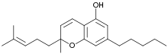
Cannabinol (CBN) Type (Eleven compounds)
The chemical structure and the isolation details of seven cannabinol derivative have been reported in 1980. Both 8-hydroxycannabinol and 8-hydroxy cannabinolic acid A were isolated from the high potency variety of C. sativa and chemically identified based on NMR and high-resolution mass (HR-MS) analysis in 2009. The compounds 1′S-hydroxy-cannabinol and 4-terpenyl cannabinolate were isolated from the same cannabis variety, and their chemical structures were confirmed by GC-MS analysis. CBN is a mildly psychoactive cannabinoid that binds to the cannabinoid receptors with more selectivity for CB2 over CB1. CBN is found in trace amounts in Cannabis. CBN is mostly found in cannabis that is aged and stored, and is derived from the plant's main psychoactive chemical, THC.
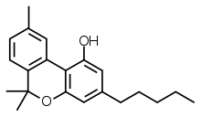
CBN was the first cannabis compound to be isolated from cannabis extract in the late 1800s. Then by the 1930s, the first to have its structure determined and in 1940, to have scientists achieve its chemical synthesis. In contrast to THC, CBN has no double bond isomers nor stereoisomer. CBN can be degraded into HU-345 from CBN oxidation (oxidative degradation).
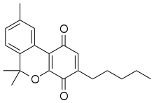
HU-345 (cannabinol quinone) is a drug that can inhibit aortic ring angiogenesis more potently than its parent compound CBN.
UV-B light + Oxygen + Air convert THC to CBN.
THC 🡪 CBN
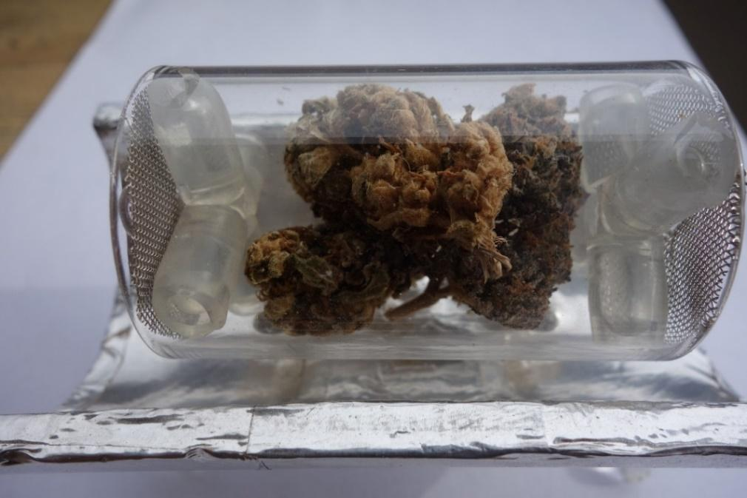
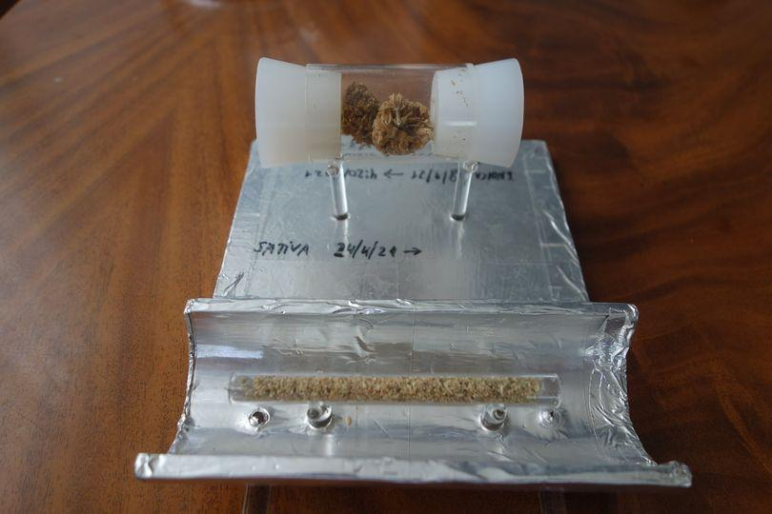
Dry cannabis flowers inside a Quartz tube
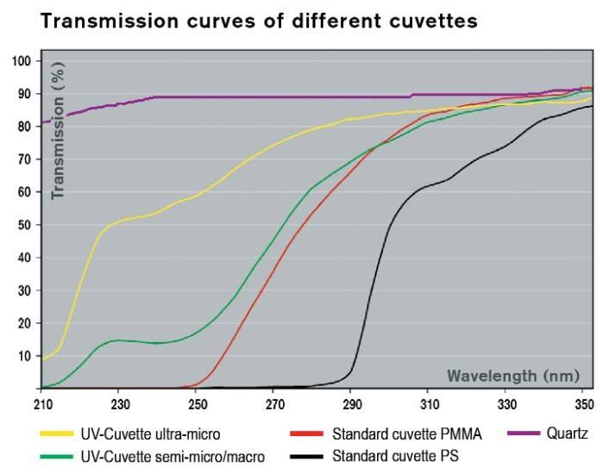
Quartz transmits all UV-B radiation.

Other Minor pCBs
Cannabitriol (CBT) Type (Nine compounds)
Nine CBT-type cannabinoids, including (−)-trans-CBT-C5, (+)-trans-CBT-C5, (±)-cis-CBT-C5, (±)-trans-CBT-C3, CBT-C3-homologue, (−)-trans-CBT-OEt-C5, (–)-trans-CBT-OEt-C3, 8,9-Di-OH-CBT-C5, and CBDA-C5 9-OH-CBT-C5 ester, have been isolated from cannabis. CBT was originally reported in 1966 from Japanese hemp, but its chemical structure was elucidated only in 1976. The configuration of this compound was later determined by X-ray analysis. The compounds (+)-trans-CBT-C5 and (–)-trans -CBT-OEt-C5 were isolated by ElSohly et al. from the ethanolic extract of cannabis, which was chromatographed on a silica gel column and identified by GC/MS. The two ethoxy cannabitriols are most likely artifacts, since ethanol was used in their isolation from cannabis.
Cannabitriol ((+)-CBT, (S,S)-9,10-Dihydroxy-Δ6a(10a)-THC) is a pCB first isolated in 1966, an oxidation product of THC which has been identified both as a trace component of cannabis and as a metabolite in cannabis users. Its pharmacology has been little studied, though it has been found to act as an antiestrogen and aromatase inhibitor.
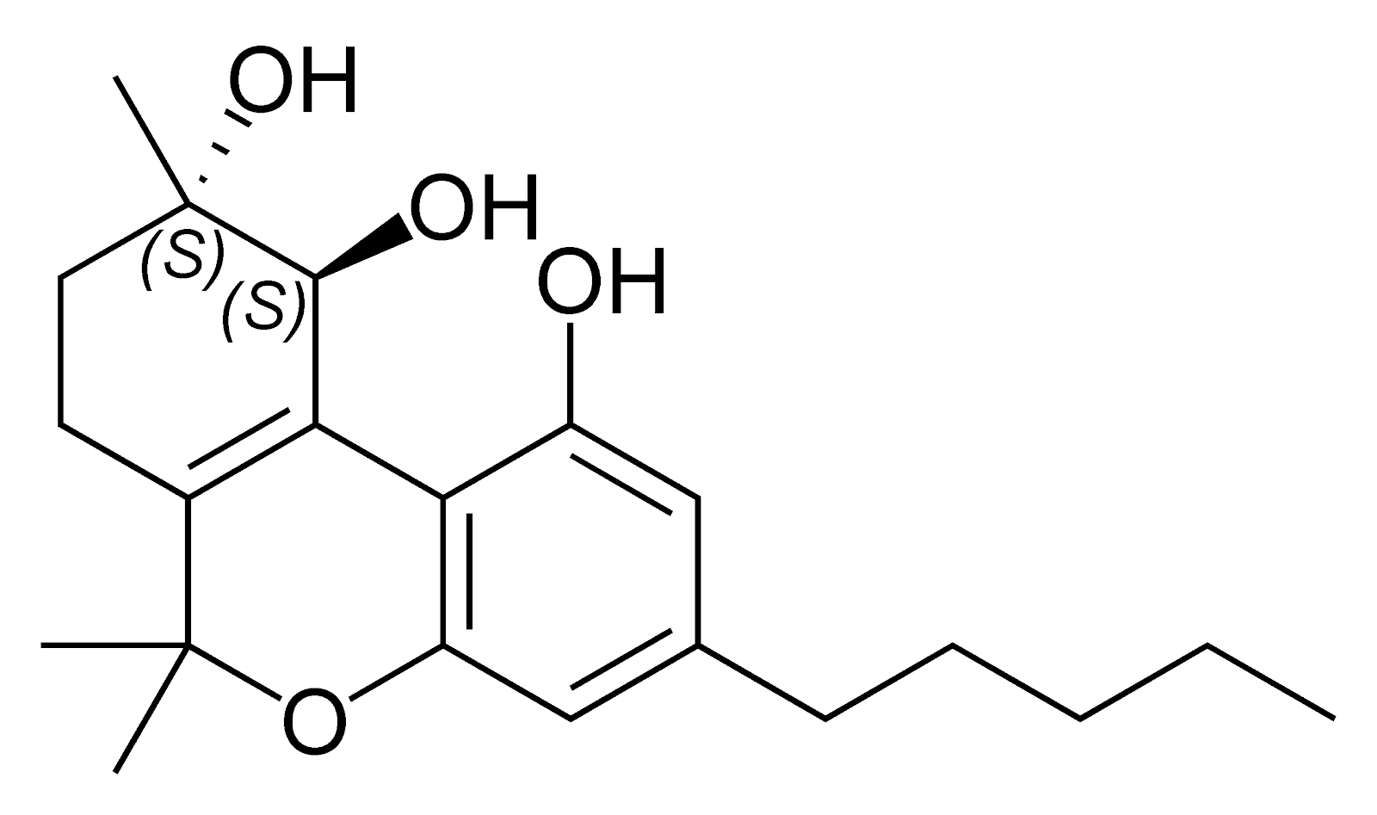
THC 🡪 CBT
Miscellaneous Types Cannabinoids (30 compounds)
A total of thirty miscellaneous type cannabinoids have been isolated from cannabis, including dehydrocannabifuran (DCBF-C5), cannabifuran (CBF-C5), 8-hydroxy-isohexahydrocannabivirin (OH-iso-HHCV-C3), 10-oxo-Δ6a(10a)-tetrahydro-cannabinol (OTHC), cannabicitran, (–)-Δ9-cis-(6aS,10aR)-tetrahydro-cannabinol (cis-Δ9-THC), cannabicoumaronone (CBCON-C5) and cannabiripsol (CBR).
Cannabitetrol (CBTT), cannabichromanone-C5 (CBCN-C5), cannabichromanone-C3 (CBCN-C3), (±)-Δ7-cis-isotetrahydrocannabivarin-C3 (cis-iso-Δ7-THCV), (–)-Δ7-trans-(1R,3R,6R)-isotetrahydrocannabivarin-C3 (trans-iso-Δ7-THCV), and (–)-Δ7-trans-(1R,3R,6R)-isotetrahydrocannabinol-C5 (trans-iso-Δ7-THC). The cyclohexane-methanol extract of Afghan hashish afforded dehydrocannabifuran (DCBF-C5), cannabifuran (CBF-C5), OTHC, and cannabichromanone-C5 (CBCN-C5) after micro-preparative GC and TLC. Their chemical structures were determined by mass and NMR spectroscopic analysis. Cannabicitran (CBT {CBCT}) was isolated from an ethanolic extract of Lebanese hashish. It was purified by counter-current distribution and silica gel chromatography. Its chemical structure was determined by GC/MS, IR and 1H NMR analyses.
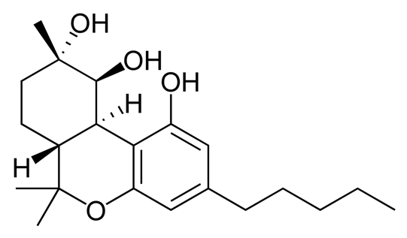
Cannabicitran (CBTC) is a pCB first isolated in 1974 as a trace component of Cannabis sativa. Structurally related compounds can be found in some other plants. It is not psychoactive but was found to reduce intraocular pressure [IOP] in tests on rabbits, which may reflect agonist activity at the NAGly receptor (formally GPR18) that is known to be a target of many structurally related cannabinoids.
Cannabiripsol (CBR) was isolated from a South African cannabis variant after hexane extraction and chromatography on silica and polyamide columns. Its chemical structure was determined by spectral means (IR, GC/MS, UV, 1H NMR) and by synthesis.
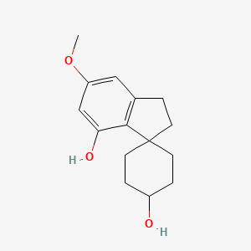
Cannabitetrol (CBTT) was obtained and identified from the hexane extract of Mexican marijuana using silica gel column chromatography.
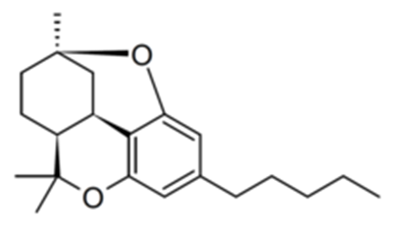
From a high potency variety of C. sativa, three cannabichromanones were isolated, namely cannabichromanone B, C, and D. The absolute configurations of these three cannabinoids were assigned on the basis of the Mosher ester and inspection of their circular dichroism spectra. The isolation of these compounds was performed using semi-preparative C18 HPLC. Additionally, (–)-(7R)-cannabicoumarononic acid, 4-acetoxy-2-geranyl-5-hydroxy-3-n-pentylphenol, and 2-geranyl-5-hydroxy-3-n-pentyl-1,4-benzoquinone were isolated from the buds and leaves of the same variety of cannabis (high potency C. sativa) using several chromatographic techniques, including silica-gel VLC, solid-phase extraction, reverse-phase columns (C18 SPE), and normal-phase HPLC. In addition, 5-acetoxy-6-geranyl-3-n-pentyl-1,4-benzoquinone was isolated on silica gel column chromatography followed by normal-phase HPLC.
In 2010, a new cannabinoid named Cannabimovone (CBM) was isolated from a non-psychotropic variety of C. sativa. This unusual metabolite is presumably formed from CBD and was isolated from a polar fraction of hemp by using flash chromatography over reverse-phase C18 silica gel followed by normal-phase HPLC. The chemical identity of CBM was revealed by a combination of 1D and 2D NMR along with ESI-MS spectroscopic techniques.
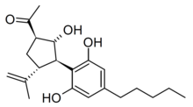
CBM is thought to be a rearrangement product of cannabidiol [CBD]. It lacks affinity for cannabinoid receptors but acts as an agonist at both TRPV1 and PPARγ.

CBD 🡪 CBM
A tetracyclic cannabinoid, Cannabioxepane, (CBX or CBO) was isolated in 2011 from a cannabis variety called "Carmagnola" a fiber cultivar of Cannabis by applying many chromatographic techniques including RP-18 column, silica gel column chromatography, and NP-HPLC chromatography. Its chemical structure was established using MS and NMR data. A novel spiranic stilbenoid isocannabispiradienone and the biphenyl-type cannabinoid cannabioxepane (CBX), a tetracyclic compound characterized by an unprecedented C-5/C-8′ oxygen bridge and devoid of cannabinoid activity.
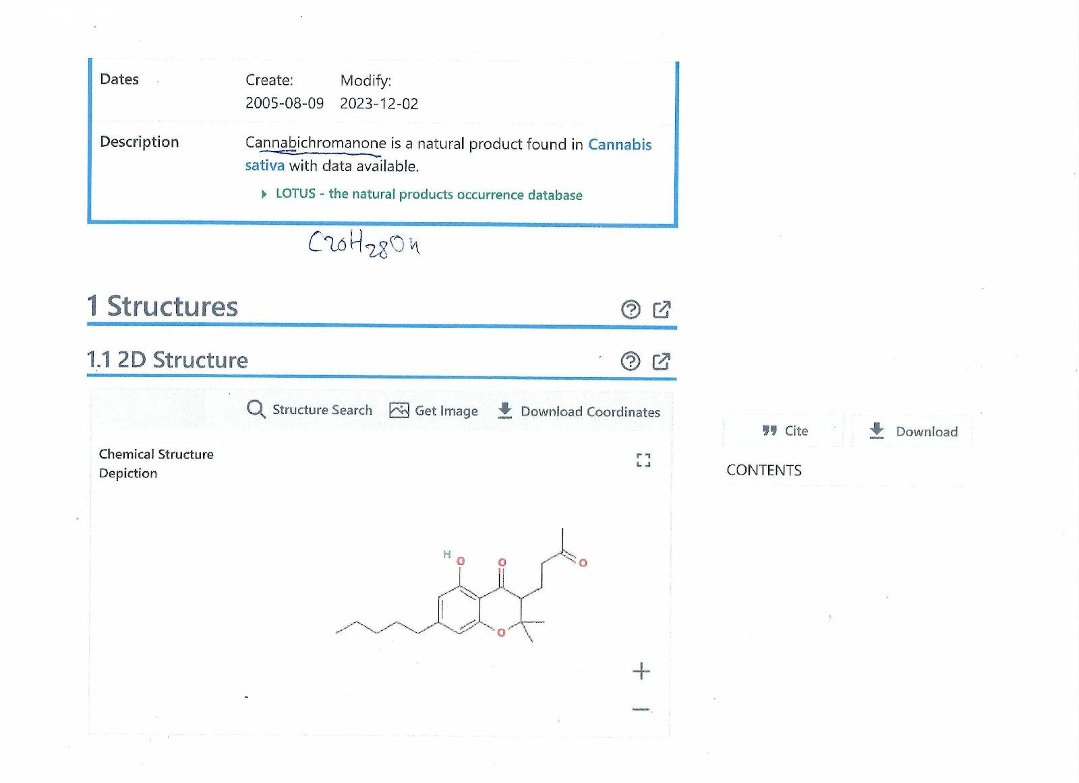
Cannabichromanone (CBCR)

Proposal for the biogenetic relationships of cannabinoid classes:
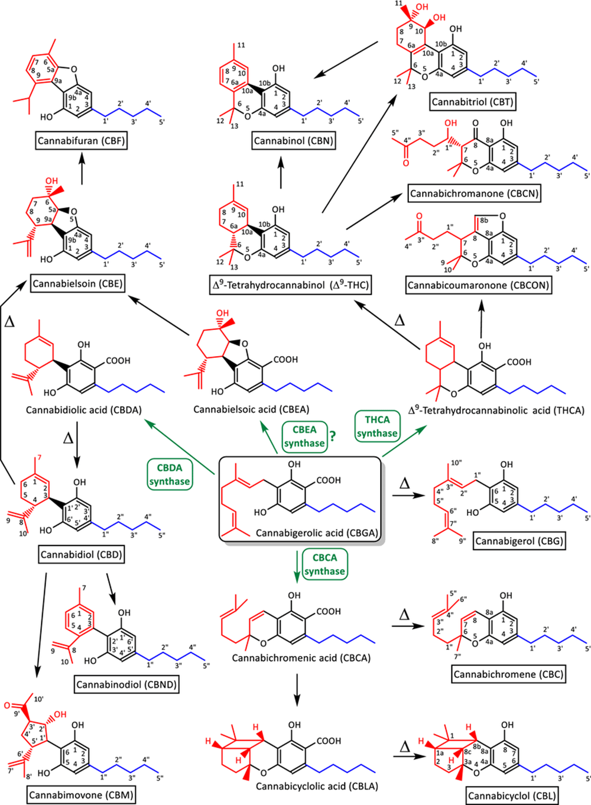
The system used in this article for the numbering of atoms forming the carbon backbone of each class is shown. Trivial names and common abbreviations are given. Reactions catalyzed by enzymes with known functions have a green arrow. Note that the existence of a CBEA synthase has not been established in cannabis but has been shown to occur in other plant species. Thermal breakdown reactions are indicated with the Greek letter Δ. The Terpene moiety is colored in red, the Phenol in black and the hydrophobic "tail" in blue.
CBE, CBF & CBCON do not have a phenol moiety in their molecules – do they absorb UV-B light?
Cannabifuran (CBF)
Recently, researcher reported a strategy to prepare several structurally diverse minor cannabinoids deriving synthetically from readily available cannabidiol [CBD]. They examined the ability of those minor pCBs to polarize activated microglia toward an anti-inflammatory phenotype using LPS-stimulated BV2 microglial cells. The minor cannabinoids studied, especially cannabielsoin [CBE], dehydrocannabielsoin, cannabimovone (CBM), and 3′-epicannabimovone, inhibited the production of prototypical pro-inflammatory biomarkers. This study represents the beginning of a systematic mapping of the roles minor cannabinoids may play in the medicinal properties of cannabis used for the treatment of pain and inflammation.
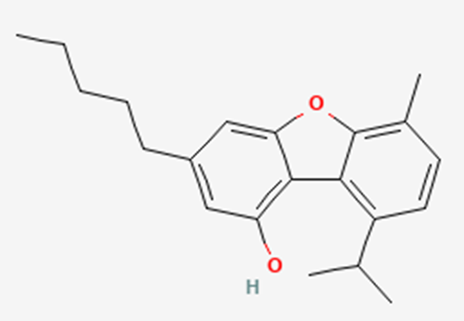

Cannabioxepane (CBO = CBX)
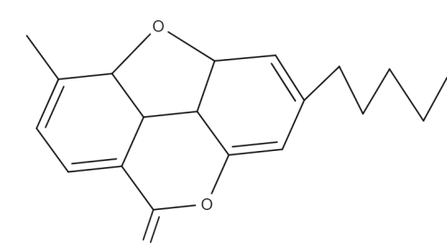
Cannabicoumaronone (CBCON)
Cannabicoumaronone [4-(4,4-Dimethyl-7-pentyl-3,4-dihydrofuro[4,3,2-de]chromen-3-yl)-2-butanone] is a natural product found in Cannabis sativa.
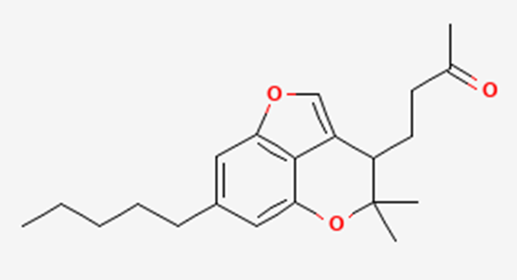
Seven more cannabinoids were isolated from a high potency variety of C. sativa and chemically elucidated by 1D & 2D NMR & HRMS analyses as:
10α-hydroxy-Δ9,11-hexahydrocannabinol [Hydroxy HHC[
9β,10β-epoxyhexahydrocannabinol [Epoxy HHC[
9α-hydroxyhexahydrocannabinol [Hydroxy HHC]
7-oxo-9α-hydroxyhexahydrocannabinol [Oxo HHC]
10α-hydroxyhexahydrocannabinol [Hydroxy HHC[
10aR-hydroxyhexahydrocannabinol [Hydroxy HHC[
9α-hydroxy-10-oxo-Δ6a,10a-THC.
Inside the secretory cavity of cannabis glandular trichome (GT), a complex "Natural Pharmacy" is producing more than 100 pCBs from one precursor pCB = GBGA.
Hypothesis: Minor (rare) pCBs, make potent cannabis highly psychoactive and add to its medicinal properties.
Our research team will study the effect of addition of minor pCBs to medical cannabis formulations for personalized medicine.
THC to CBN or CBT
CBD to CBE, CBF, CBO (CBX) or CBM
CBC to CBL
CBN to CBND
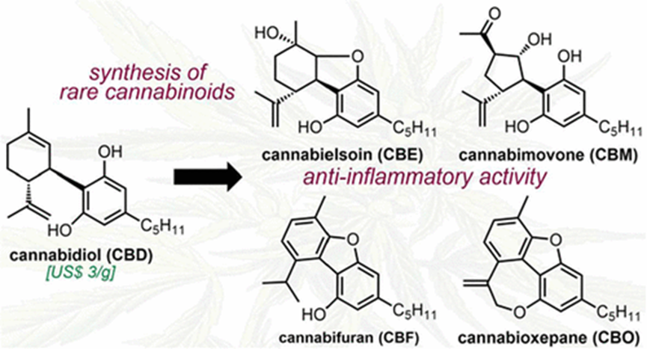

Citronellal
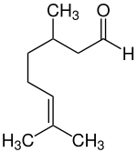
Citronellal or rhodinal (C10H18O) is a monoterpenoid aldehyde, the main component in the mixture of terpenoid chemical compounds that give citronella oil its distinctive lemon scent.
Citronellal is a main isolate in distilled oils from the plants Cymbopogon (excepting C. citratus, culinary lemongrass), lemon-scented gum, and lemon-scented Teatree. The (S)-(−)-enantiomer of citronellal makes up to 80% of the oil from kaffir lime leaves and is the compound responsible for its characteristic aroma.
Citronellal has insect repellent properties, and research shows high repellent effectiveness against mosquitoes. Another research shows that citronellal has strong antifungal qualities.

